 | Client: | Wildlife Management Institute
 | Client Contact: | Meghan Gilbart
 | Project Name: | Maine NABAT
 | Project Code: | MAMM-NG26-007
 | Project Manager: | Joshua Guilbert
Project Information
Name of Permitted Biologist: | Bri Frankina
Federal Permit Number: | TE63633A
Personnel*: | BRF, ECG
Habitat Assessment Dates: | 7/8/2026
First Deployment Date: | 7/8/2026
Target Recovery
Final Recovery/Last Service: | 8/5/2026
Servicing Dates: | None
Survey Type | Summer - Acoustic
Site Type: | Inland
Landowner Information: | Seven Islands
Site: | 105059-NW3
Site Label: | 105059-NW3
County: | Oxford
State: | Maine
Site Coordinates: | 44.782195, -70.883353
Detector Info:
Deployment Date: | 7/8/2026
ARU Make, Model & Serial #: | Wildlife Acoustics, SM4BatFS, S4U17643
Power Make, Model & Serial #: | Internal power, 4 x D Batteries
Microphone Make, Model & Serial: | Wildlife Acoustics, U2, MU220468
Microphone Height (m) | 3
Microphone Direction(degrees): | 9
Microphone Orientation: | 45
Status Check: Settings†: | Yes
Status Check: Hardware ‡: | Yes
Survey Schedule

Servicing Events
Date | Staff* | Action | Notes
None

Recovery Date: | 8/5/2026
ARU Make, Model & Serial #: | Wildlife Acoustics, SM4BatFS, S4U17643
Power Make, Model & Serial #: | Internal power, 4 x D Batteries
Microphone Make, Model & Serial#: | Wildlife Acoustics, U2, MU220468
Microphone Height (m) | 3
Microphone Direction (degrees): | 9
Microphone Vertical Orientation: | 45
Status Check: Settings†:
Status Check: Hardware ‡:
Survey Schedule
Notes

Habitat Assessment:
Assessment date: | 7/8/2026
Habitat Assessment Area: | 20m x 20m plot with mic at the center
Basic Overall Site Description: | Small clearing along mixed forest targeting edge habitat
Targeted Feature for Deployment: | Forest Edge
Bat Roost Habitat: | None
Water Resources: | No water resources present at site
Distance Mic to Nearest Water (m):
Type of Nearest Water: | standing or ponded freshwater
Tree Species Dominant | Sugar Maple
Tree Species All Present (within view) | Sugar Maple, Poplar, White Birch, Yellow Birch
Understory Species Dominant | Birch, Cherry
Understory Species All Present (within view) | Cherry, Birch, Maple
DBH of Surrounding Stand: | 5-15cm present
Stand Age: | Young/even aged
Understory Clutter | Semi-cluttered (cluttered but gaps present)
Microphone Distance to Clutter (m): | 3
Land Cover: | Trees present but fragmented

ARU Photos
No photo found | No photo found
Figure 1: 105059-NW3 deployment setup (Left) and microphone view (Right).
No photo found | No photo found
Figure 2: 105059-NW3 view for North (Left) and East (Right)
No photo found | No photo found
Figure 3: 105059-NW3 view for South (Left) and West (Right)
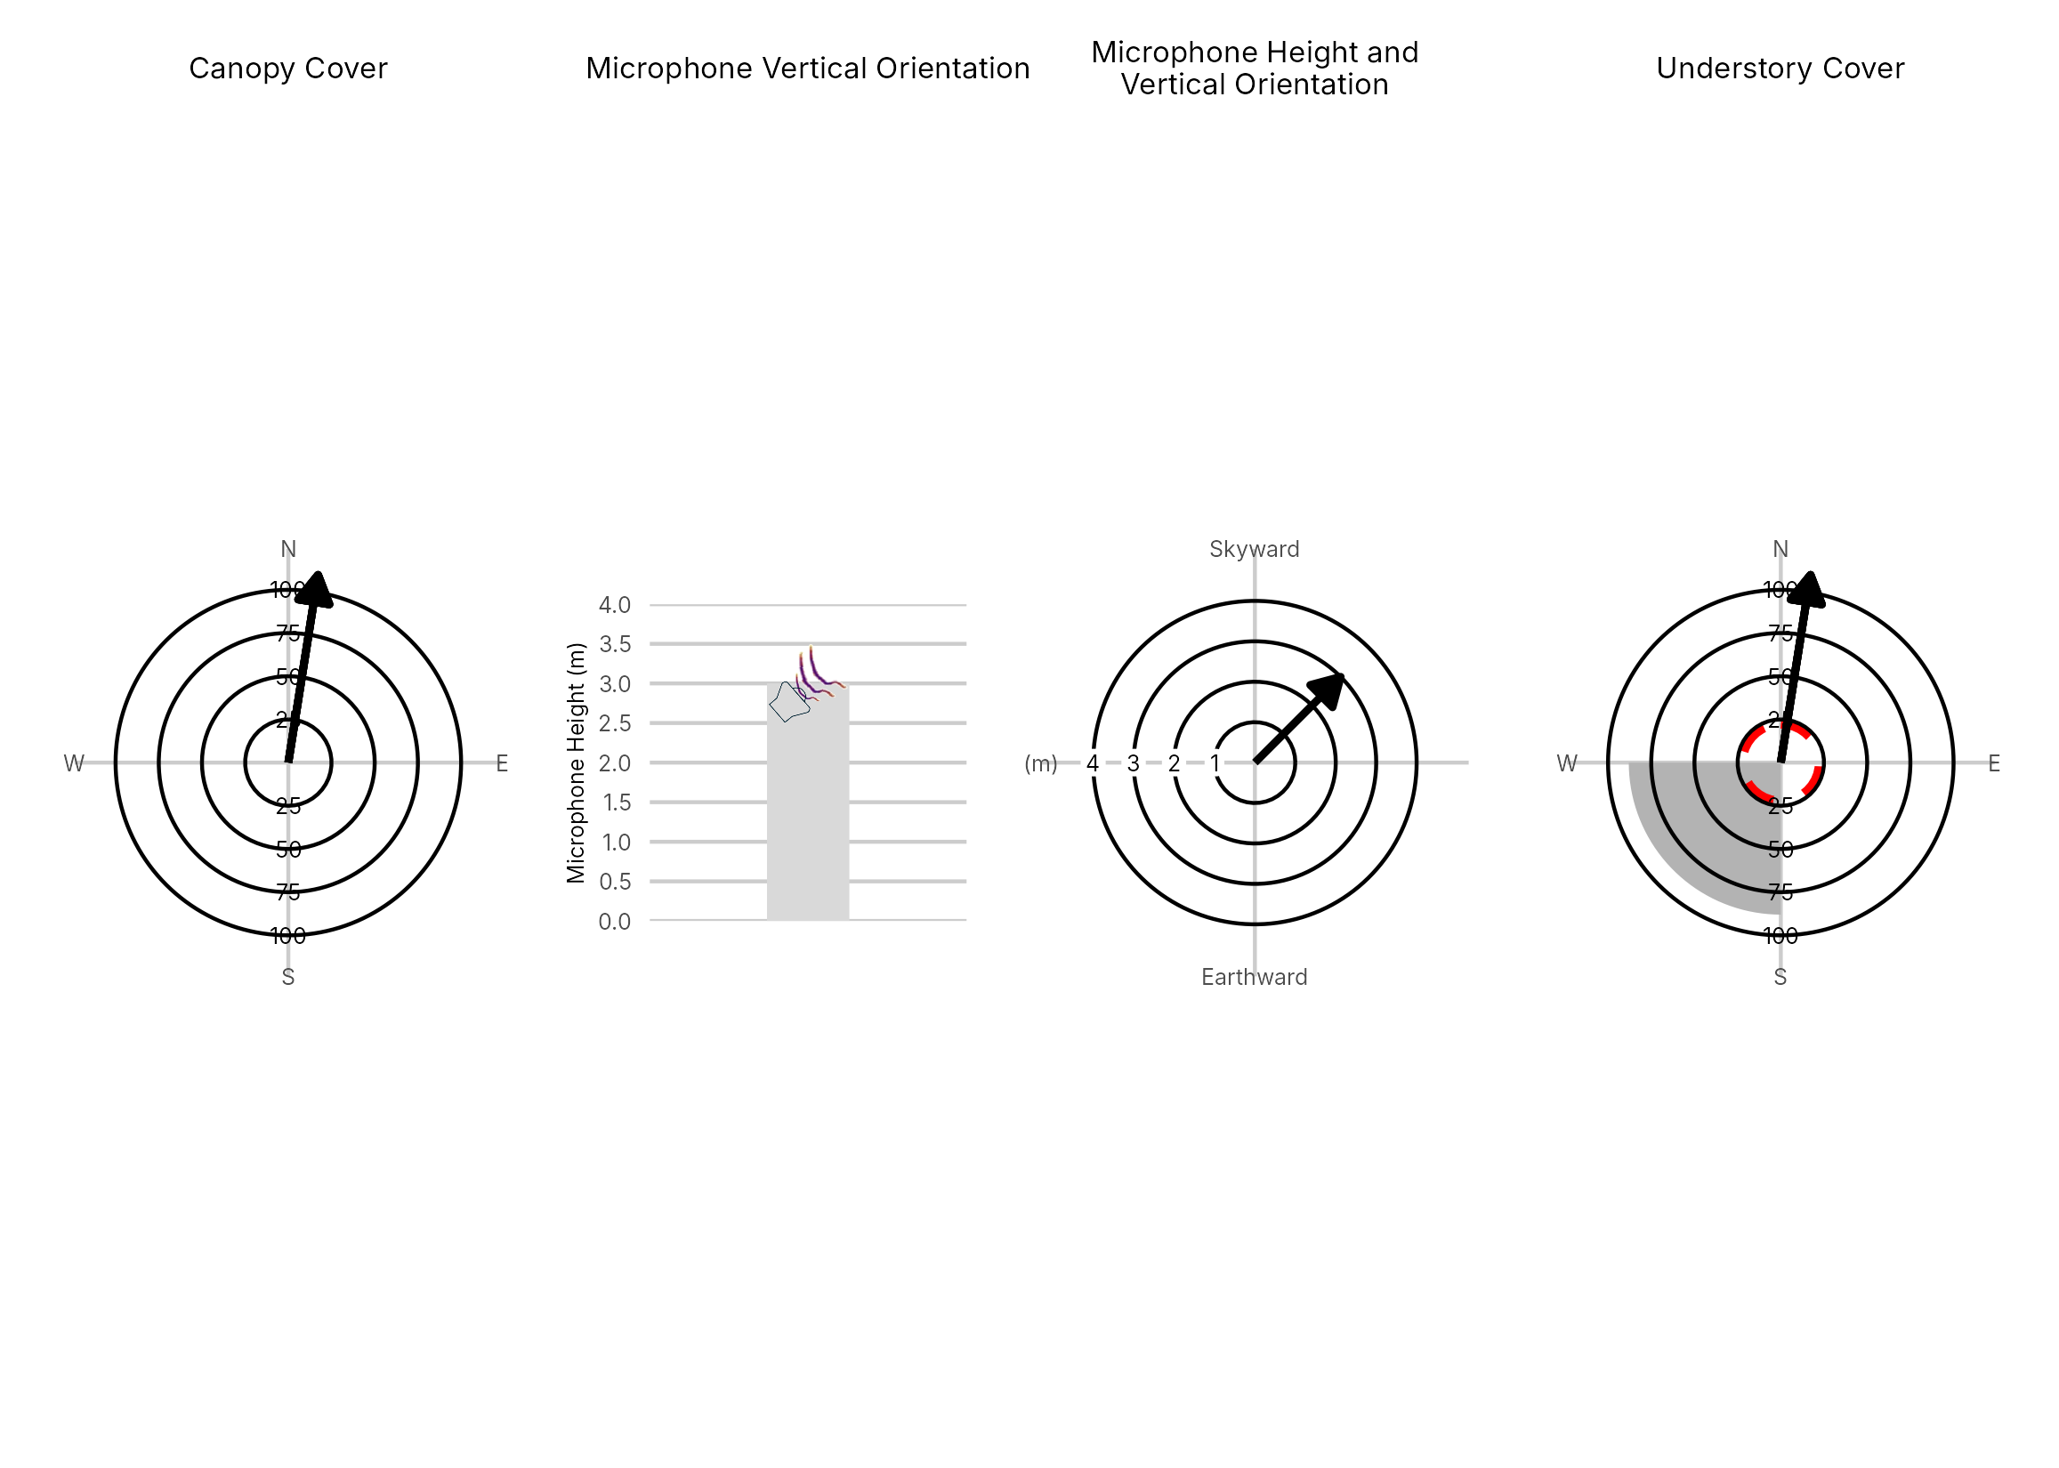

Figure 4: Percentage clutter for the understory and canopy cover at the 105059-NW3 compared with all sites within the study. Clutter was measured in each of the four 10x10m quadrants (Northeast, Southeast, Southwest and Northwest), surrounding the microphone. Percentage clutter and canopy cover categories were 0-5%, 10-25,25-50,50-75,76-95, 95-100%. The average clutter for the site was calculated by taking the meaning of the mid-point of each quadrant. The direction of the microphone is indicated by the arrow.

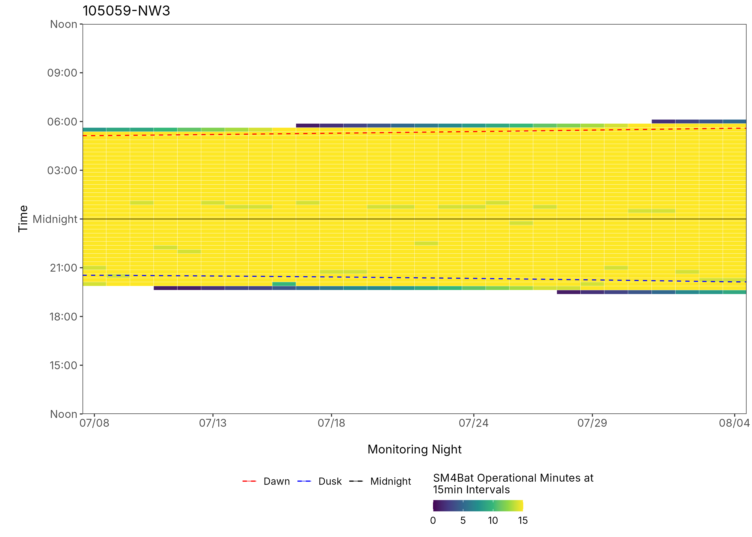
Figure 5: ARU activity plot

 | Client: | Wildlife Management Institute
 | Client Contact: | Meghan Gilbart
 | Project Name: | Maine NABAT
 | Project Code: | MAMM-NG26-007
 | Project Manager: | Joshua Guilbert
Project Information
Name of Permitted Biologist: | Bri Frankina
Federal Permit Number: | TE63633A
Personnel*: | BRF, ECG
Habitat Assessment Dates: | 7/8/2026
First Deployment Date: | 7/8/2026
Target Recovery
Final Recovery/Last Service: | 8/6/2026
Servicing Dates: | None
Survey Type | Summer - Acoustic
Site Type: | Inland
Landowner Information: | Seven Islands
Site: | 105059-SE3
Site Label: | 105059-SE3
County: | Oxford
State: | Maine
Site Coordinates: | 44.743860, -70.835666
Detector Info:
Deployment Date: | 7/8/2026
ARU Make, Model & Serial #: | Wildlife Acoustics, SM4BatFS, S4U17642
Power Make, Model & Serial #: | Internal power, 4 x D Batteries
Microphone Make, Model & Serial: | Wildlife Acoustics, U2, MU220559
Microphone Height (m) | 4
Microphone Direction(degrees): | 184
Microphone Orientation: | 0
Status Check: Settings†: | Yes
Status Check: Hardware ‡: | Yes
Survey Schedule

Servicing Events
Date | Staff* | Action | Notes
None

Recovery Date: | 8/6/2026
ARU Make, Model & Serial #: | Wildlife Acoustics, SM4BatFS, S4U17642
Power Make, Model & Serial #: | Internal power, 4 x D Batteries
Microphone Make, Model & Serial#: | Wildlife Acoustics, U2, MU220559
Microphone Height (m) | 4
Microphone Direction (degrees): | 184
Microphone Vertical Orientation: | 0
Status Check: Settings†:
Status Check: Hardware ‡:
Survey Schedule
Notes

Habitat Assessment:
Assessment date: | 7/8/2026
Habitat Assessment Area: | 20m x 20m plot with mic at the center
Basic Overall Site Description: | Along edge where wetland meets forest next to pond.
Targeted Feature for Deployment: | Pond
Bat Roost Habitat: | Snags & damaged live trees
Water Resources: | Water present but not optimal
Distance Mic to Nearest Water (m): | 1
Type of Nearest Water: | freshwater wetland
Tree Species Dominant | Balsalm Fir
Tree Species All Present (within view) | Spruce, Balsam Fir, Balsalm Fir, White Pine, Birch
Understory Species Dominant | Birch, Balsam Fir
Understory Species All Present (within view) | Spruce, Birch, Balsam Fir, Alder
DBH of Surrounding Stand: | 5-15cm present
Stand Age: | Young/even aged
Understory Clutter | Semi-cluttered (cluttered but gaps present)
Microphone Distance to Clutter (m): | 2
Land Cover: | Trees present but fragmented

ARU Photos
No photo found | No photo found
Figure 1: 105059-SE3 deployment setup (Left) and microphone view (Right).
No photo found | No photo found
Figure 2: 105059-SE3 view for North (Left) and East (Right)
No photo found | No photo found
Figure 3: 105059-SE3 view for South (Left) and West (Right)
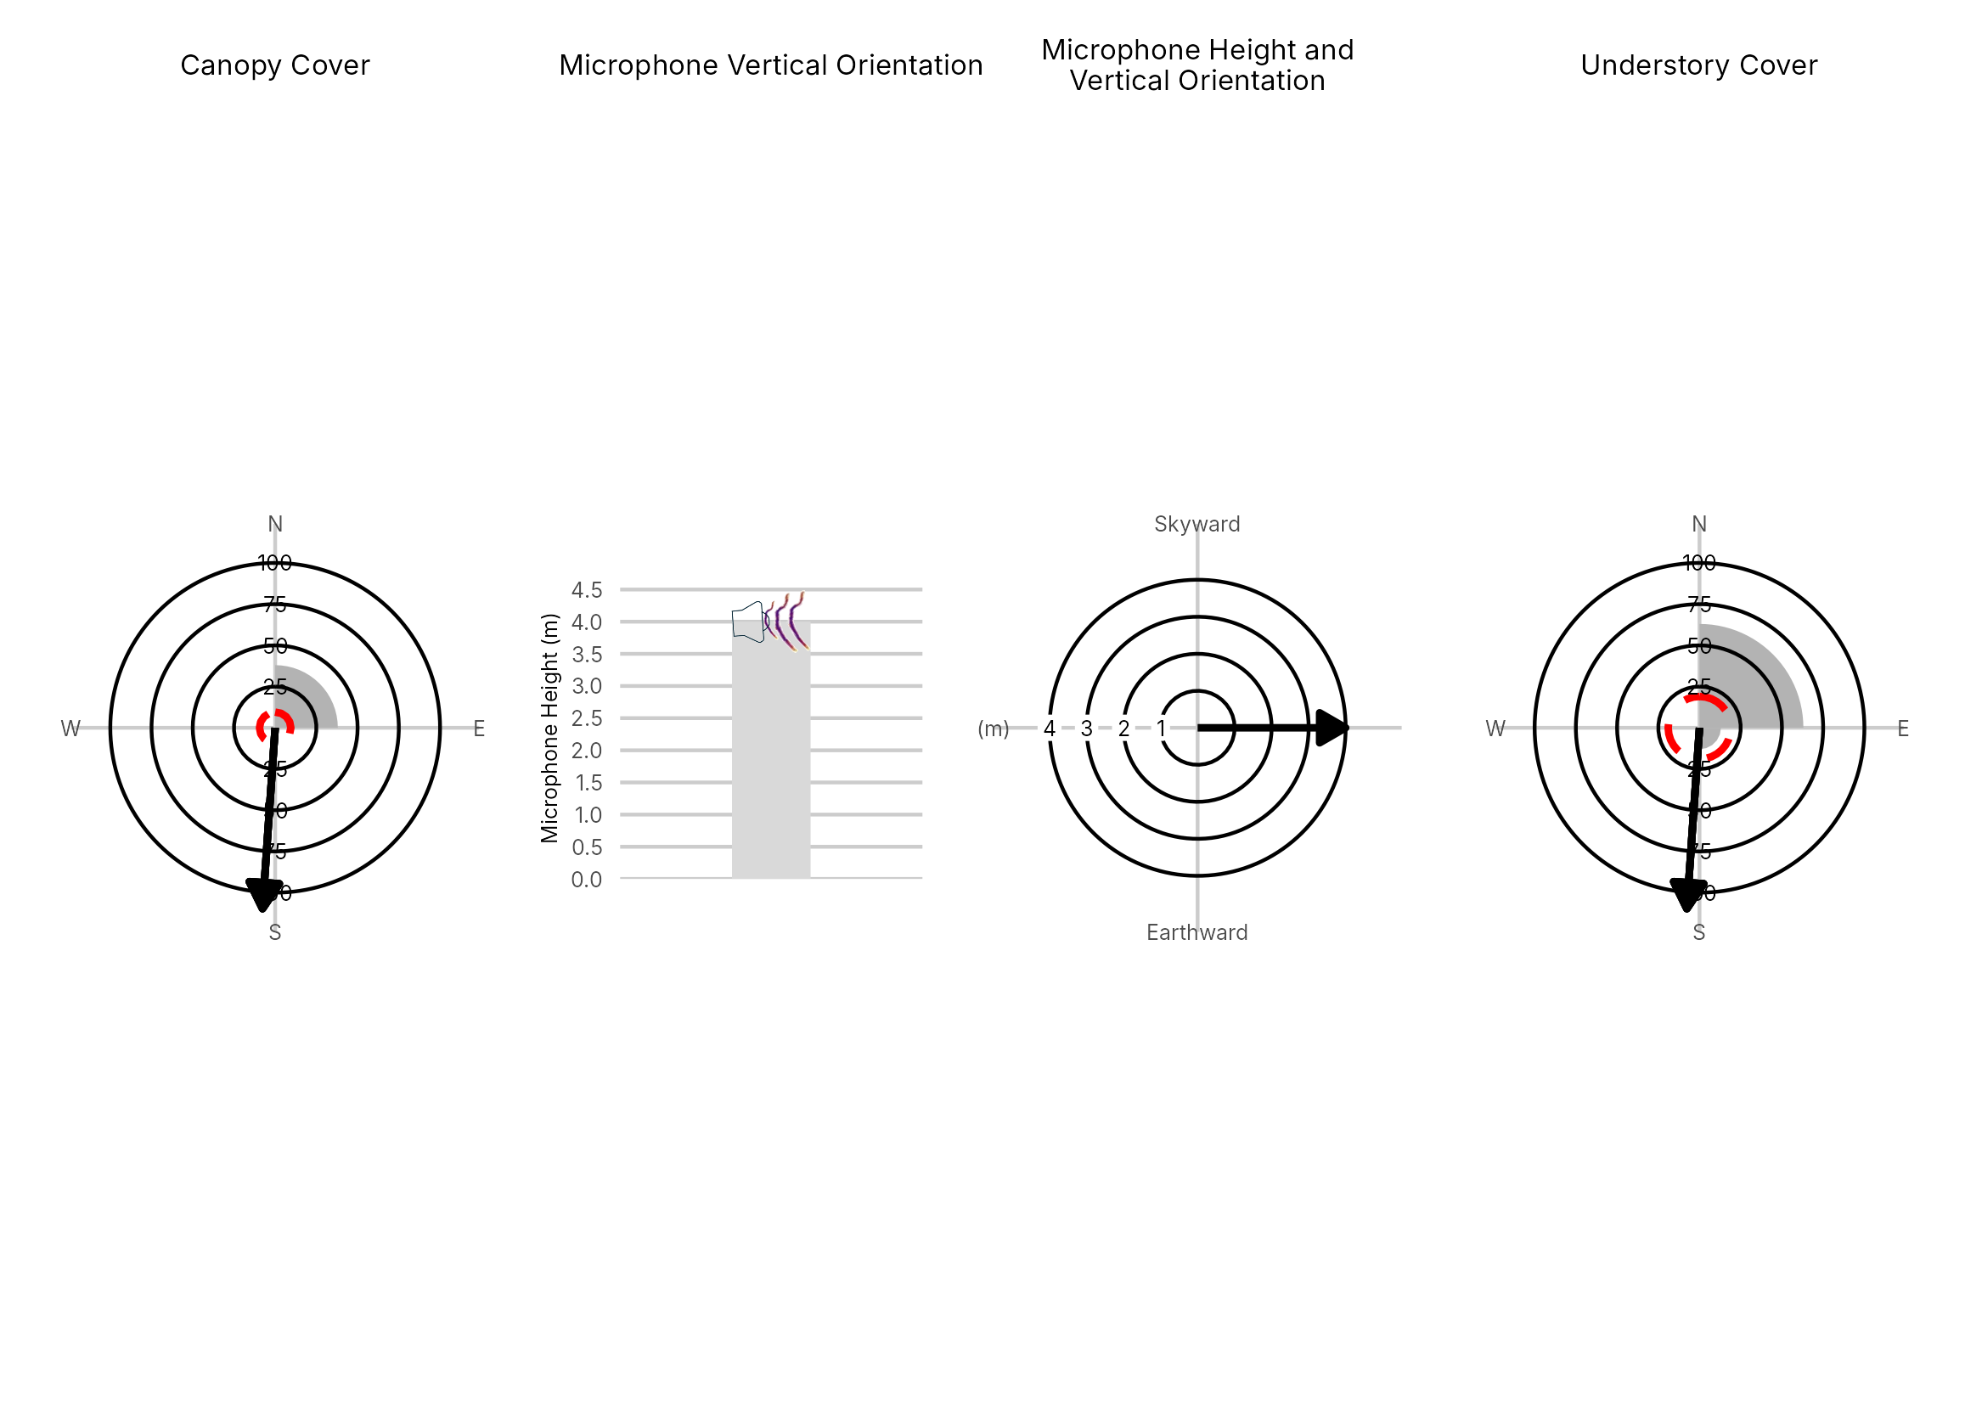

Figure 4: Percentage clutter for the understory and canopy cover at the 105059-SE3 compared with all sites within the study. Clutter was measured in each of the four 10x10m quadrants (Northeast, Southeast, Southwest and Northwest), surrounding the microphone. Percentage clutter and canopy cover categories were 0-5%, 10-25,25-50,50-75,76-95, 95-100%. The average clutter for the site was calculated by taking the meaning of the mid-point of each quadrant. The direction of the microphone is indicated by the arrow.

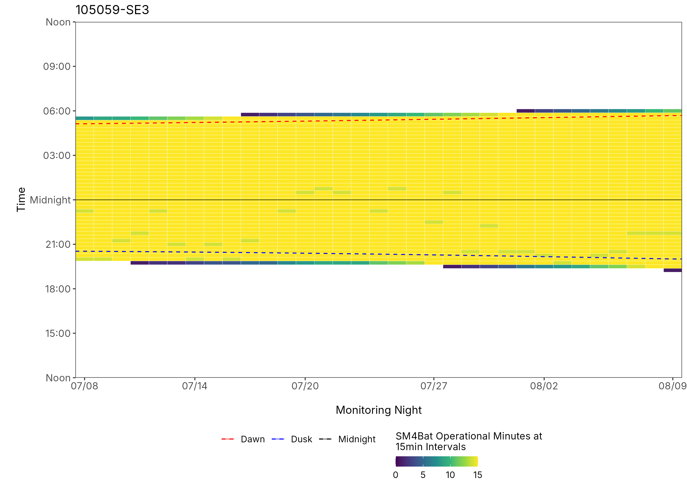
Figure 5: ARU activity plot

 | Client: | Wildlife Management Institute
 | Client Contact: | Meghan Gilbart
 | Project Name: | Maine NABAT
 | Project Code: | MAMM-NG26-007
 | Project Manager: | Joshua Guilbert
Project Information
Name of Permitted Biologist: | Bri Frankina
Federal Permit Number: | TE63633A
Personnel*: | BRF, ECG
Habitat Assessment Dates: | 7/7/2026
First Deployment Date: | 7/7/2026
Target Recovery
Final Recovery/Last Service: | 8/6/2026
Servicing Dates: | None
Survey Type | Summer - Acoustic
Site Type: | Inland
Landowner Information: | Seven Islands
Site: | 105059-SW3
Site Label: | 105059-SW3
County: | Oxford
State: | Maine
Site Coordinates: | 44.737016, -70.915936
Detector Info:
Deployment Date: | 7/7/2026
ARU Make, Model & Serial #: | Wildlife Acoustics, SM4BatFS, S4U19379
Power Make, Model & Serial #: | Internal power, 4 x D Batteries
Microphone Make, Model & Serial: | Wildlife Acoustics, U2, MU220482
Microphone Height (m) | 3
Microphone Direction(degrees): | 280
Microphone Orientation: | 45
Status Check: Settings†: | Yes
Status Check: Hardware ‡: | Yes
Survey Schedule

Servicing Events
Date | Staff* | Action | Notes
None

Recovery Date: | 8/6/2026
ARU Make, Model & Serial #: | Wildlife Acoustics, SM4BatFS, S4U19379
Power Make, Model & Serial #: | Internal power, 4 x D Batteries
Microphone Make, Model & Serial#: | Wildlife Acoustics, U2, MU220482
Microphone Height (m) | 3
Microphone Direction (degrees): | 280
Microphone Vertical Orientation: | 45
Status Check: Settings†:
Status Check: Hardware ‡:
Survey Schedule
Notes

Habitat Assessment:
Assessment date: | 7/7/2026
Habitat Assessment Area: | 20m x 20m plot with mic at the center
Basic Overall Site Description: | Forest edge along intersection of old forested logging roads
Targeted Feature for Deployment: | Forest Edge
Bat Roost Habitat: | Snags & damaged live trees
Water Resources: | No water resources present at site
Distance Mic to Nearest Water (m):
Type of Nearest Water: | freshwater wetland
Tree Species Dominant | Spruce
Tree Species All Present (within view) | Pine, Spruce, Sugar Maple, Striped Maple, Balsam Fir
Understory Species Dominant | Balsam Fir, Maple, Red Spruce, Striped Maple
Understory Species All Present (within view) | Balsam Fir, Maple, Red Spruce, Striped Maple
DBH of Surrounding Stand: | Majority <5cm
Stand Age: | Young/even aged
Understory Clutter | Minimal clutter (open understory facilitates flight)
Microphone Distance to Clutter (m): | 3
Land Cover: | Trees present but fragmented

ARU Photos
No photo found | No photo found
Figure 1: 105059-SW3 deployment setup (Left) and microphone view (Right).
No photo found | No photo found
Figure 2: 105059-SW3 view for North (Left) and East (Right)
No photo found | No photo found
Figure 3: 105059-SW3 view for South (Left) and West (Right)
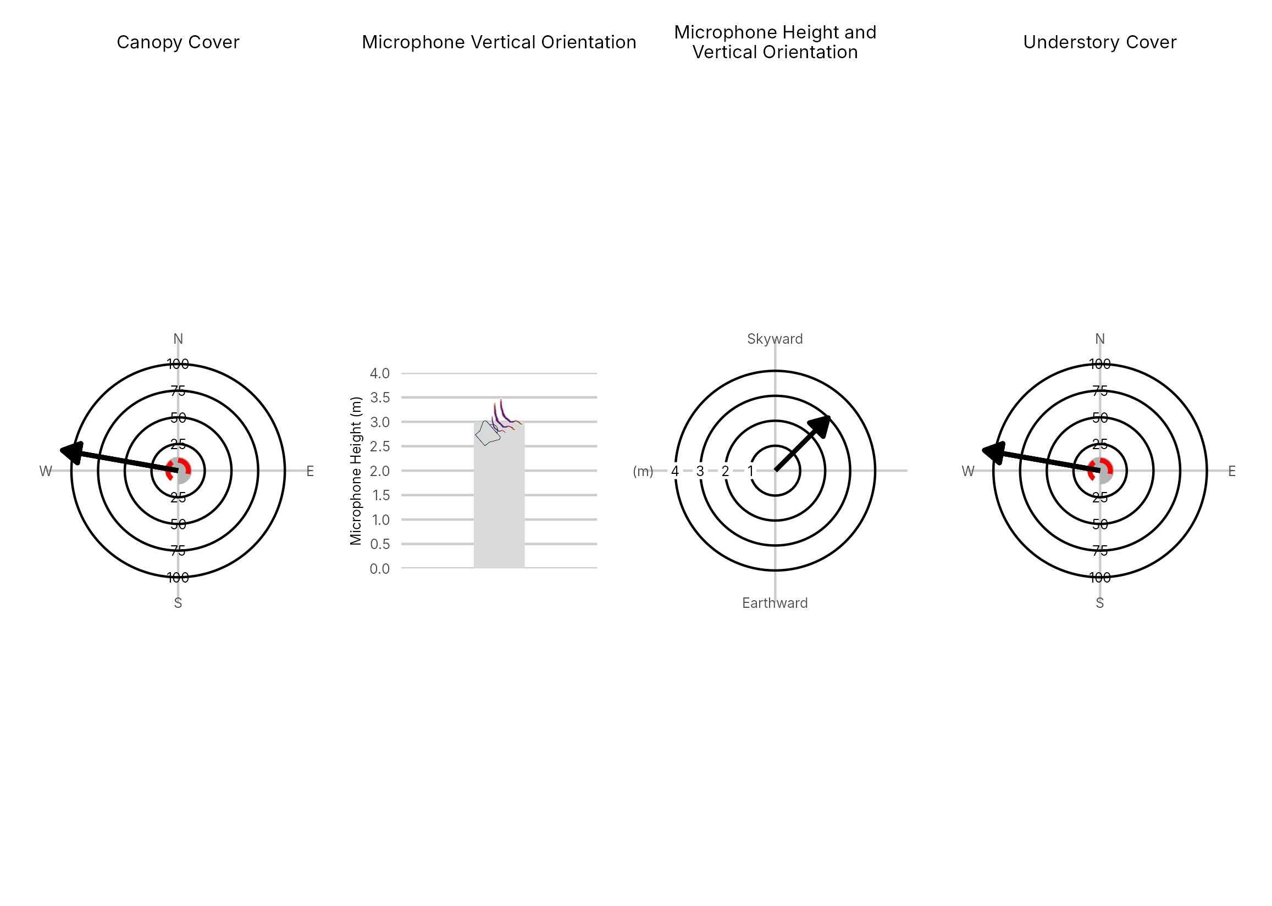

Figure 4: Percentage clutter for the understory and canopy cover at the 105059-SW3 compared with all sites within the study. Clutter was measured in each of the four 10x10m quadrants (Northeast, Southeast, Southwest and Northwest), surrounding the microphone. Percentage clutter and canopy cover categories were 0-5%, 10-25,25-50,50-75,76-95, 95-100%. The average clutter for the site was calculated by taking the meaning of the mid-point of each quadrant. The direction of the microphone is indicated by the arrow.

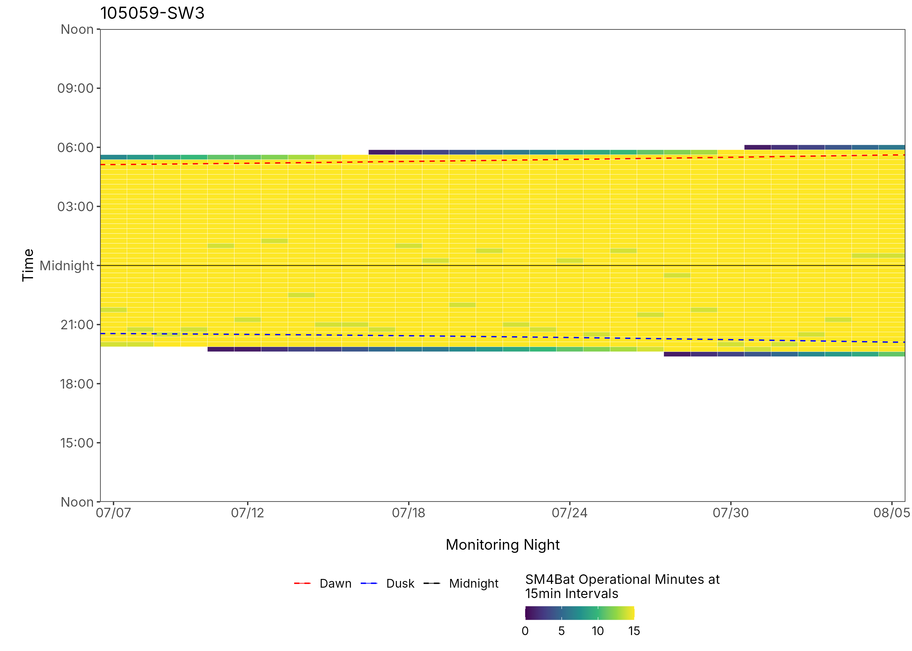
Figure 5: ARU activity plot

 | Client: | Wildlife Management Institute
 | Client Contact: | Meghan Gilbart
 | Project Name: | Maine NABAT
 | Project Code: | MAMM-NG26-007
 | Project Manager: | Joshua Guilbert
Project Information
Name of Permitted Biologist: | Bri Frankina
Federal Permit Number: | TE63633A
Personnel*: | BRF, ECG
Habitat Assessment Dates: | 7/8/2026
First Deployment Date: | 7/8/2026
Target Recovery
Final Recovery/Last Service:
Servicing Dates: | None
Survey Type | Summer - Acoustic
Site Type: | Inland
Landowner Information: | Seven Islands
Site: | 107802-NW1
Site Label: | 107802-NW1
County: | Oxford
State: | Maine
Site Coordinates: | 44.713498, -70.876353
Detector Info:
Deployment Date: | 7/8/2026
ARU Make, Model & Serial #: | Wildlife Acoustics, SM4BatFS, S4U17671
Power Make, Model & Serial #: | Internal power, 4 x D Batteries
Microphone Make, Model & Serial: | Wildlife Acoustics, U2, MU220465
Microphone Height (m) | 4
Microphone Direction(degrees): | 302
Microphone Orientation: | 0
Status Check: Settings†: | Yes
Status Check: Hardware ‡: | Yes
Survey Schedule

Servicing Events
Date | Staff* | Action | Notes
None

Recovery Date: | No retrieval visit recorded
ARU Make, Model & Serial #:
Power Make, Model & Serial #:
Microphone Make, Model & Serial#:
Microphone Height (m)
Microphone Direction (degrees):
Microphone Vertical Orientation:
Status Check: Settings†:
Status Check: Hardware ‡:
Survey Schedule
Notes

Habitat Assessment:
Assessment date: | 7/8/2026
Habitat Assessment Area: | 20m x 20m plot with mic at the center
Basic Overall Site Description: | Forest edge in small clearing targeting flyways to the pond
Targeted Feature for Deployment: | Pond and Forest Edge
Bat Roost Habitat: | None
Water Resources: | No water resources present at site
Distance Mic to Nearest Water (m):
Type of Nearest Water: | standing or ponded freshwater
Tree Species Dominant | Maple
Tree Species All Present (within view) | Maple, Oak, Spruce
Understory Species Dominant | Maple, Spruce, White Birch
Understory Species All Present (within view) | Maple, Spruce, Birch, White Birch, Willow, Striped Maple
DBH of Surrounding Stand: | 5-15cm present
Stand Age: | Young/even aged
Understory Clutter | Minimal clutter (open understory facilitates flight)
Microphone Distance to Clutter (m): | 3
Land Cover: | Trees present but fragmented

ARU Photos
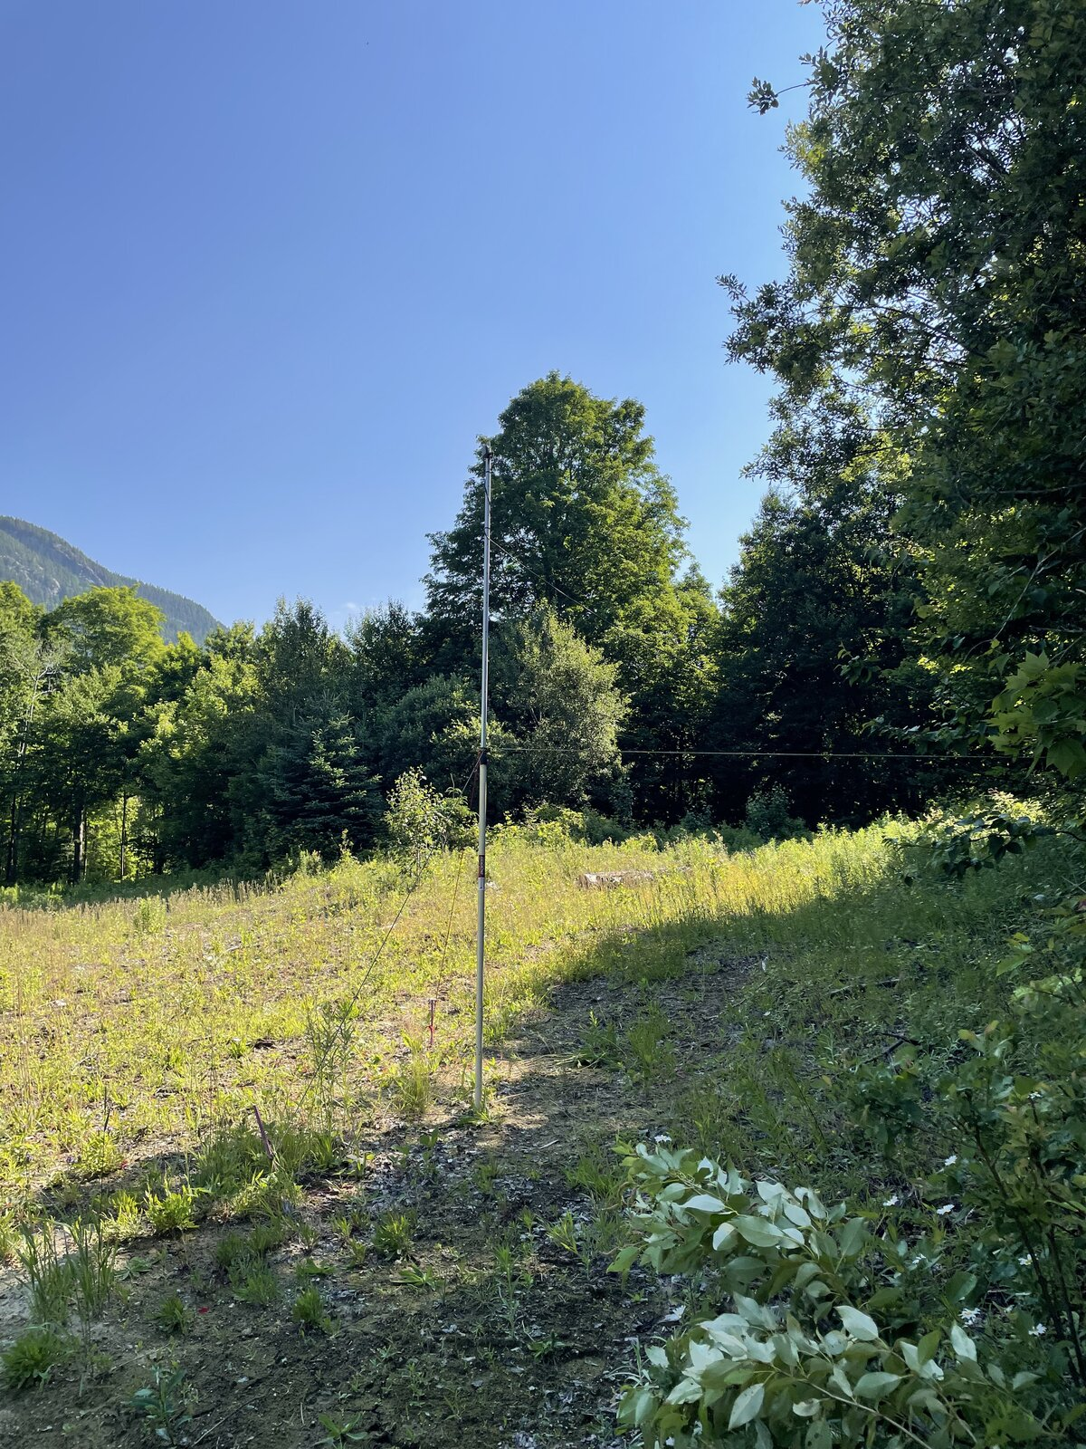 | 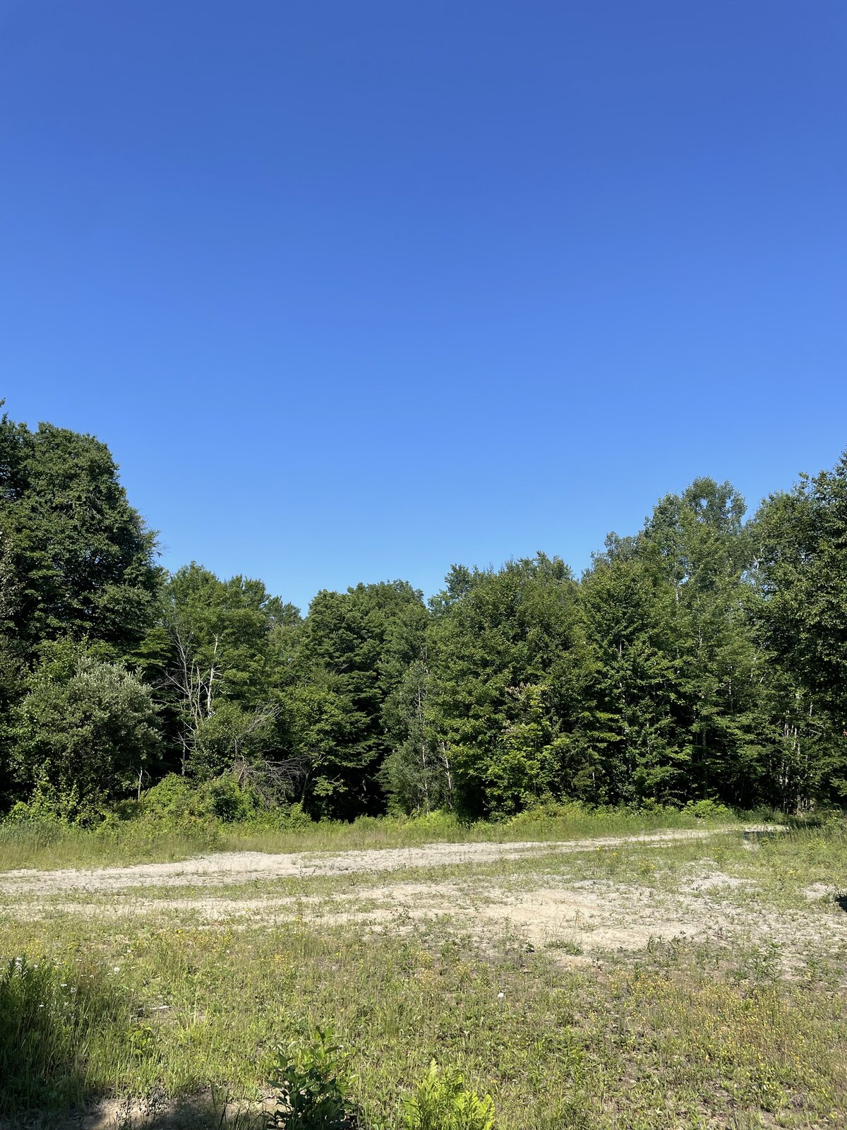
Figure 1: 107802-NW1 deployment setup (Left) and microphone view (Right).
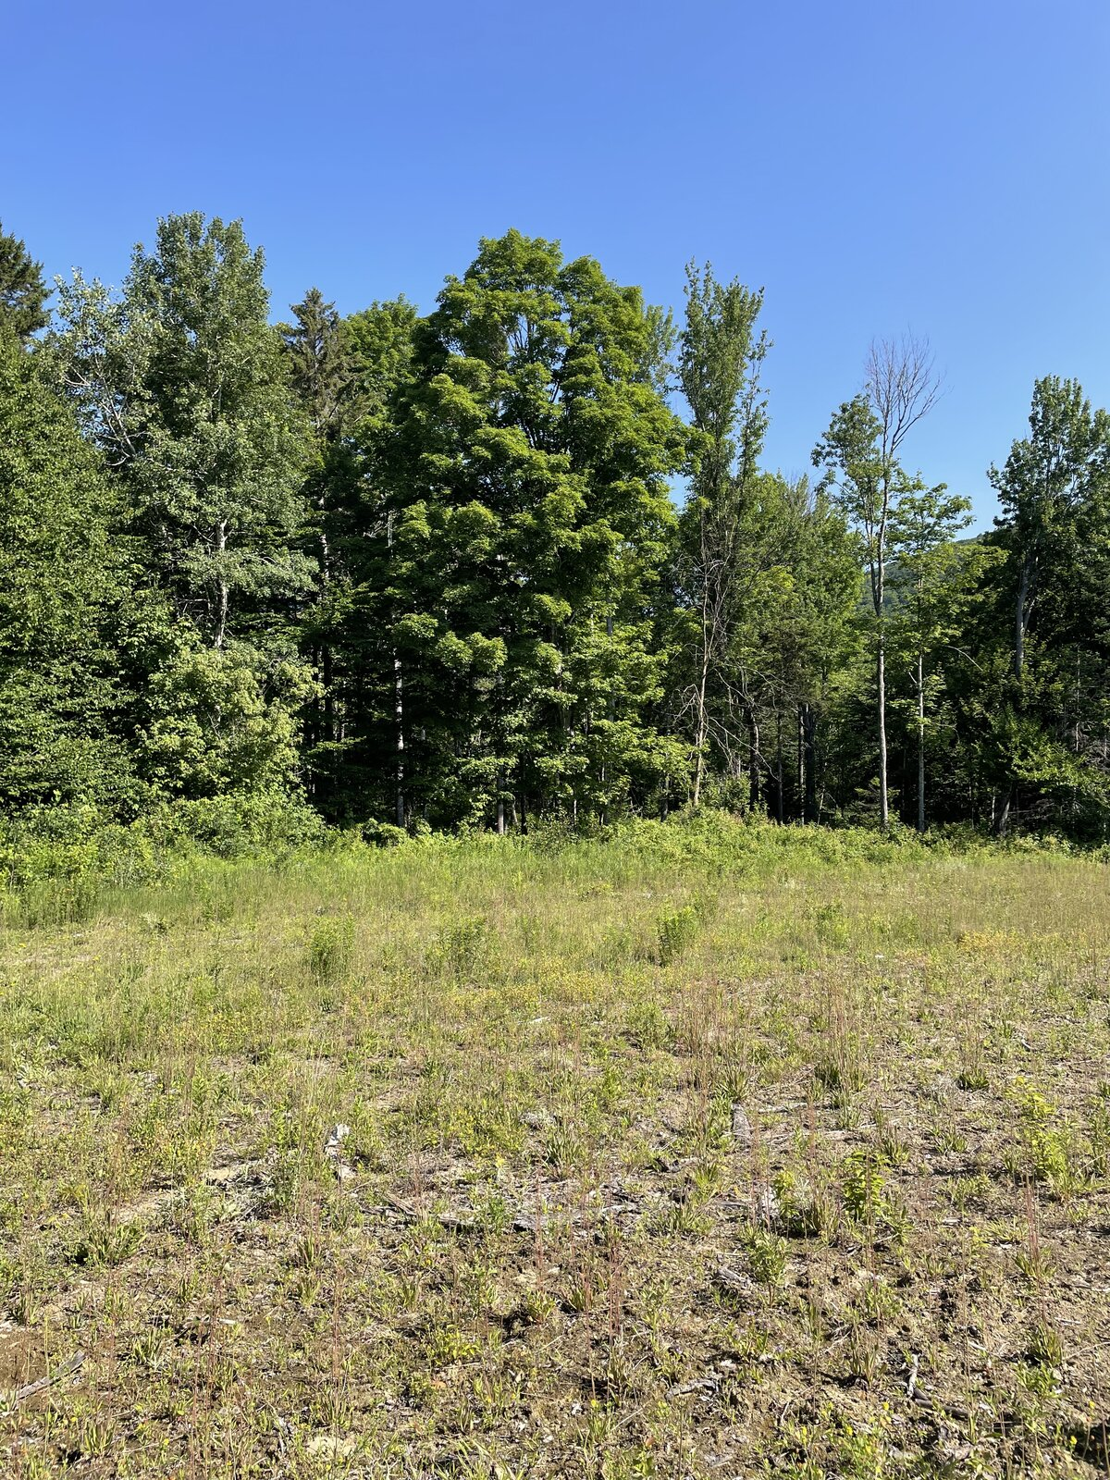 | 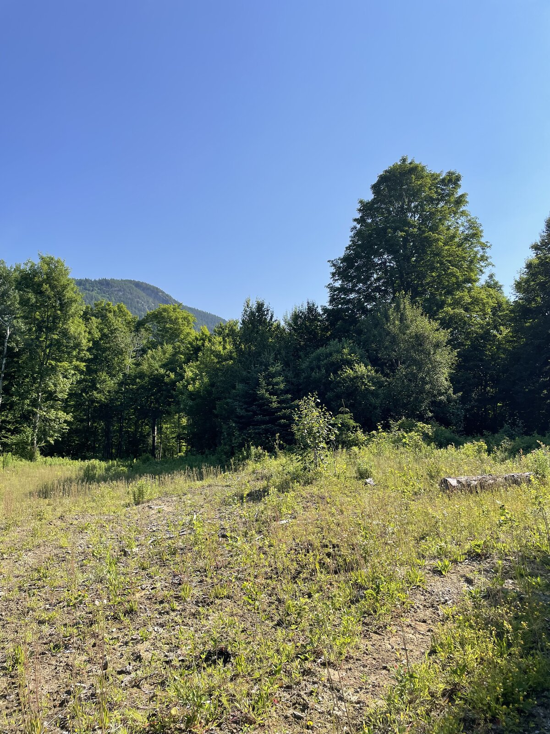
Figure 2: 107802-NW1 view for North (Left) and East (Right)
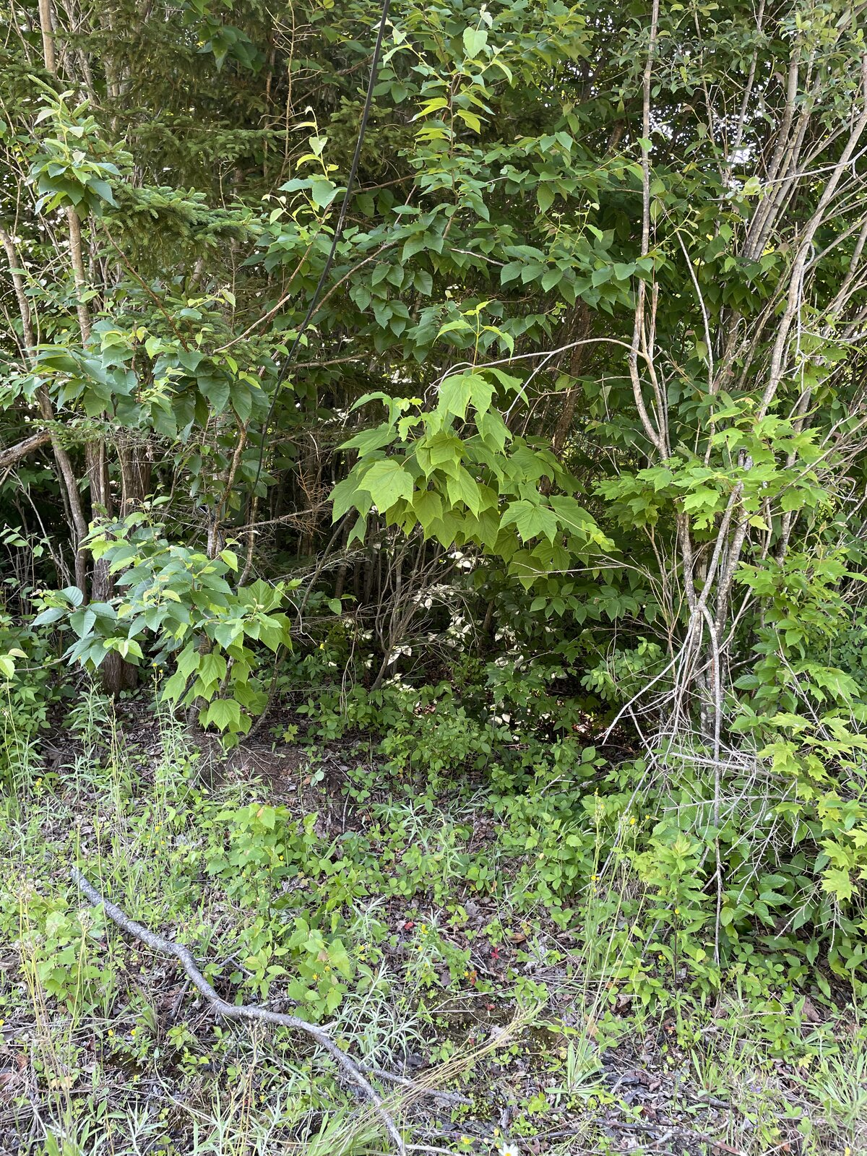 | 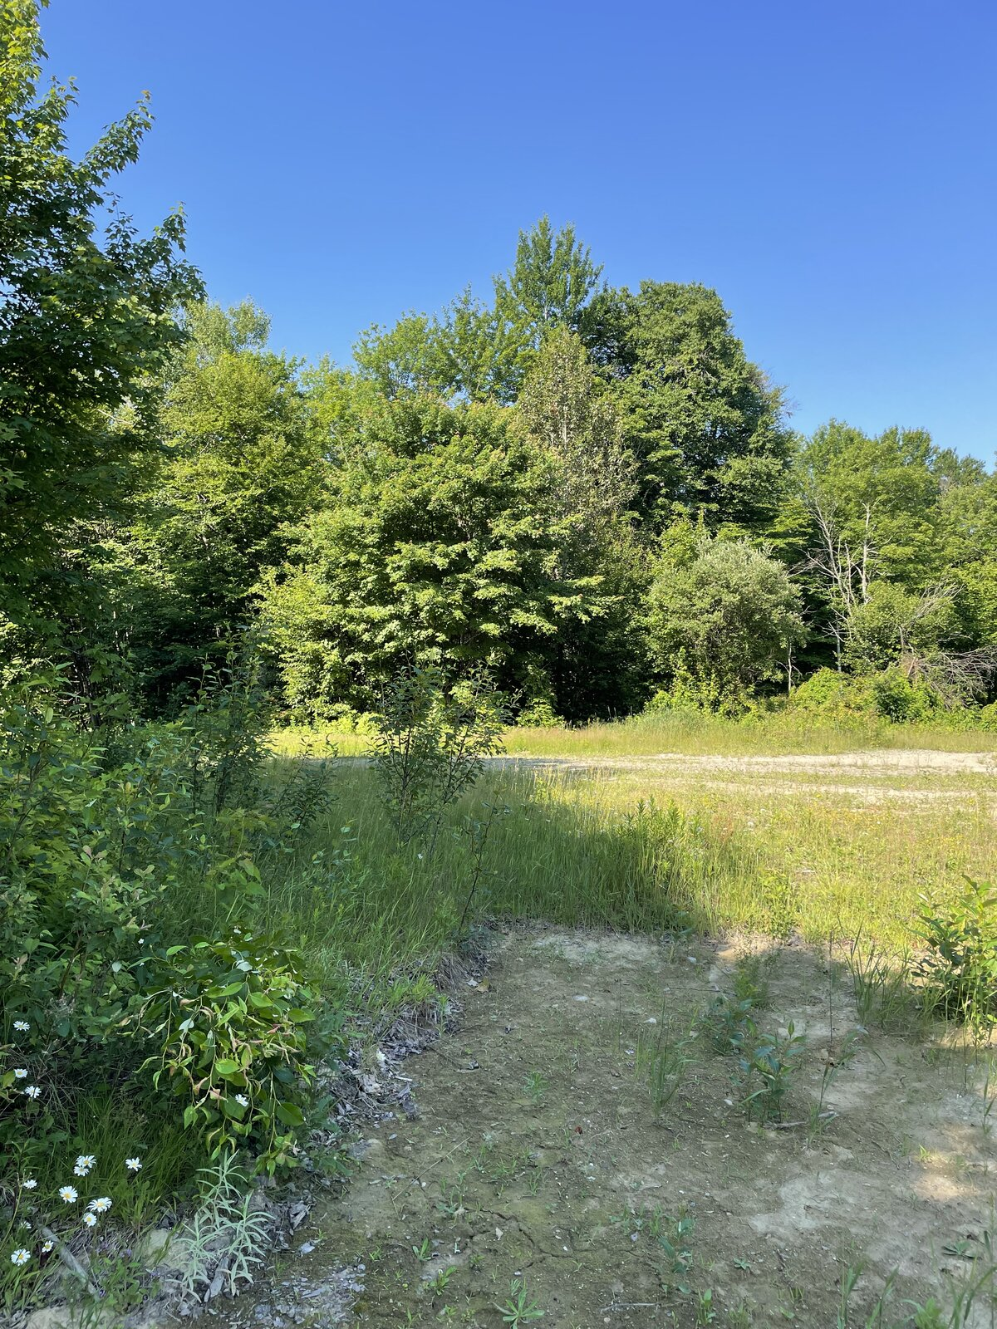
Figure 3: 107802-NW1 view for South (Left) and West (Right)
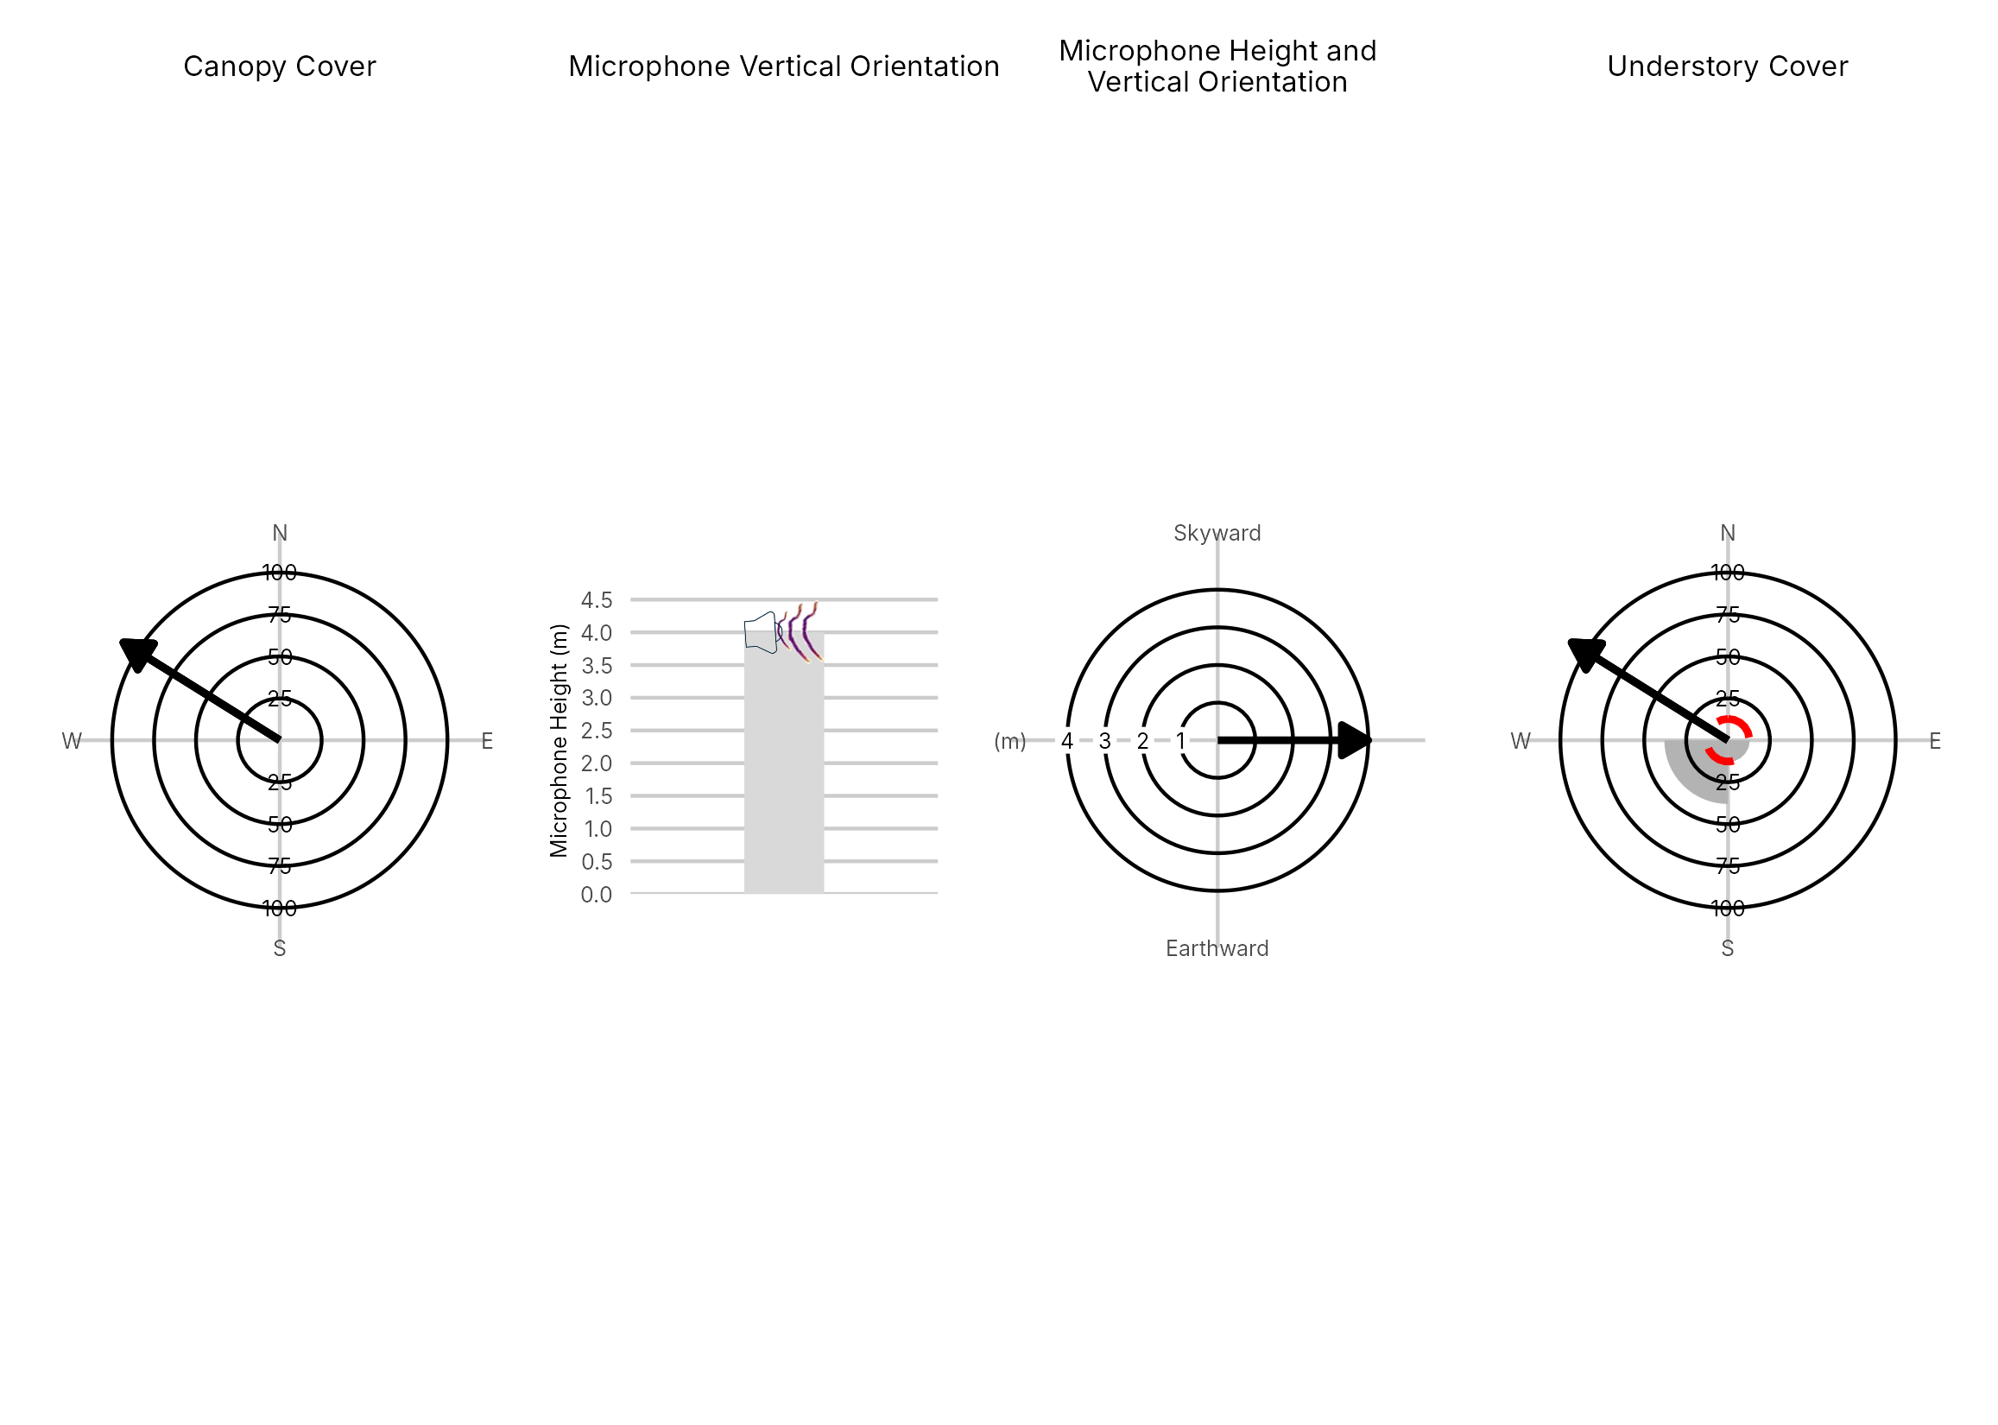

Figure 4: Percentage clutter for the understory and canopy cover at the 107802-NW1 compared with all sites within the study. Clutter was measured in each of the four 10x10m quadrants (Northeast, Southeast, Southwest and Northwest), surrounding the microphone. Percentage clutter and canopy cover categories were 0-5%, 10-25,25-50,50-75,76-95, 95-100%. The average clutter for the site was calculated by taking the meaning of the mid-point of each quadrant. The direction of the microphone is indicated by the arrow.

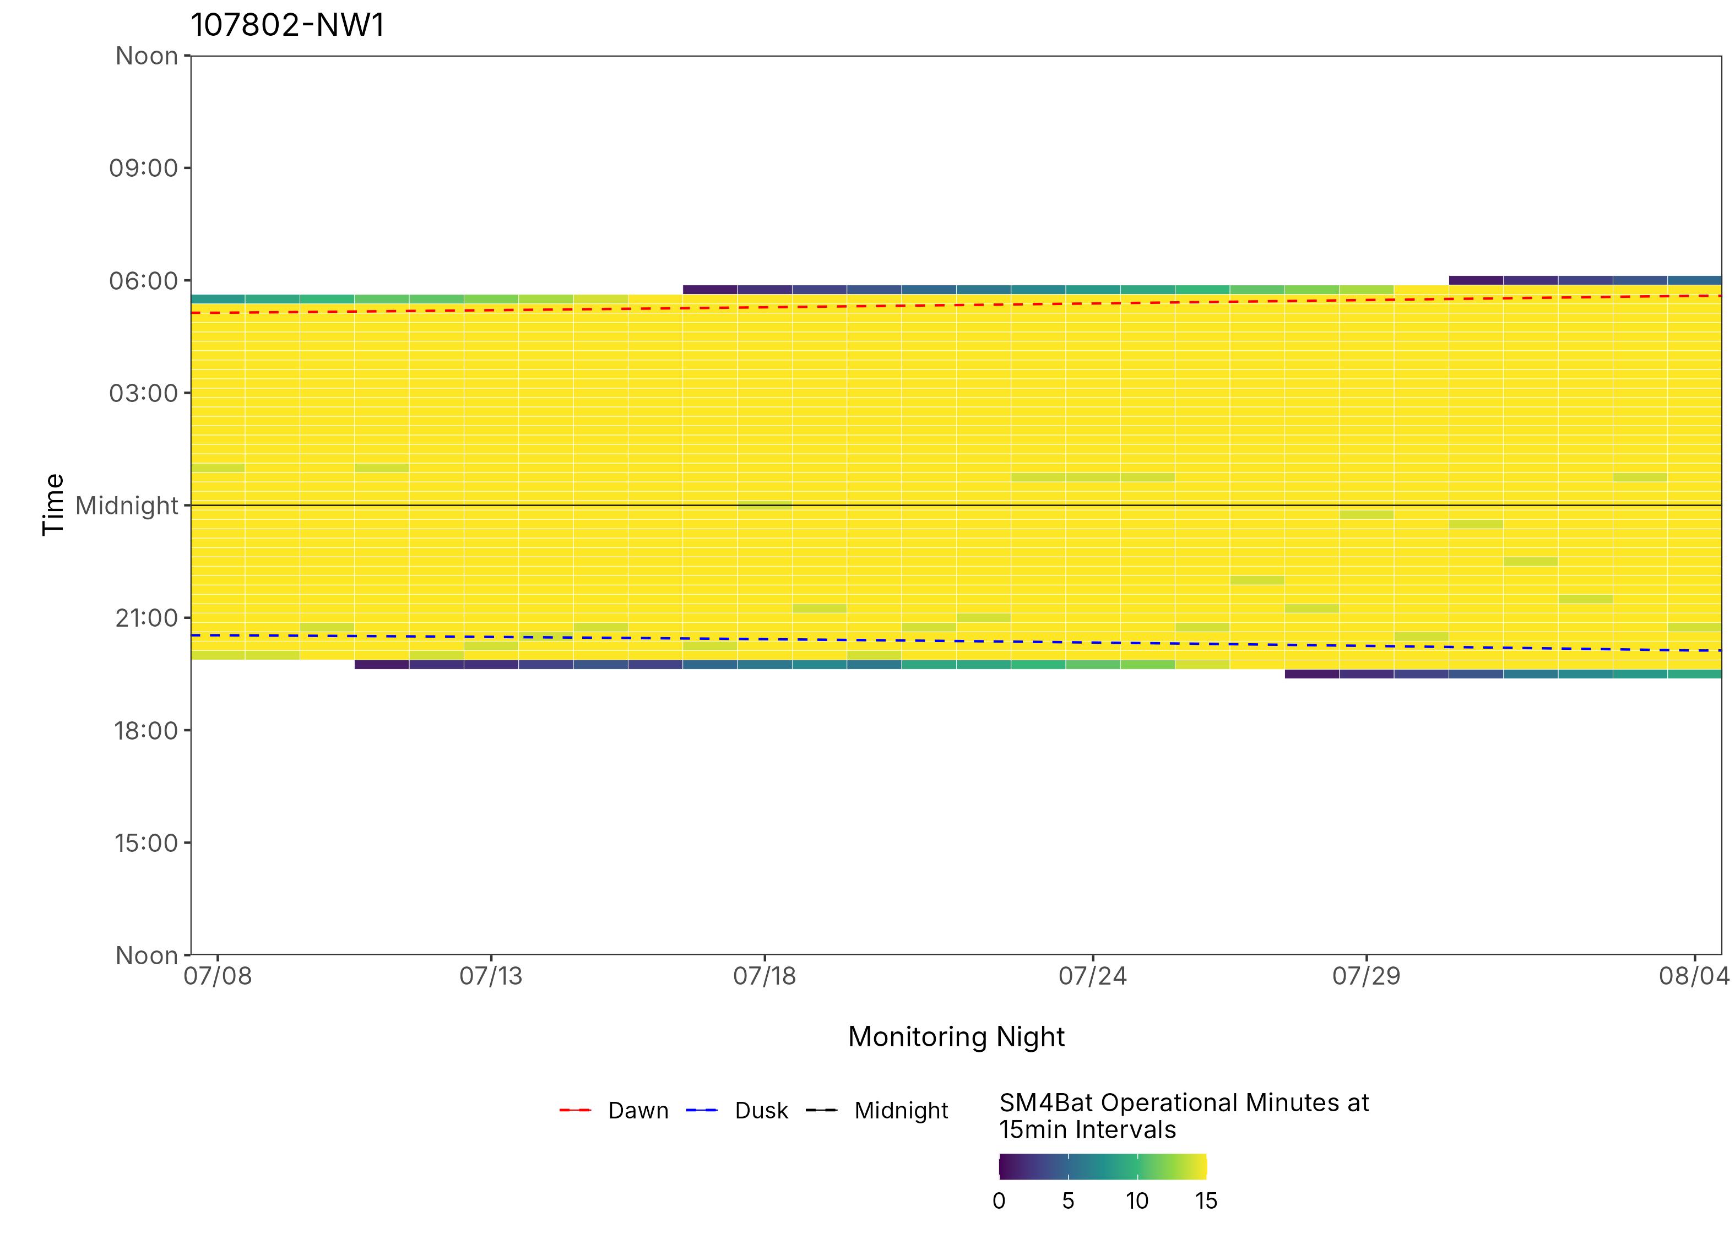
Figure 5: ARU activity plot

 | Client: | Wildlife Management Institute
 | Client Contact: | Meghan Gilbart
 | Project Name: | Maine NABAT
 | Project Code: | MAMM-NG26-007
 | Project Manager: | Joshua Guilbert
Project Information
Name of Permitted Biologist: | Bri Frankina
Federal Permit Number: | TE63633A
Personnel*: | BRF, ECG
Habitat Assessment Dates: | 7/7/2026
First Deployment Date: | 7/7/2026
Target Recovery
Final Recovery/Last Service:
Servicing Dates: | None
Survey Type | Summer - Acoustic
Site Type: | Inland
Landowner Information: | Seven Islands
Site: | 107802-NW3
Site Label: | 107802-NW3
County: | Oxford
State: | Maine
Site Coordinates: | 44.697996, -70.904884
Detector Info:
Deployment Date: | 7/7/2026
ARU Make, Model & Serial #: | Wildlife Acoustics, SM4BatFS, S4U19410
Power Make, Model & Serial #: | Internal power, 4 x D Batteries
Microphone Make, Model & Serial: | Wildlife Acoustics, U2, MU220601
Microphone Height (m) | 4
Microphone Direction(degrees): | 91
Microphone Orientation: | 0
Status Check: Settings†: | Yes
Status Check: Hardware ‡: | Yes
Survey Schedule

Servicing Events
Date | Staff* | Action | Notes
None

Recovery Date: | No retrieval visit recorded
ARU Make, Model & Serial #:
Power Make, Model & Serial #:
Microphone Make, Model & Serial#:
Microphone Height (m)
Microphone Direction (degrees):
Microphone Vertical Orientation:
Status Check: Settings†:
Status Check: Hardware ‡:
Survey Schedule
Notes

Habitat Assessment:
Assessment date: | 7/7/2026
Habitat Assessment Area: | 20m x 20m plot with mic at the center
Basic Overall Site Description: | Gap in forest alongside brook
Targeted Feature for Deployment: | Brook
Bat Roost Habitat: | Snags & damaged live trees, Rock
Water Resources: | Water present but not optimal
Distance Mic to Nearest Water (m): | 15
Type of Nearest Water: | flowing freshwater
Tree Species Dominant | Balsalm Fir
Tree Species All Present (within view) | Spruce, Balsalm Fir, Pine, Maple, Striped Maple
Understory Species Dominant | Sugar Maple, Striped Maple, Spruce, Fir, White Birch
Understory Species All Present (within view) | Balsam Fir, Spruce, Sugar Maple, Striped Maple, Fir, White Birch, Ash, Beech, Red Spruce
DBH of Surrounding Stand: | 5-15cm present
Stand Age: | Some diversity in stand
Understory Clutter | Semi-cluttered (cluttered but gaps present)
Microphone Distance to Clutter (m): | 4
Land Cover: | Mostly Forested

ARU Photos
No photo found | No photo found
Figure 1: 107802-NW3 deployment setup (Left) and microphone view (Right).
No photo found | No photo found
Figure 2: 107802-NW3 view for North (Left) and East (Right)
No photo found | No photo found
Figure 3: 107802-NW3 view for South (Left) and West (Right)
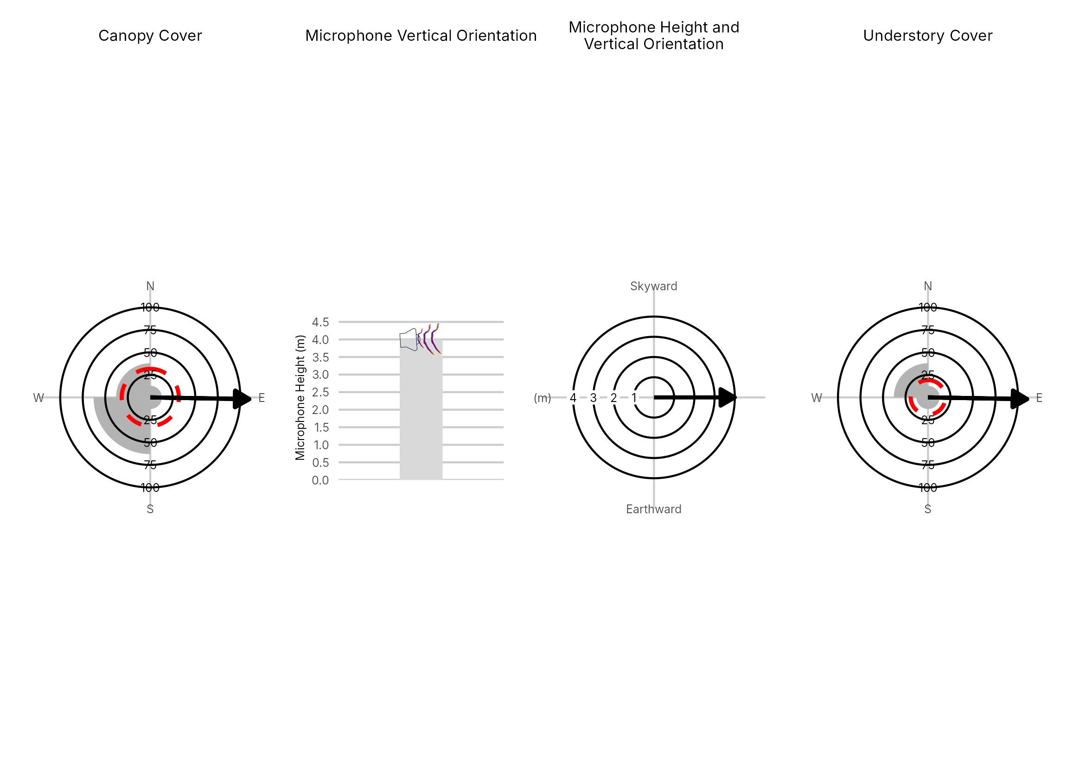

Figure 4: Percentage clutter for the understory and canopy cover at the 107802-NW3 compared with all sites within the study. Clutter was measured in each of the four 10x10m quadrants (Northeast, Southeast, Southwest and Northwest), surrounding the microphone. Percentage clutter and canopy cover categories were 0-5%, 10-25,25-50,50-75,76-95, 95-100%. The average clutter for the site was calculated by taking the meaning of the mid-point of each quadrant. The direction of the microphone is indicated by the arrow.

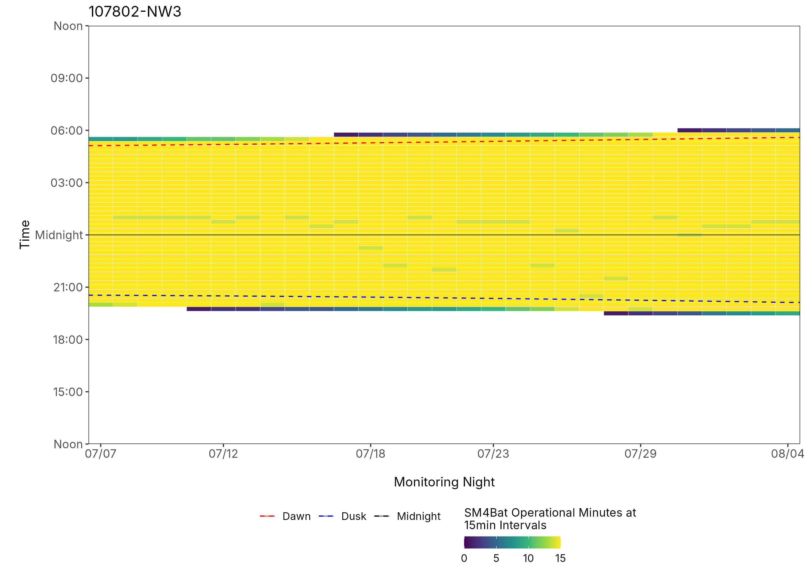
Figure 5: ARU activity plot

 | Client: | Wildlife Management Institute
 | Client Contact: | Meghan Gilbart
 | Project Name: | Maine NABAT
 | Project Code: | MAMM-NG26-007
 | Project Manager: | Joshua Guilbert
Project Information
Name of Permitted Biologist: | Bri Frankina
Federal Permit Number: | TE63633A
Personnel*: | BRF, ECG
Habitat Assessment Dates: | 7/7/2026
First Deployment Date: | 7/7/2026
Target Recovery
Final Recovery/Last Service:
Servicing Dates: | None
Survey Type | Summer - Acoustic
Site Type: | Inland
Landowner Information: | Seven Islands
Site: | 107802-SW1
Site Label: | 107802-SW1
County: | Oxford
State: | Maine
Site Coordinates: | 44.671910, -70.921087
Detector Info:
Deployment Date: | 7/7/2026
ARU Make, Model & Serial #: | Wildlife Acoustics, SM4BatFS, S4U17657
Power Make, Model & Serial #: | Internal power, 4 x D Batteries
Microphone Make, Model & Serial: | Wildlife Acoustics, U2, MU220161
Microphone Height (m) | 3
Microphone Direction(degrees): | 7
Microphone Orientation: | 45
Status Check: Settings†: | Yes
Status Check: Hardware ‡: | Yes
Survey Schedule

Servicing Events
Date | Staff* | Action | Notes
None

Recovery Date: | No retrieval visit recorded
ARU Make, Model & Serial #:
Power Make, Model & Serial #:
Microphone Make, Model & Serial#:
Microphone Height (m)
Microphone Direction (degrees):
Microphone Vertical Orientation:
Status Check: Settings†:
Status Check: Hardware ‡:
Survey Schedule
Notes

Habitat Assessment:
Assessment date: | 7/7/2026
Habitat Assessment Area: | 20m x 20m plot with mic at the center
Basic Overall Site Description: | Small wetland clearing in forest edge next 20m from roadway
Targeted Feature for Deployment: | Wetland
Bat Roost Habitat: | Snags & damaged live trees
Water Resources: | Water present but not optimal
Distance Mic to Nearest Water (m): | 20
Type of Nearest Water: | flowing freshwater
Tree Species Dominant | Maple
Tree Species All Present (within view) | Maple, White Birch, Hickory, Birch, Balsam Fir
Understory Species Dominant | Beech, Balsam Fir, Maple, Striped Maple
Understory Species All Present (within view) | Balsam Fir, Striped Maple, Ash, Beech, Maple
DBH of Surrounding Stand: | 5-15cm present
Stand Age: | Some diversity in stand
Understory Clutter | Semi-cluttered (cluttered but gaps present)
Microphone Distance to Clutter (m): | 3
Land Cover: | Mostly Forested

ARU Photos
No photo found | No photo found
Figure 1: 107802-SW1 deployment setup (Left) and microphone view (Right).
No photo found | No photo found
Figure 2: 107802-SW1 view for North (Left) and East (Right)
No photo found | No photo found
Figure 3: 107802-SW1 view for South (Left) and West (Right)
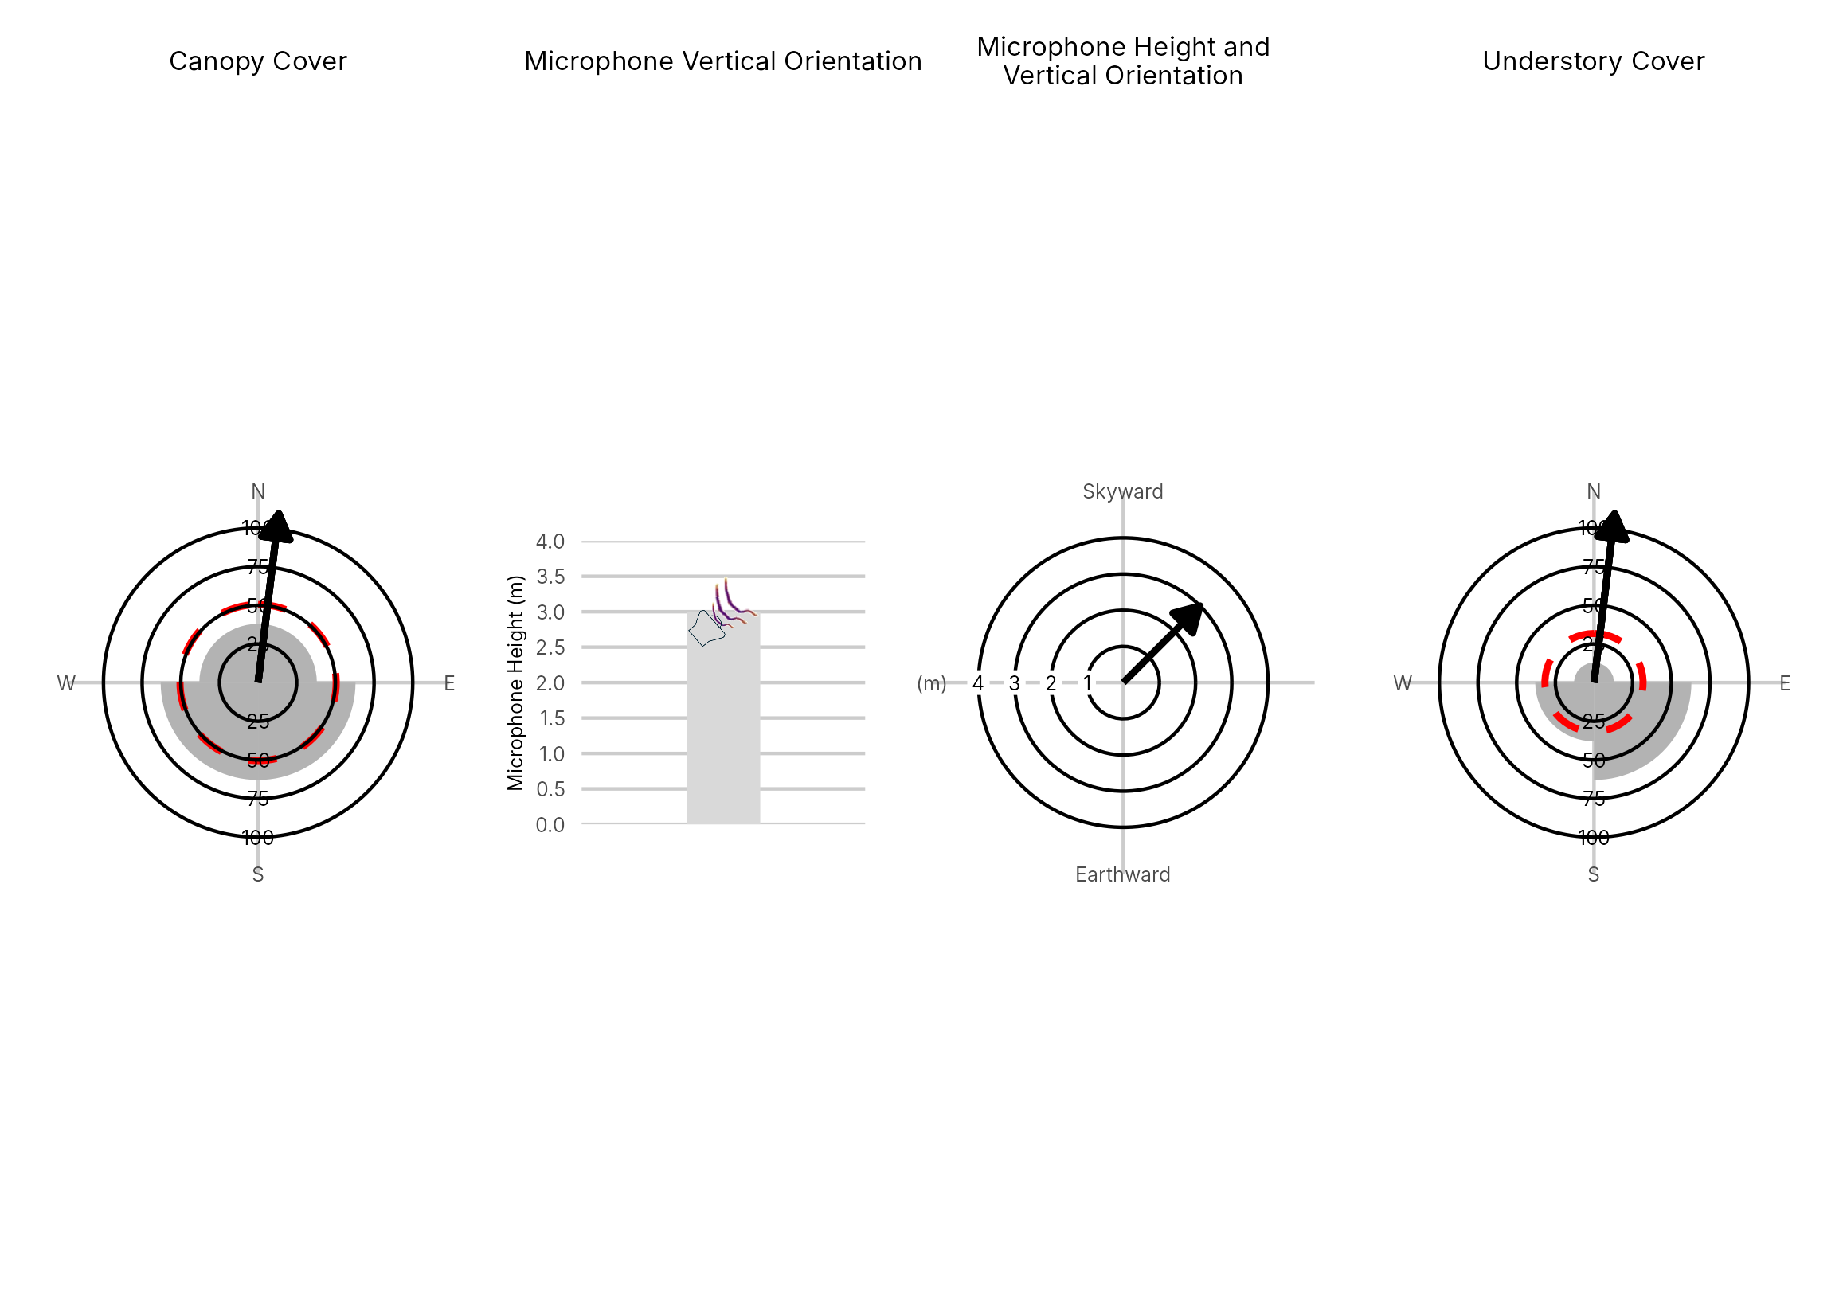

Figure 4: Percentage clutter for the understory and canopy cover at the 107802-SW1 compared with all sites within the study. Clutter was measured in each of the four 10x10m quadrants (Northeast, Southeast, Southwest and Northwest), surrounding the microphone. Percentage clutter and canopy cover categories were 0-5%, 10-25,25-50,50-75,76-95, 95-100%. The average clutter for the site was calculated by taking the meaning of the mid-point of each quadrant. The direction of the microphone is indicated by the arrow.

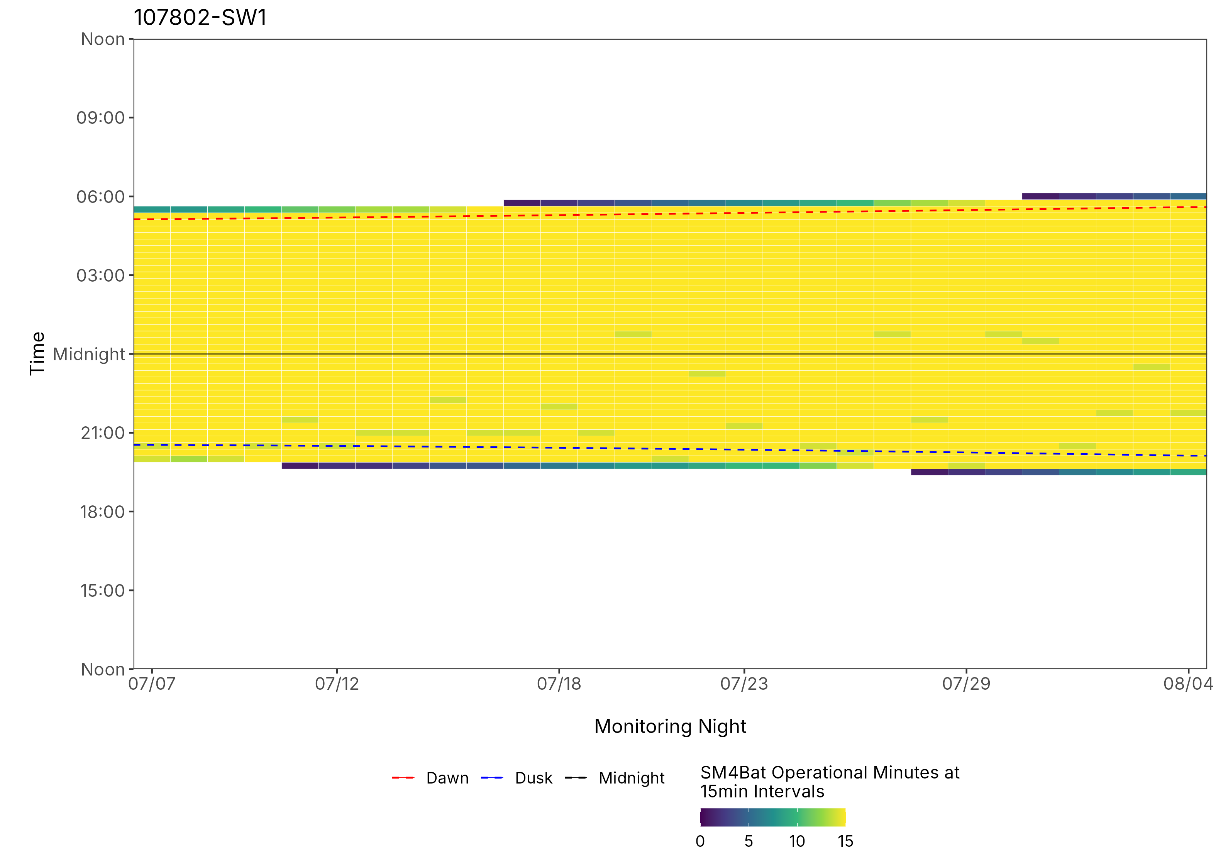
Figure 5: ARU activity plot

 | Client: | Wildlife Management Institute
 | Client Contact: | Meghan Gilbart
 | Project Name: | Maine NABAT
 | Project Code: | MAMM-NG26-007
 | Project Manager: | Joshua Guilbert
Project Information
Name of Permitted Biologist: | Bri Frankina
Federal Permit Number: | TE63633A
Personnel*: | BRF, ECG
Habitat Assessment Dates: | 7/17/2026
First Deployment Date: | 7/17/2026
Target Recovery
Final Recovery/Last Service: | 8/17/2026
Servicing Dates: | 7/30/2026
Survey Type | Summer - Acoustic
Site Type: | Inland
Landowner Information: | Seven Islands
Site: | 1079-NE1
Site Label: | 1079-NE1
County: | Aroostook
State: | Maine
Site Coordinates: | 46.796416, -68.801822
Detector Info:
Deployment Date: | 7/17/2026
ARU Make, Model & Serial #: | Wildlife Acoustics, SM4BatFS, S4U28586
Power Make, Model & Serial #: | Internal power, 4 x D Batteries
Microphone Make, Model & Serial: | Wildlife Acoustics, U2, MU236551
Microphone Height (m) | 3
Microphone Direction(degrees): | 62
Microphone Orientation: | 45
Status Check: Settings†: | Yes
Status Check: Hardware ‡: | Yes
Survey Schedule

Servicing Events
Date | Staff* | Action | Notes
7/30/2026 | BRF | SD cards swapped | 5.5 battery, 6 GB on Card A

Recovery Date: | 8/17/2026
ARU Make, Model & Serial #: | Wildlife Acoustics, SM4BatFS, S4U28586
Power Make, Model & Serial #: | Internal power, 4 x D Batteries
Microphone Make, Model & Serial#: | Wildlife Acoustics, U2, MU236551
Microphone Height (m) | 3
Microphone Direction (degrees): | 62
Microphone Vertical Orientation: | 45
Status Check: Settings†:
Status Check: Hardware ‡:
Survey Schedule
Notes | 9 GB Card A, 5V battery

Habitat Assessment:
Assessment date: | 7/17/2026
Habitat Assessment Area: | 20m x 20m plot with mic at the center
Basic Overall Site Description: | Small roadside clearing
Targeted Feature for Deployment: | Forest Edge
Bat Roost Habitat: | None
Water Resources: | No water resources present at site
Distance Mic to Nearest Water (m):
Type of Nearest Water: | flowing freshwater
Tree Species Dominant
Tree Species All Present (within view) | Cedar, Quaking Aspen, Birch
Understory Species Dominant | Balsam Fir, Maple
Understory Species All Present (within view) | Maple, Balsam Poplar, Balsam Fir
DBH of Surrounding Stand: | 5-15cm present
Stand Age: | Young/even aged
Understory Clutter | Semi-cluttered (cluttered but gaps present)
Microphone Distance to Clutter (m): | 4
Land Cover: | Trees present but fragmented

ARU Photos
No photo found | No photo found
Figure 1: 1079-NE1 deployment setup (Left) and microphone view (Right).
No photo found | No photo found
Figure 2: 1079-NE1 view for North (Left) and East (Right)
No photo found | No photo found
Figure 3: 1079-NE1 view for South (Left) and West (Right)
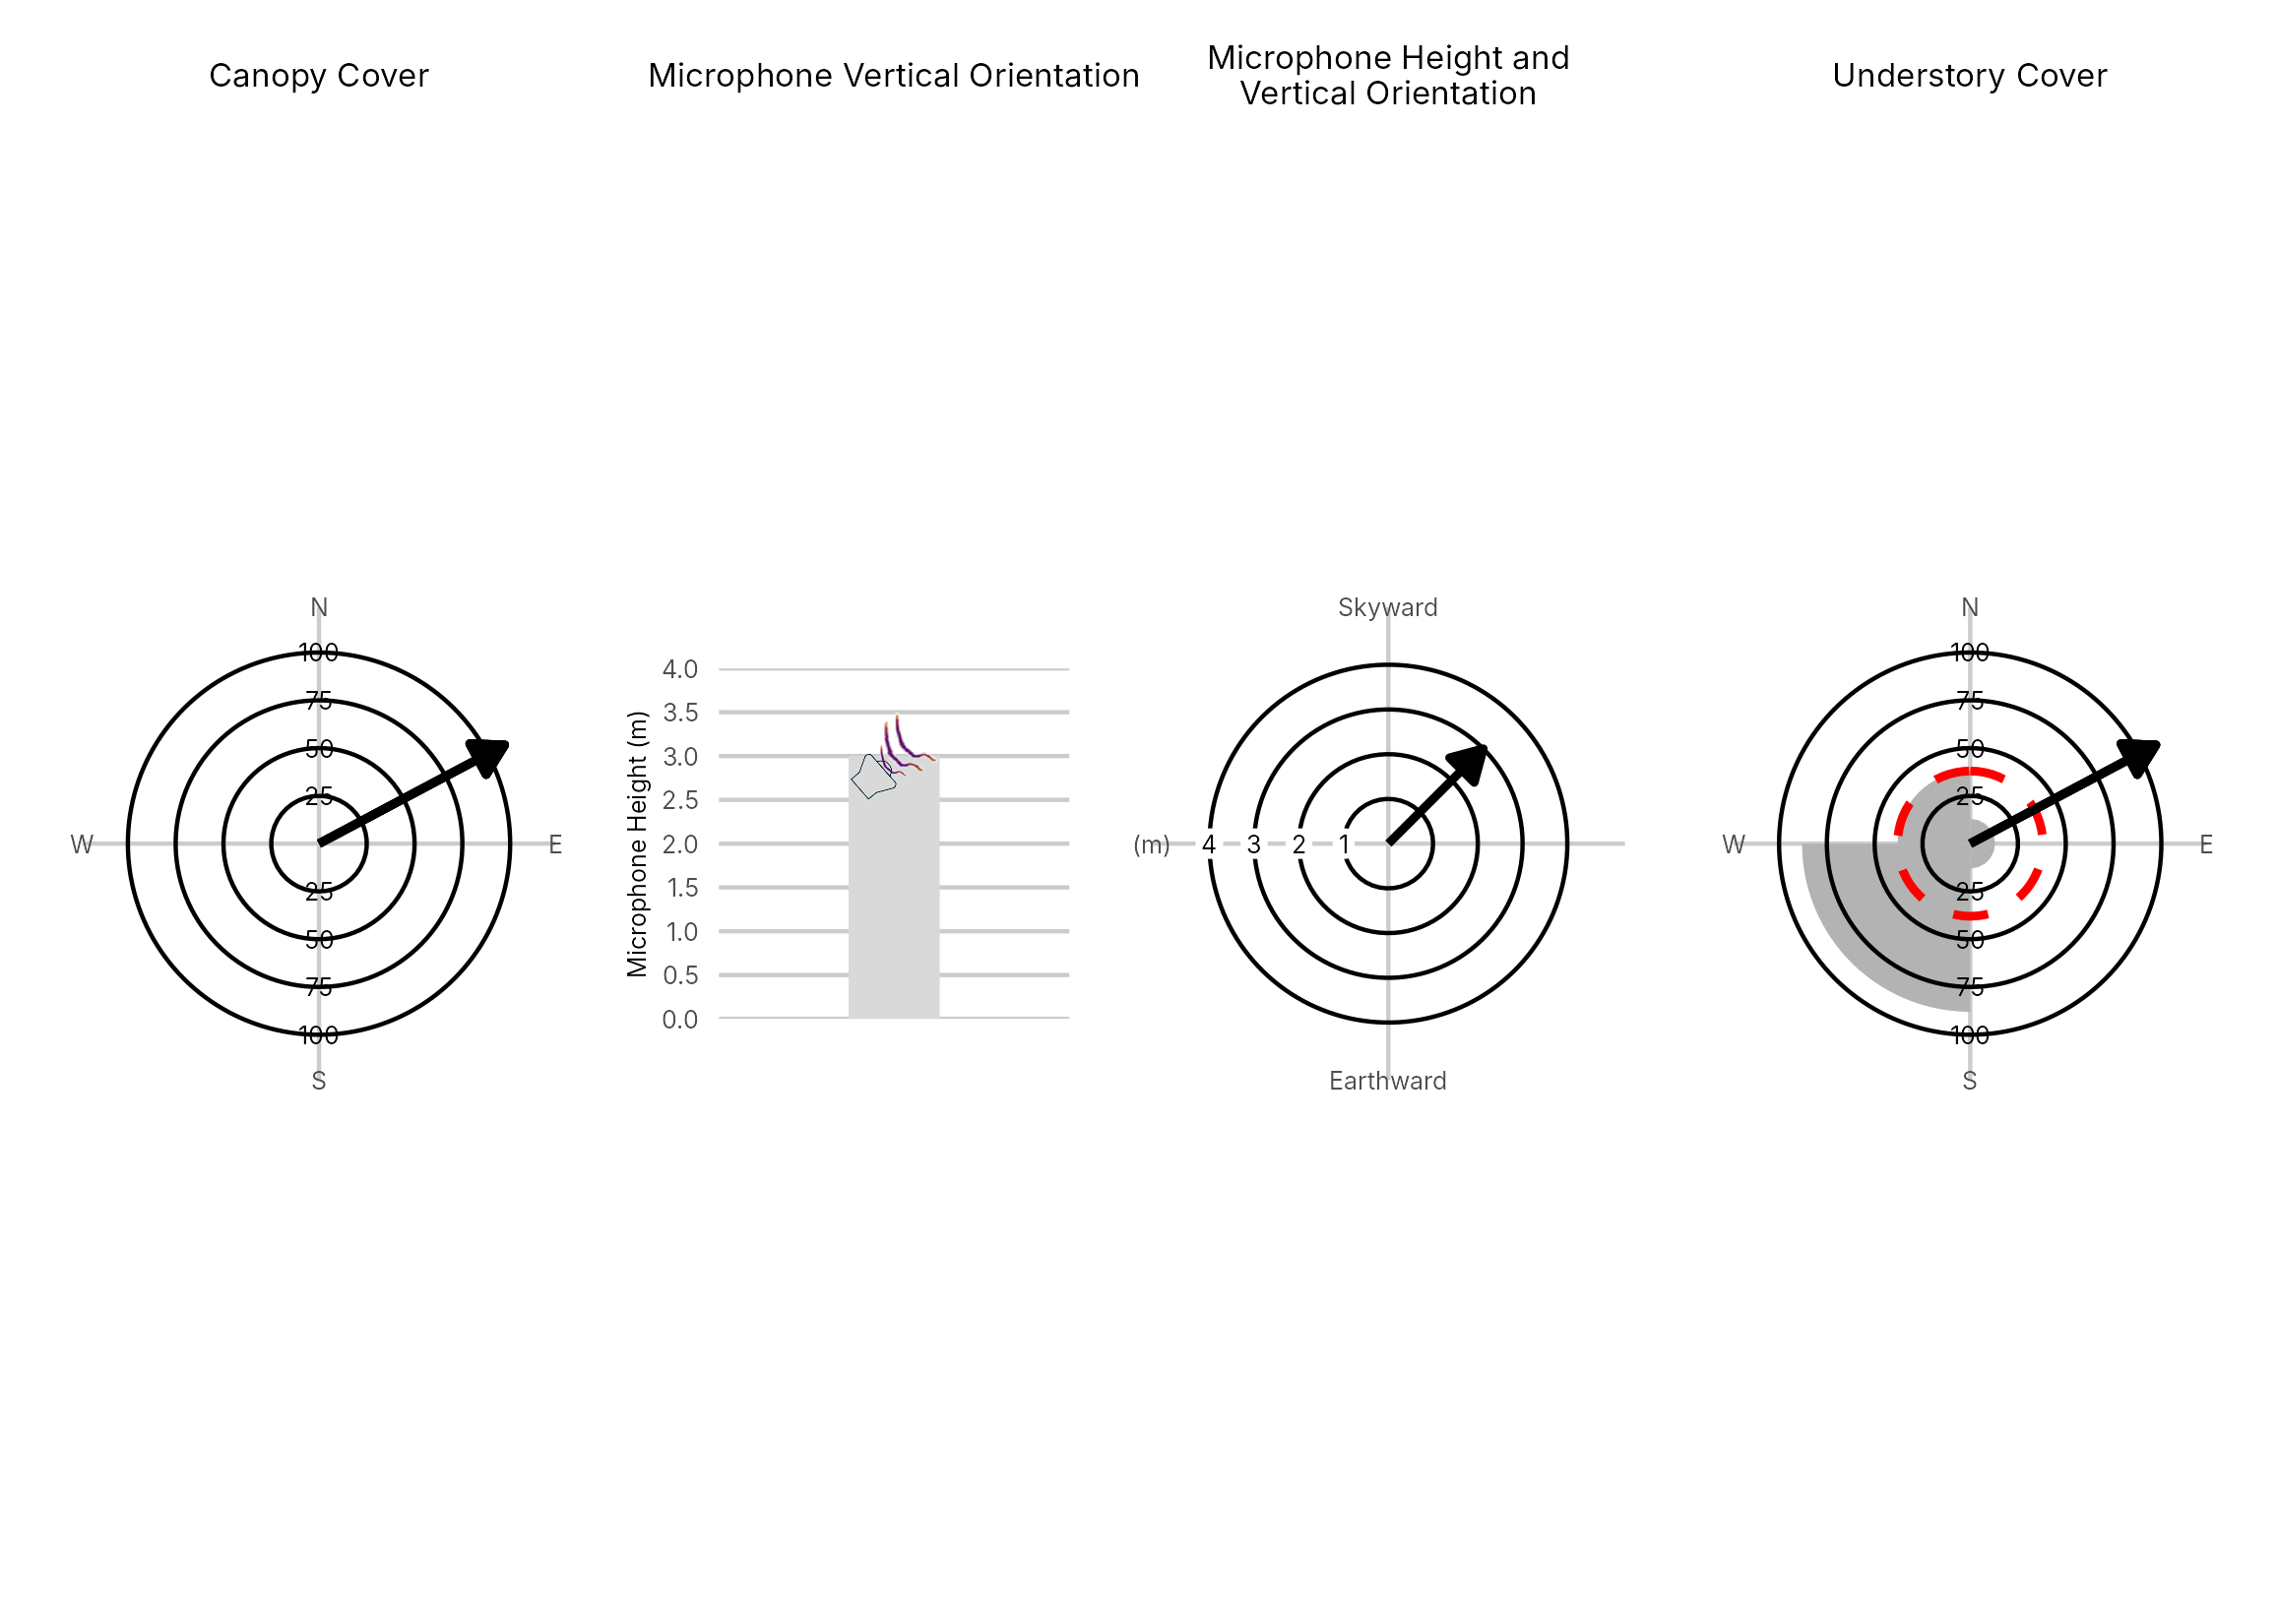

Figure 4: Percentage clutter for the understory and canopy cover at the 1079-NE1 compared with all sites within the study. Clutter was measured in each of the four 10x10m quadrants (Northeast, Southeast, Southwest and Northwest), surrounding the microphone. Percentage clutter and canopy cover categories were 0-5%, 10-25,25-50,50-75,76-95, 95-100%. The average clutter for the site was calculated by taking the meaning of the mid-point of each quadrant. The direction of the microphone is indicated by the arrow.

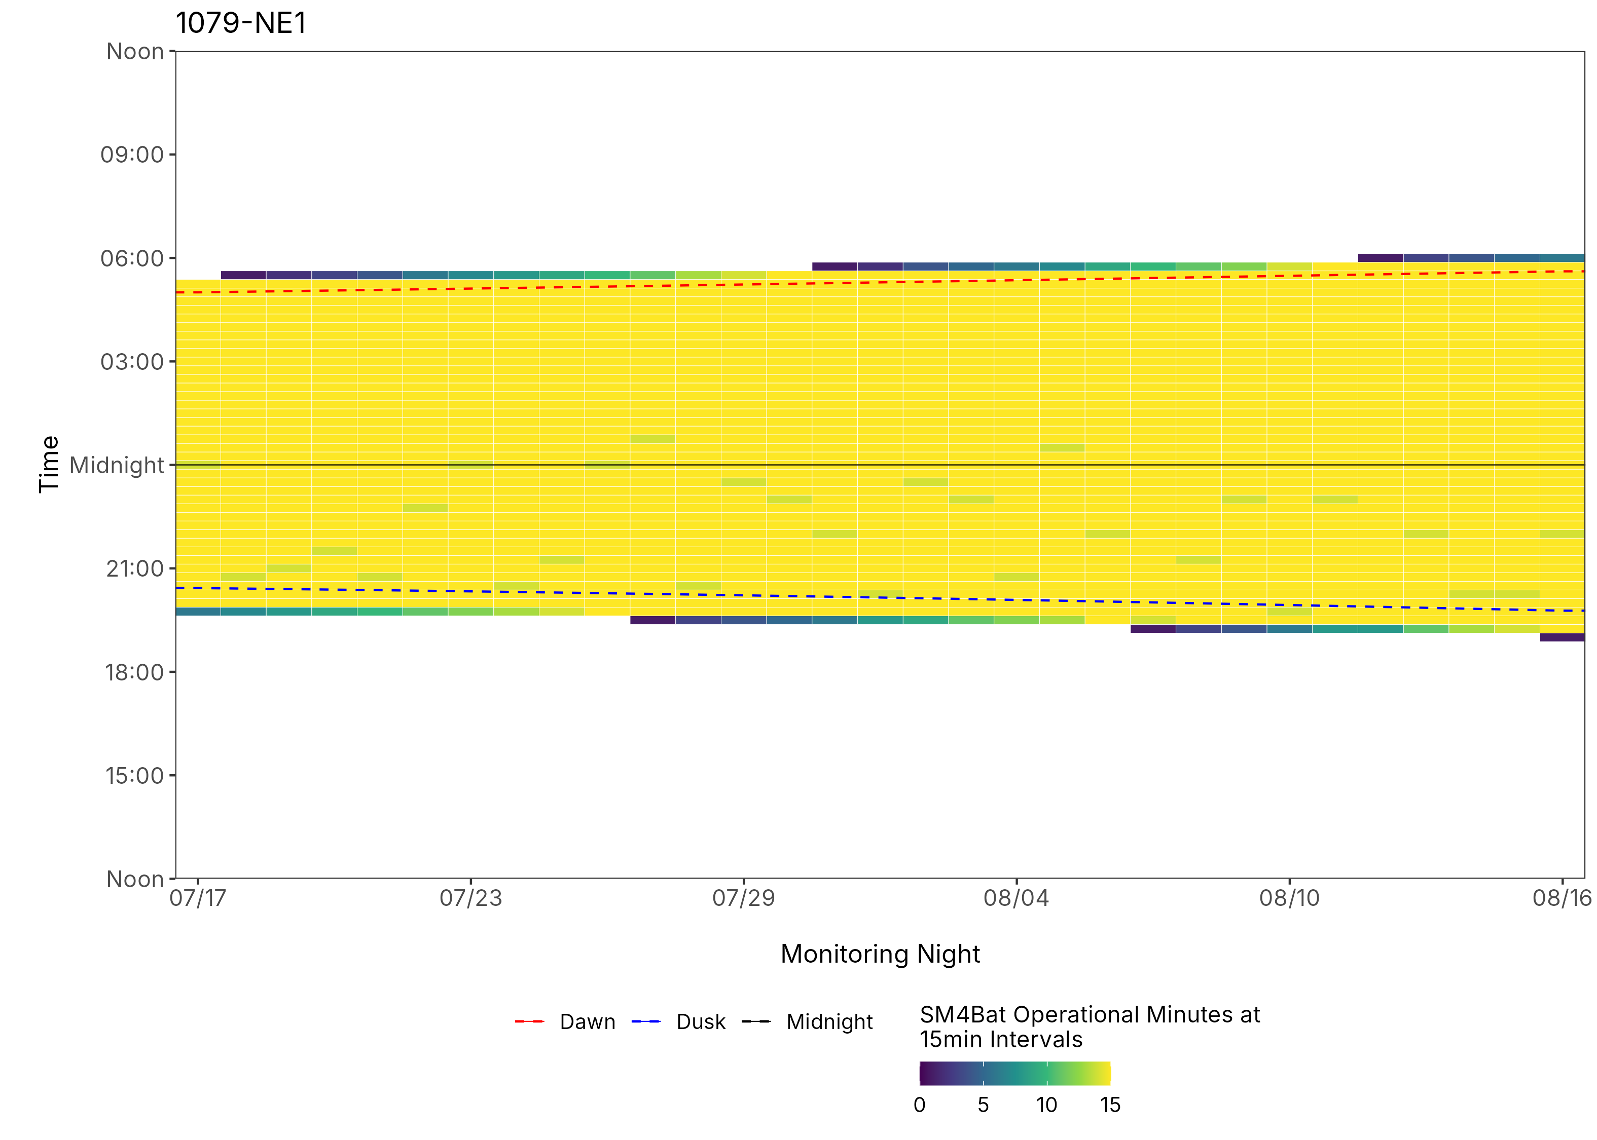
Figure 5: ARU activity plot

 | Client: | Wildlife Management Institute
 | Client Contact: | Meghan Gilbart
 | Project Name: | Maine NABAT
 | Project Code: | MAMM-NG26-007
 | Project Manager: | Joshua Guilbert
Project Information
Name of Permitted Biologist: | Bri Frankina
Federal Permit Number: | TE63633A
Personnel*: | BRF, ECG
Habitat Assessment Dates: | 7/17/2026
First Deployment Date: | 7/17/2026
Target Recovery
Final Recovery/Last Service: | 7/30/2026
Servicing Dates: | 7/30/2026
Survey Type | Summer - Acoustic
Site Type: | Inland
Landowner Information: | Seven Islands
Site: | 1079-NE2
Site Label: | 1079-NE2
County: | Aroostook
State: | Maine
Site Coordinates: | 46.827154, -68.791395
Detector Info:
Deployment Date: | 7/17/2026
ARU Make, Model & Serial #: | Wildlife Acoustics, SM4BatFS, S4U28485
Power Make, Model & Serial #: | Internal power, 4 x D Batteries
Microphone Make, Model & Serial: | Wildlife Acoustics, U2, MU236345
Microphone Height (m) | 4
Microphone Direction(degrees): | 70
Microphone Orientation: | 45
Status Check: Settings†: | Yes
Status Check: Hardware ‡: | Yes
Survey Schedule

Servicing Events
Date | Staff* | Action | Notes
7/30/2026 | BRF | SD cards swapped, Location Moved | Unit moved due to vandalism. Mic pole down upon arrival and mic disconnected. Paracord untied and moved. Battery 5.7 and 1 GB on Card A

Recovery Date: | No retrieval visit recorded
ARU Make, Model & Serial #:
Power Make, Model & Serial #:
Microphone Make, Model & Serial#:
Microphone Height (m)
Microphone Direction (degrees):
Microphone Vertical Orientation:
Status Check: Settings†:
Status Check: Hardware ‡:
Survey Schedule
Notes

Habitat Assessment:
Assessment date: | 7/17/2026
Habitat Assessment Area: | 20m x 20m plot with mic at the center
Basic Overall Site Description: | Small clearing along roadside at the convergence of several corridors leading to the water
Targeted Feature for Deployment: | Forest Edge and Pond
Bat Roost Habitat: | None
Water Resources: | No water resources present at site
Distance Mic to Nearest Water (m):
Type of Nearest Water: | standing or ponded freshwater
Tree Species Dominant
Tree Species All Present (within view) | Maple. Spruce, Cherry, Hemlock, Ash/Hickory, Maple, Balsalm Fir
Understory Species Dominant | White Birch, Balsam Fir, Maple
Understory Species All Present (within view) | Maple, Willow, Balsam Fir, White Birch
DBH of Surrounding Stand: | 5-15cm present
Stand Age: | Young/even aged
Understory Clutter | Semi-cluttered (cluttered but gaps present)
Microphone Distance to Clutter (m): | 4
Land Cover: | Trees present but fragmented

ARU Photos
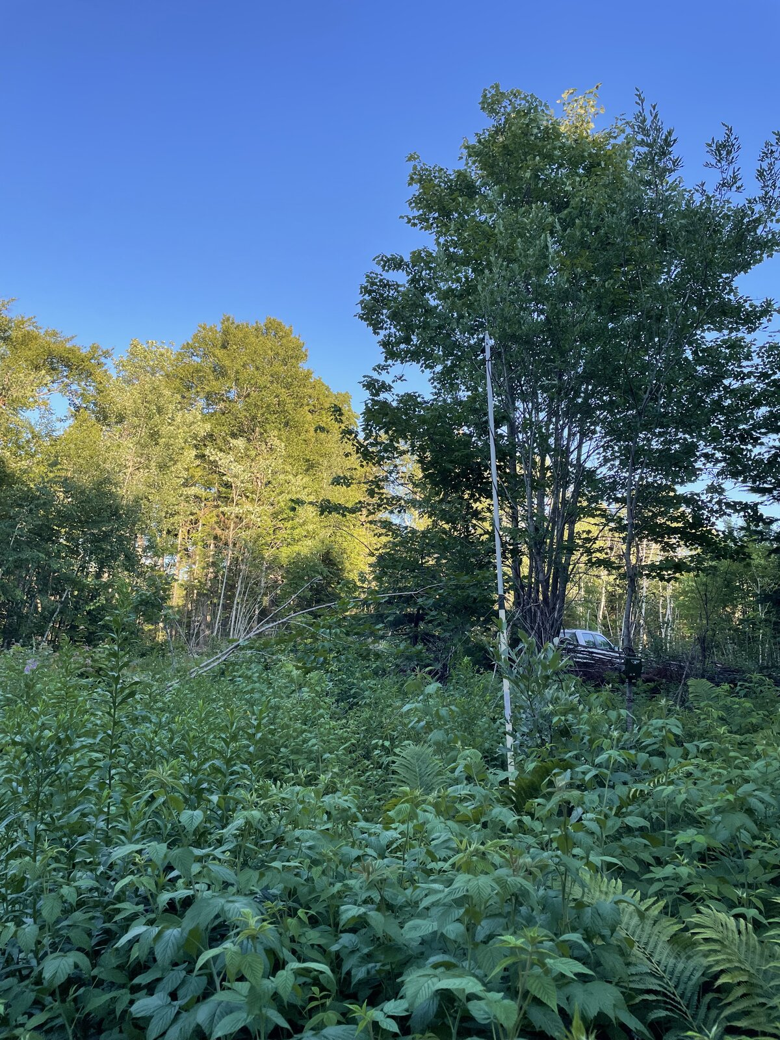 | No photo found
Figure 1: 1079-NE2 deployment setup (Left) and microphone view (Right).
No photo found | No photo found
Figure 2: 1079-NE2 view for North (Left) and East (Right)
No photo found | No photo found
Figure 3: 1079-NE2 view for South (Left) and West (Right)
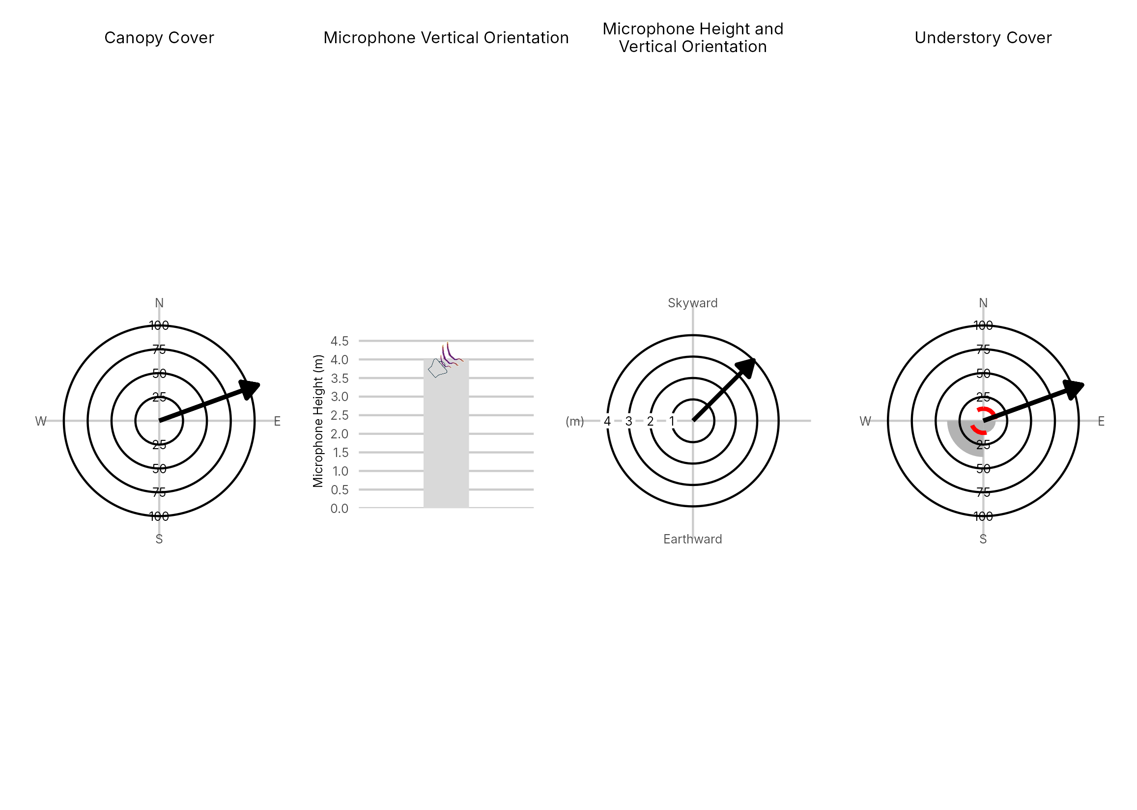

Figure 4: Percentage clutter for the understory and canopy cover at the 1079-NE2 compared with all sites within the study. Clutter was measured in each of the four 10x10m quadrants (Northeast, Southeast, Southwest and Northwest), surrounding the microphone. Percentage clutter and canopy cover categories were 0-5%, 10-25,25-50,50-75,76-95, 95-100%. The average clutter for the site was calculated by taking the meaning of the mid-point of each quadrant. The direction of the microphone is indicated by the arrow.

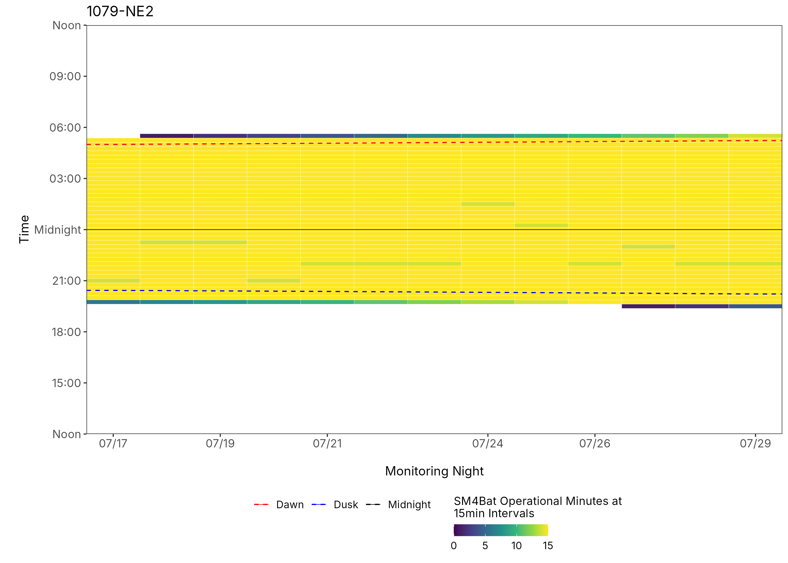
Figure 5: ARU activity plot

 | Client: | Wildlife Management Institute
 | Client Contact: | Meghan Gilbart
 | Project Name: | Maine NABAT
 | Project Code: | MAMM-NG26-007
 | Project Manager: | Joshua Guilbert
Project Information
Name of Permitted Biologist: | Bri Frankina
Federal Permit Number: | TE63633A
Personnel*: | BRF, JMG
Habitat Assessment Dates: | 7/30/2026
First Deployment Date: | 7/30/2026
Target Recovery
Final Recovery/Last Service: | 8/17/2026
Servicing Dates: | None
Survey Type | Summer - Acoustic
Site Type: | Inland
Landowner Information: | Seven Islands
Site: | 1079-NE2-2
Site Label: | 1079-NE2-2
County: | Aroostook
State: | Maine
Site Coordinates: | 46.814195, -68.792795
Detector Info:
Deployment Date: | 7/30/2026
ARU Make, Model & Serial #: | Wildlife Acoustics, SM4BatFS, S4U28485
Power Make, Model & Serial #: | Internal power, 4 x D Batteries
Microphone Make, Model & Serial: | Wildlife Acoustics, U2, MU236345
Microphone Height (m) | 4
Microphone Direction(degrees): | 323
Microphone Orientation: | 45
Status Check: Settings†: | Yes
Status Check: Hardware ‡: | Yes
Survey Schedule

Servicing Events
Date | Staff* | Action | Notes
None

Recovery Date: | 8/17/2026
ARU Make, Model & Serial #: | Wildlife Acoustics, SM4BatFS, S4U28485
Power Make, Model & Serial #: | Internal power, 4 x D Batteries
Microphone Make, Model & Serial#: | Wildlife Acoustics, U2, MU236345
Microphone Height (m) | 4
Microphone Direction (degrees): | 323
Microphone Vertical Orientation: | 45
Status Check: Settings†:
Status Check: Hardware ‡:
Survey Schedule
Notes

Habitat Assessment:
Assessment date: | 7/30/2026
Habitat Assessment Area: | 20m x 20m plot with mic at the center
Basic Overall Site Description: | Small clearing adjacent to forested roadway
Targeted Feature for Deployment: | Forest Edge and Pond
Bat Roost Habitat: | None
Water Resources: | No water resources present at site
Distance Mic to Nearest Water (m):
Type of Nearest Water: | standing or ponded freshwater
Tree Species Dominant | Aspen
Tree Species All Present (within view) | Maple, Aspen, Cedar, Spruce, Quaking Aspen, Ash, White Birch
Understory Species Dominant | Birch, Maple, Balsam Fir
Understory Species All Present (within view) | Maple, Birch, Balsam Fir
DBH of Surrounding Stand: | Majority <5cm
Stand Age: | Young/even aged
Understory Clutter | Semi-cluttered (cluttered but gaps present)
Microphone Distance to Clutter (m): | 3
Land Cover: | Trees present but fragmented

ARU Photos
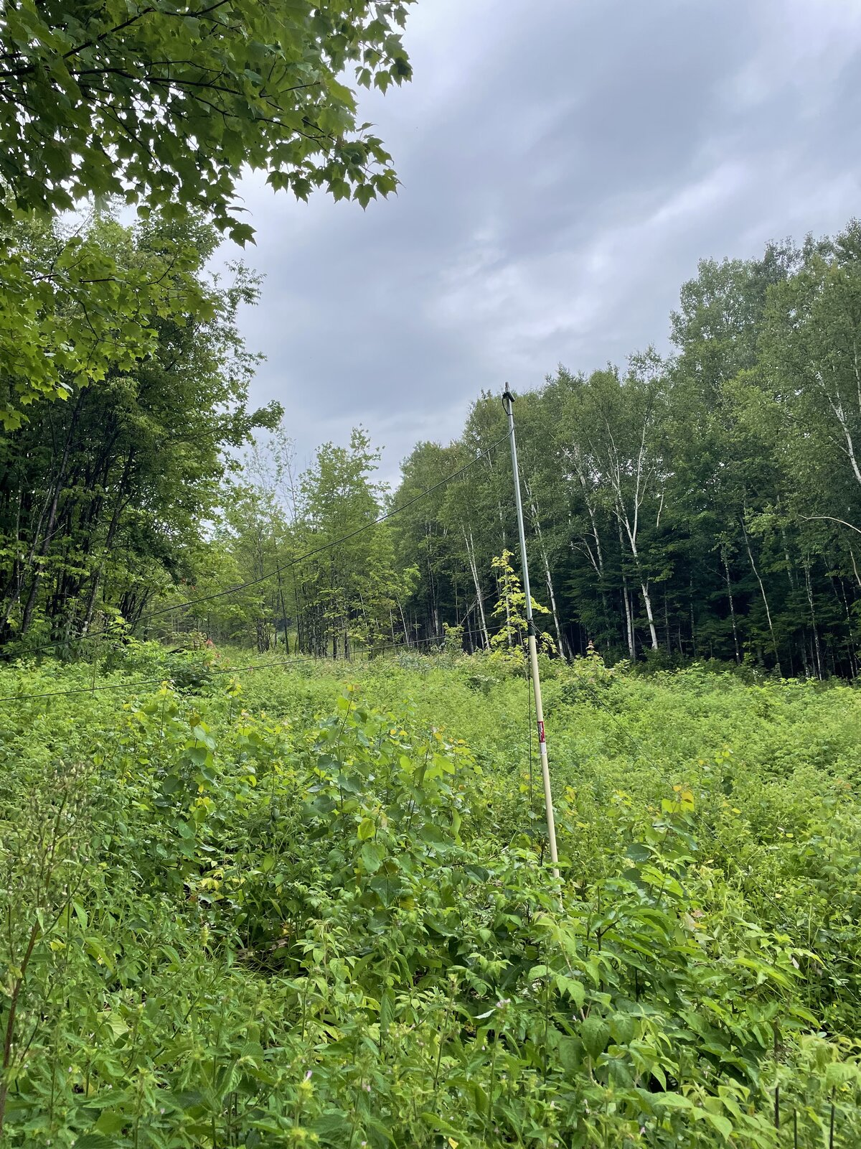 | No photo found
Figure 1: 1079-NE2-2 deployment setup (Left) and microphone view (Right).
No photo found | No photo found
Figure 2: 1079-NE2-2 view for North (Left) and East (Right)
No photo found | No photo found
Figure 3: 1079-NE2-2 view for South (Left) and West (Right)
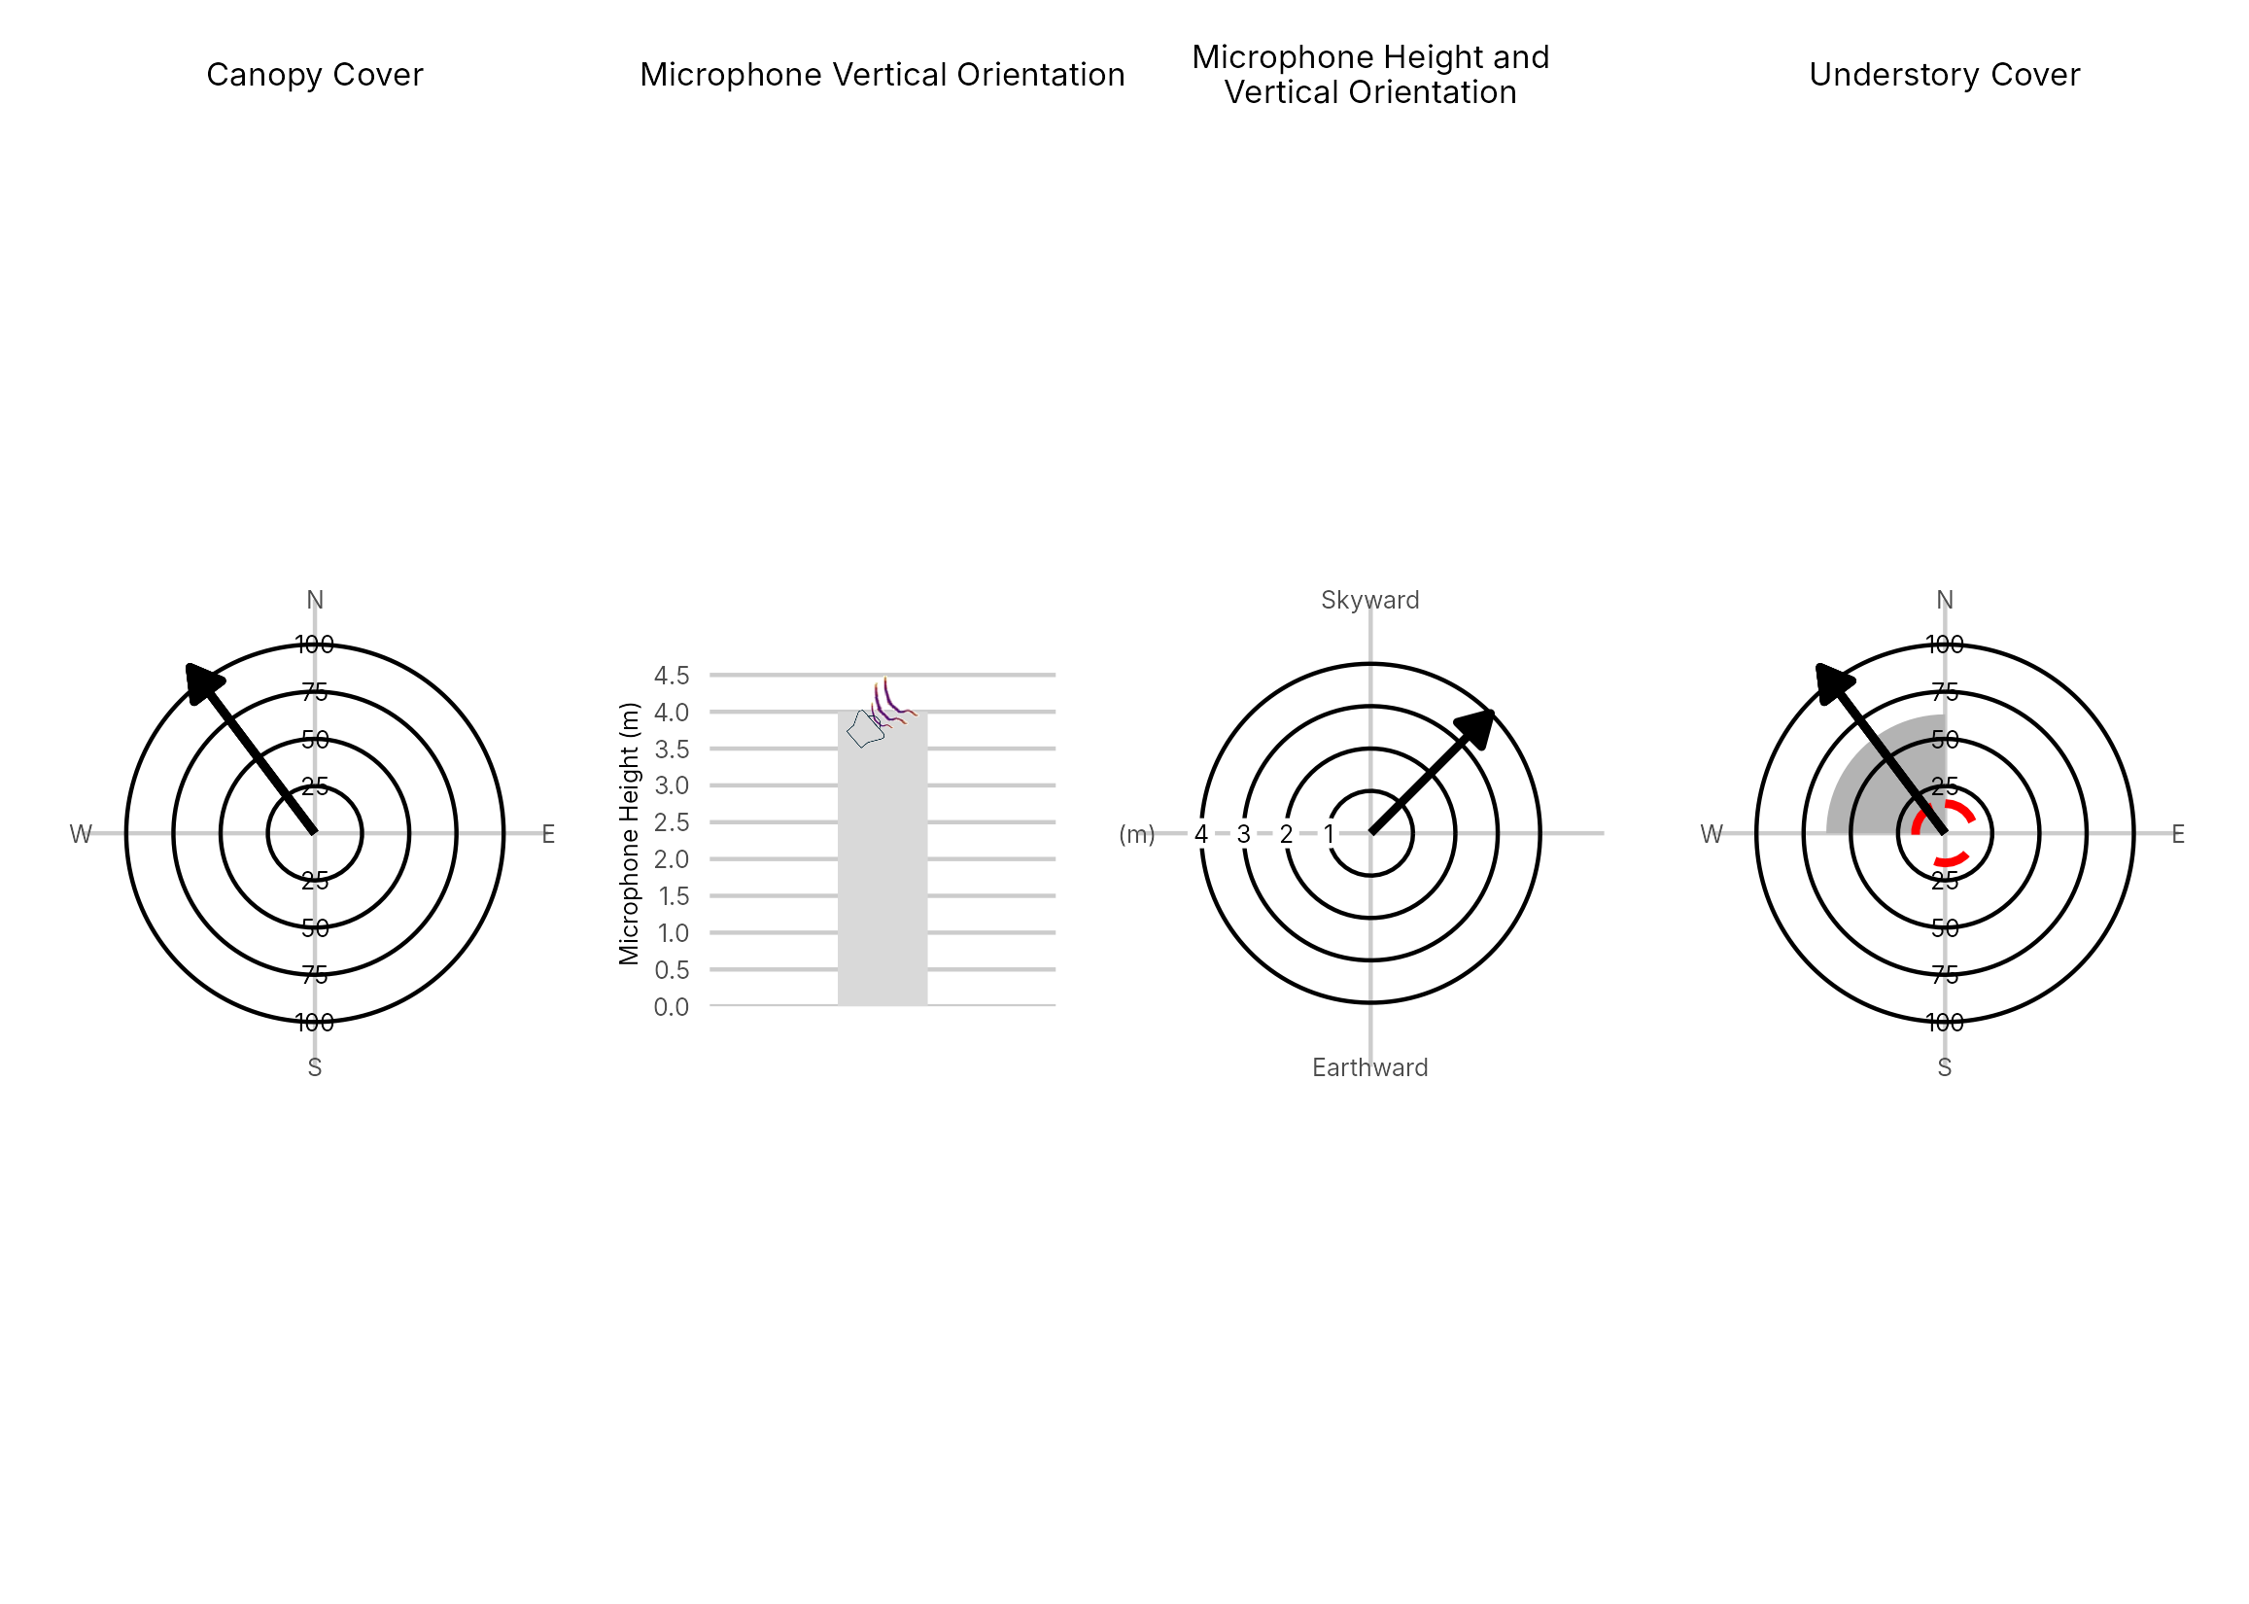

Figure 4: Percentage clutter for the understory and canopy cover at the 1079-NE2-2 compared with all sites within the study. Clutter was measured in each of the four 10x10m quadrants (Northeast, Southeast, Southwest and Northwest), surrounding the microphone. Percentage clutter and canopy cover categories were 0-5%, 10-25,25-50,50-75,76-95, 95-100%. The average clutter for the site was calculated by taking the meaning of the mid-point of each quadrant. The direction of the microphone is indicated by the arrow.

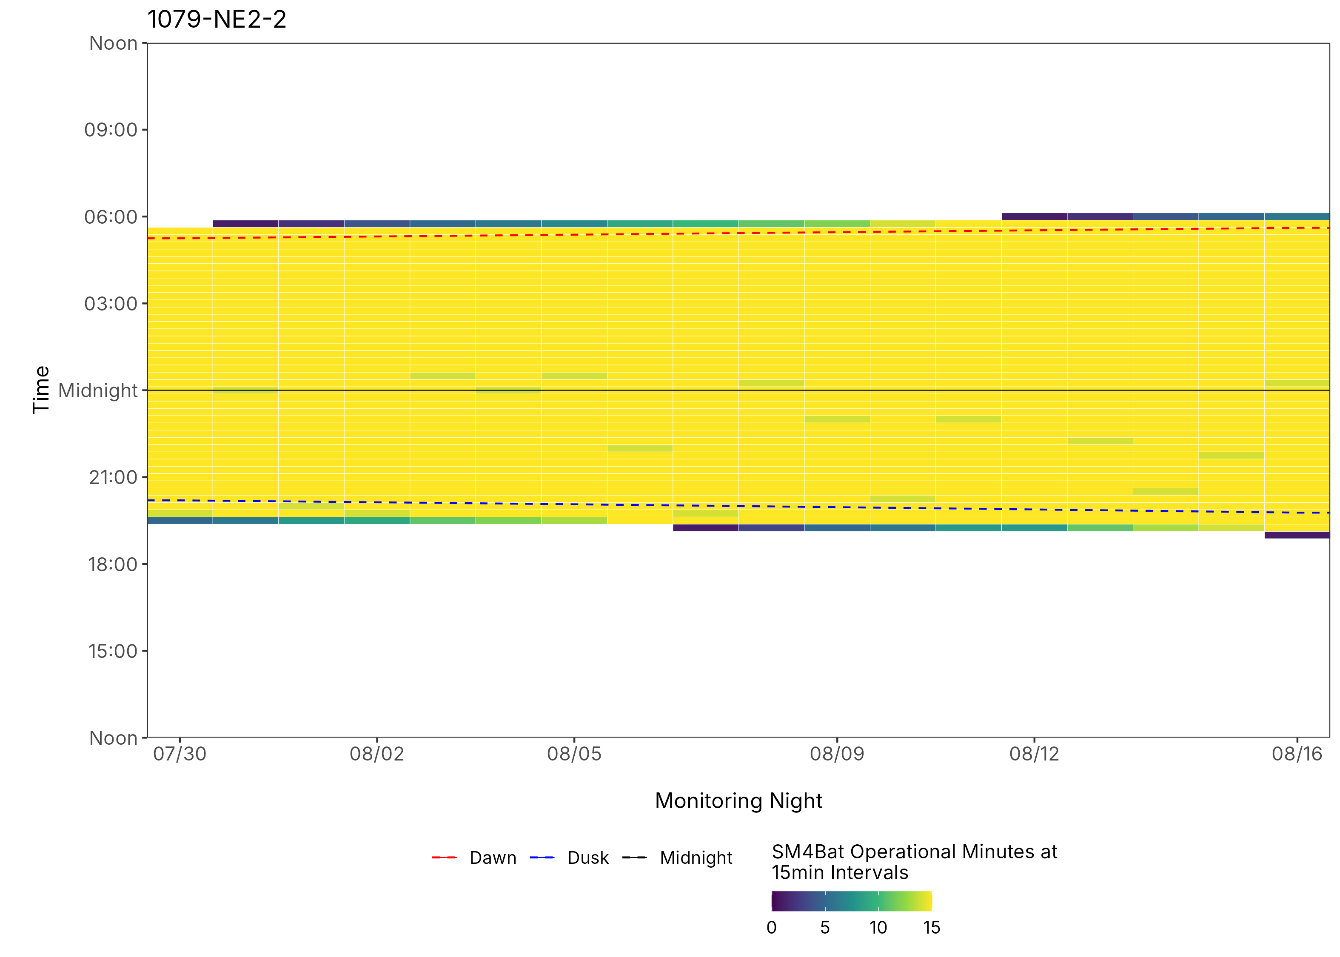
Figure 5: ARU activity plot

 | Client: | Wildlife Management Institute
 | Client Contact: | Meghan Gilbart
 | Project Name: | Maine NABAT
 | Project Code: | MAMM-NG26-007
 | Project Manager: | Joshua Guilbert
Project Information
Name of Permitted Biologist: | Bri Frankina
Federal Permit Number: | TE63633A
Personnel*: | BRF, ECG
Habitat Assessment Dates: | 7/17/2026
First Deployment Date: | 7/17/2026
Target Recovery
Final Recovery/Last Service: | 8/17/2026
Servicing Dates: | 7/30/2026
Survey Type | Summer - Acoustic
Site Type: | Inland
Landowner Information: | Seven Islands
Site: | 1079-SE1
Site Label: | 1079-SE1
County: | Aroostook
State: | Maine
Site Coordinates: | 46.793546, -68.816757
Detector Info:
Deployment Date: | 7/17/2026
ARU Make, Model & Serial #: | Wildlife Acoustics, SM4BatFS, S4U28613
Power Make, Model & Serial #: | Internal power, 4 x D Batteries
Microphone Make, Model & Serial: | Wildlife Acoustics, U2, MU236552
Microphone Height (m) | 4
Microphone Direction(degrees): | 166
Microphone Orientation: | 45
Status Check: Settings†: | Yes
Status Check: Hardware ‡: | Yes
Survey Schedule

Servicing Events
Date | Staff* | Action | Notes
7/30/2026 | BRF | SD cards swapped | Battery at 5.5, 15GB on card A

Recovery Date: | 8/17/2026
ARU Make, Model & Serial #: | Wildlife Acoustics, SM4BatFS, S4U28613
Power Make, Model & Serial #: | Internal power, 4 x D Batteries
Microphone Make, Model & Serial#: | Wildlife Acoustics, U2, MU236552
Microphone Height (m) | 4
Microphone Direction (degrees): | 166
Microphone Vertical Orientation: | 45
Status Check: Settings†:
Status Check: Hardware ‡:
Survey Schedule
Notes

Habitat Assessment:
Assessment date: | 7/17/2026
Habitat Assessment Area: | 20m x 20m plot with mic at the center
Basic Overall Site Description: | Clearing next to roadway and bridge in small outlet of wetland
Targeted Feature for Deployment: | Brook
Bat Roost Habitat: | Rock, Bridge
Water Resources: | Good water source present
Distance Mic to Nearest Water (m): | 10
Type of Nearest Water: | flowing freshwater
Tree Species Dominant | Balsam Fir, Spruce
Tree Species All Present (within view) | Elm, Balsam Fir, Spruce, Maple, Striped Maple. Sugar Maple, Alder
Understory Species Dominant | White Birch
Understory Species All Present (within view) | Alder, Hazelnut/Alder, White Birch, Spruce
DBH of Surrounding Stand: | 5-15cm present
Stand Age: | Young/even aged
Understory Clutter | Semi-cluttered (cluttered but gaps present)
Microphone Distance to Clutter (m): | 3
Land Cover: | Mostly Forested

ARU Photos
No photo found | No photo found
Figure 1: 1079-SE1 deployment setup (Left) and microphone view (Right).
No photo found | No photo found
Figure 2: 1079-SE1 view for North (Left) and East (Right)
No photo found | No photo found
Figure 3: 1079-SE1 view for South (Left) and West (Right)
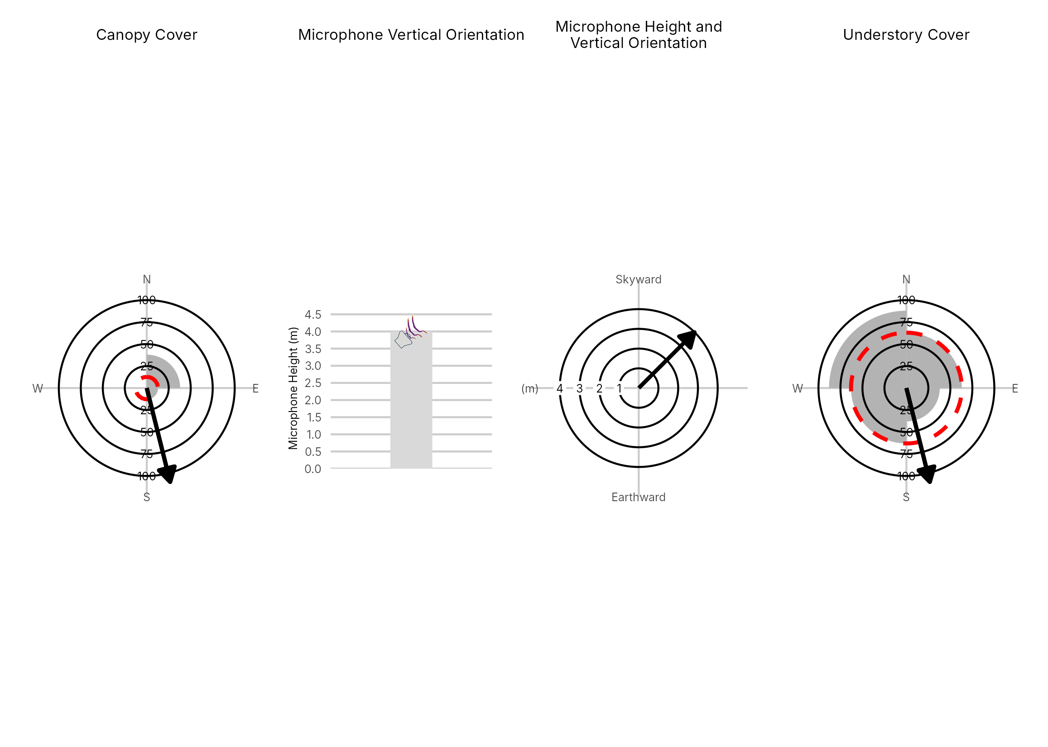

Figure 4: Percentage clutter for the understory and canopy cover at the 1079-SE1 compared with all sites within the study. Clutter was measured in each of the four 10x10m quadrants (Northeast, Southeast, Southwest and Northwest), surrounding the microphone. Percentage clutter and canopy cover categories were 0-5%, 10-25,25-50,50-75,76-95, 95-100%. The average clutter for the site was calculated by taking the meaning of the mid-point of each quadrant. The direction of the microphone is indicated by the arrow.

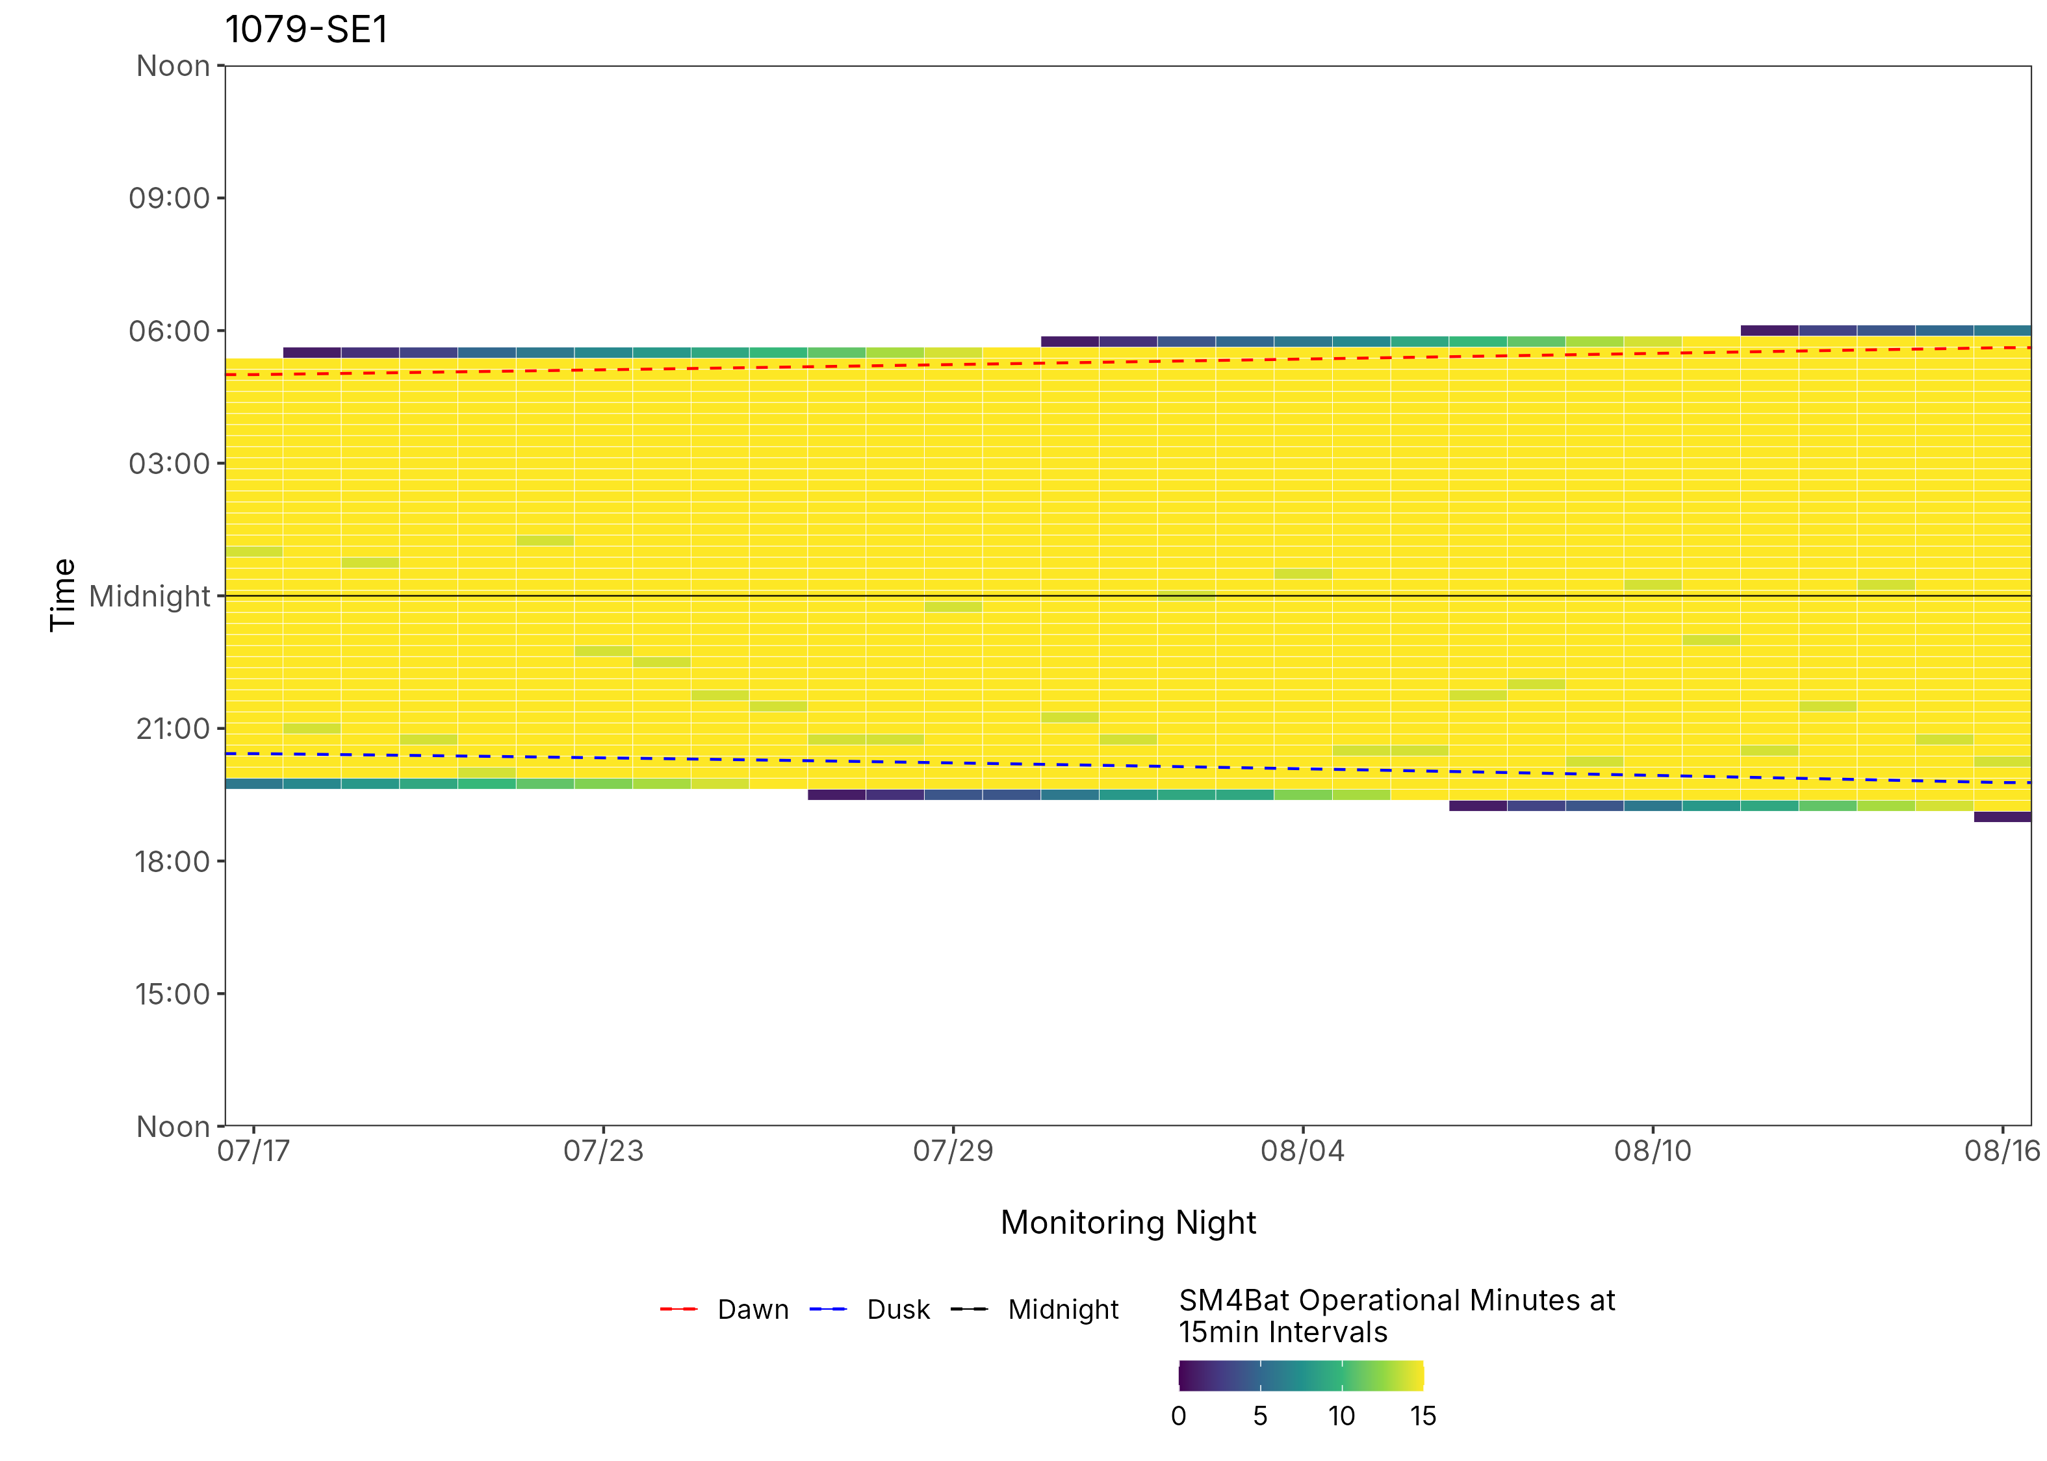
Figure 5: ARU activity plot

 | Client: | Wildlife Management Institute
 | Client Contact: | Meghan Gilbart
 | Project Name: | Maine NABAT
 | Project Code: | MAMM-NG26-007
 | Project Manager: | Joshua Guilbert
Project Information
Name of Permitted Biologist: | Josh Guilbert
Federal Permit Number: | TE63633A
Personnel*: | JMG
Habitat Assessment Dates: | 7/8/2026
First Deployment Date: | 7/8/2026
Target Recovery
Final Recovery/Last Service: | 8/6/2026
Servicing Dates: | None
Survey Type | Summer - Acoustic
Site Type: | Inland
Landowner Information: | Seven Islands
Site: | 108325-1
Site Label: | 108325-1
County: | Oxford
State: | Maine
Site Coordinates: | 45.110416, -70.864249
Detector Info:
Deployment Date: | 7/8/2026
ARU Make, Model & Serial #: | Wildlife Acoustics, SM4BatFS, S4U19367
Power Make, Model & Serial #: | Internal power, 4 x D Batteries
Microphone Make, Model & Serial: | Wildlife Acoustics, U2, MU228366
Microphone Height (m) | 3
Microphone Direction(degrees): | 309
Microphone Orientation: | 45
Status Check: Settings†: | Yes
Status Check: Hardware ‡: | Yes
Survey Schedule

Servicing Events
Date | Staff* | Action | Notes
None

Recovery Date: | 8/6/2026
ARU Make, Model & Serial #: | Wildlife Acoustics, SM4BatFS, S4U19367
Power Make, Model & Serial #: | Internal power, 4 x D Batteries
Microphone Make, Model & Serial#: | Wildlife Acoustics, U2, MU228366
Microphone Height (m) | 3
Microphone Direction (degrees): | 309
Microphone Vertical Orientation: | 45
Status Check: Settings†:
Status Check: Hardware ‡:
Survey Schedule
Notes

Habitat Assessment:
Assessment date: | 7/8/2026
Habitat Assessment Area: | 20m x 20m plot with mic at the center
Basic Overall Site Description: | Pine forest edge 10m from road
Targeted Feature for Deployment: | Forest Edge
Bat Roost Habitat: | Rock, Snags & damaged live trees
Water Resources: | No water resources present at site
Distance Mic to Nearest Water (m):
Type of Nearest Water: | flowing freshwater
Tree Species Dominant | Red Spruce
Tree Species All Present (within view) | Red Spruce
Understory Species Dominant | Spruce, Balsam Fir, Cherry
Understory Species All Present (within view) | Spruce, Balsam Fir, Cherry
DBH of Surrounding Stand: | Majority <5cm
Stand Age: | Young/even aged
Understory Clutter | Minimal clutter (open understory facilitates flight)
Microphone Distance to Clutter (m): | 5
Land Cover: | Mostly Forested

ARU Photos
No photo found | No photo found
Figure 1: 108325-1 deployment setup (Left) and microphone view (Right).
No photo found | No photo found
Figure 2: 108325-1 view for North (Left) and East (Right)
No photo found | No photo found
Figure 3: 108325-1 view for South (Left) and West (Right)
No quadrant cover data for this site

Figure 4: Percentage clutter for the understory and canopy cover at the 108325-1 compared with all sites within the study. Clutter was measured in each of the four 10x10m quadrants (Northeast, Southeast, Southwest and Northwest), surrounding the microphone. Percentage clutter and canopy cover categories were 0-5%, 10-25,25-50,50-75,76-95, 95-100%. The average clutter for the site was calculated by taking the meaning of the mid-point of each quadrant. The direction of the microphone is indicated by the arrow.

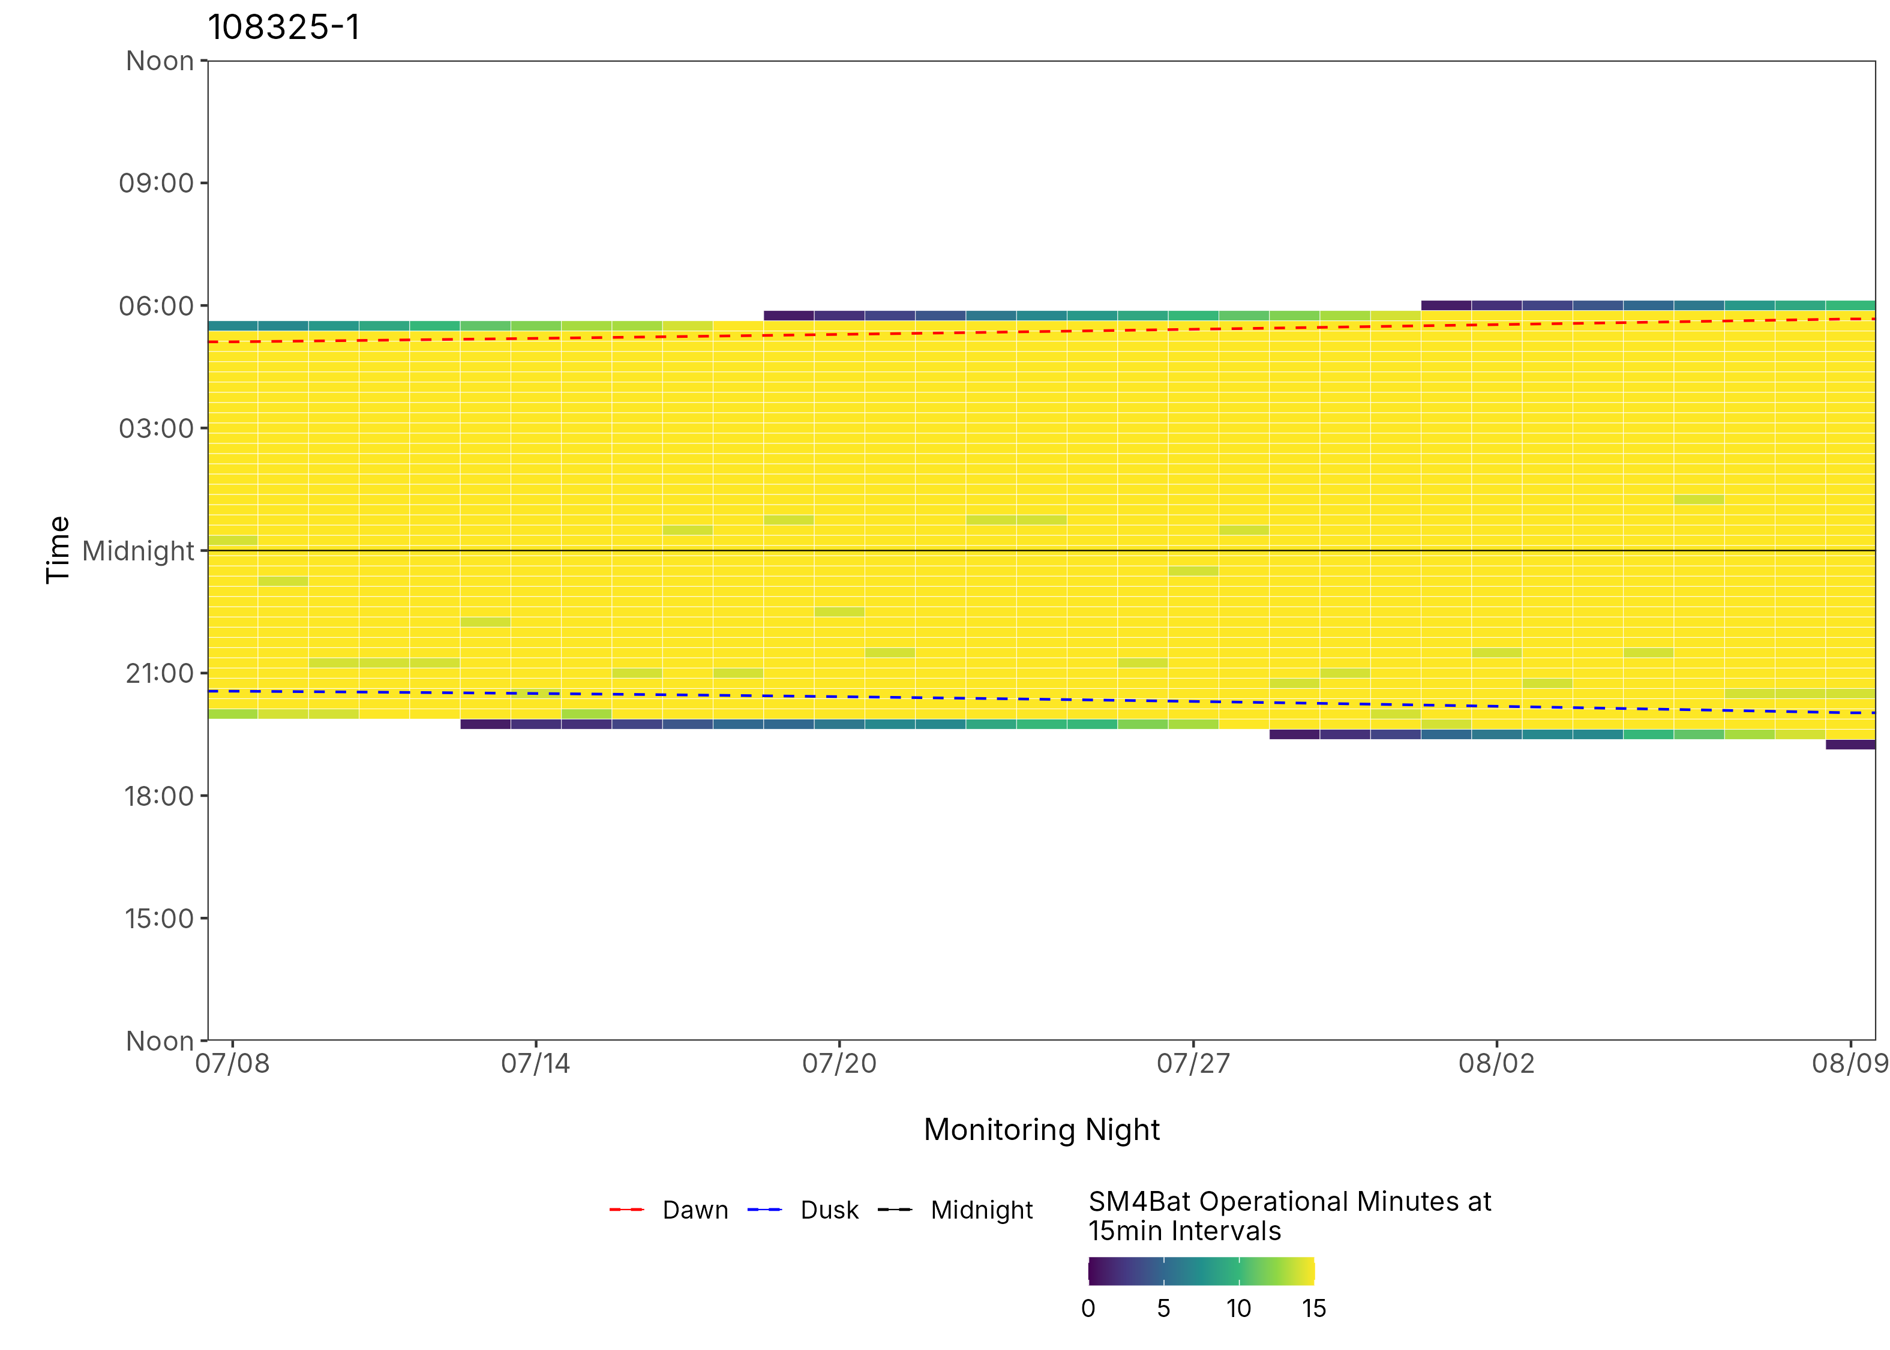
Figure 5: ARU activity plot

 | Client: | Wildlife Management Institute
 | Client Contact: | Meghan Gilbart
 | Project Name: | Maine NABAT
 | Project Code: | MAMM-NG26-007
 | Project Manager: | Joshua Guilbert
Project Information
Name of Permitted Biologist: | Josh Guilbert
Federal Permit Number: | TE63633A
Personnel*: | JMG
Habitat Assessment Dates: | 7/8/2026
First Deployment Date: | 7/8/2026
Target Recovery
Final Recovery/Last Service: | 8/6/2026
Servicing Dates: | None
Survey Type | Summer - Acoustic
Site Type: | Inland
Landowner Information: | Seven Islands
Site: | 108325-2NE
Site Label: | 108325-2NE
County: | Oxford
State: | Maine
Site Coordinates: | 45.157577, -70.825223
Detector Info:
Deployment Date: | 7/8/2026
ARU Make, Model & Serial #: | Wildlife Acoustics, SM4BatFS, S4U17685
Power Make, Model & Serial #: | Internal power, 4 x D Batteries
Microphone Make, Model & Serial: | Wildlife Acoustics, U2, MU228465
Microphone Height (m) | 3
Microphone Direction(degrees): | 195
Microphone Orientation: | 45
Status Check: Settings†: | Yes
Status Check: Hardware ‡: | Yes
Survey Schedule

Servicing Events
Date | Staff* | Action | Notes
None

Recovery Date: | 8/6/2026
ARU Make, Model & Serial #: | Wildlife Acoustics, SM4BatFS, S4U17685
Power Make, Model & Serial #: | Internal power, 4 x D Batteries
Microphone Make, Model & Serial#: | Wildlife Acoustics, U2, MU228465
Microphone Height (m) | 3
Microphone Direction (degrees): | 195
Microphone Vertical Orientation: | 45
Status Check: Settings†:
Status Check: Hardware ‡:
Survey Schedule
Notes

Habitat Assessment:
Assessment date: | 7/8/2026
Habitat Assessment Area: | 20m x 20m plot with mic at the center
Basic Overall Site Description: | Forest edge next to clear cut and wetland
Targeted Feature for Deployment: | Forest Edge
Bat Roost Habitat: | Snags & damaged live trees
Water Resources: | Water present but not optimal
Distance Mic to Nearest Water (m): | 4
Type of Nearest Water: | freshwater wetland
Tree Species Dominant | Balsalm Fir
Tree Species All Present (within view) | Balsam Fir, Balsalm Fir, White Birch
Understory Species Dominant | Balsam Fir
Understory Species All Present (within view) | Balsam Fir
DBH of Surrounding Stand: | 5-15cm present
Stand Age: | Young/even aged
Understory Clutter | Semi-cluttered (cluttered but gaps present)
Microphone Distance to Clutter (m): | 3
Land Cover: | Mostly Forested

ARU Photos
No photo found | No photo found
Figure 1: 108325-2NE deployment setup (Left) and microphone view (Right).
No photo found | No photo found
Figure 2: 108325-2NE view for North (Left) and East (Right)
No photo found | No photo found
Figure 3: 108325-2NE view for South (Left) and West (Right)
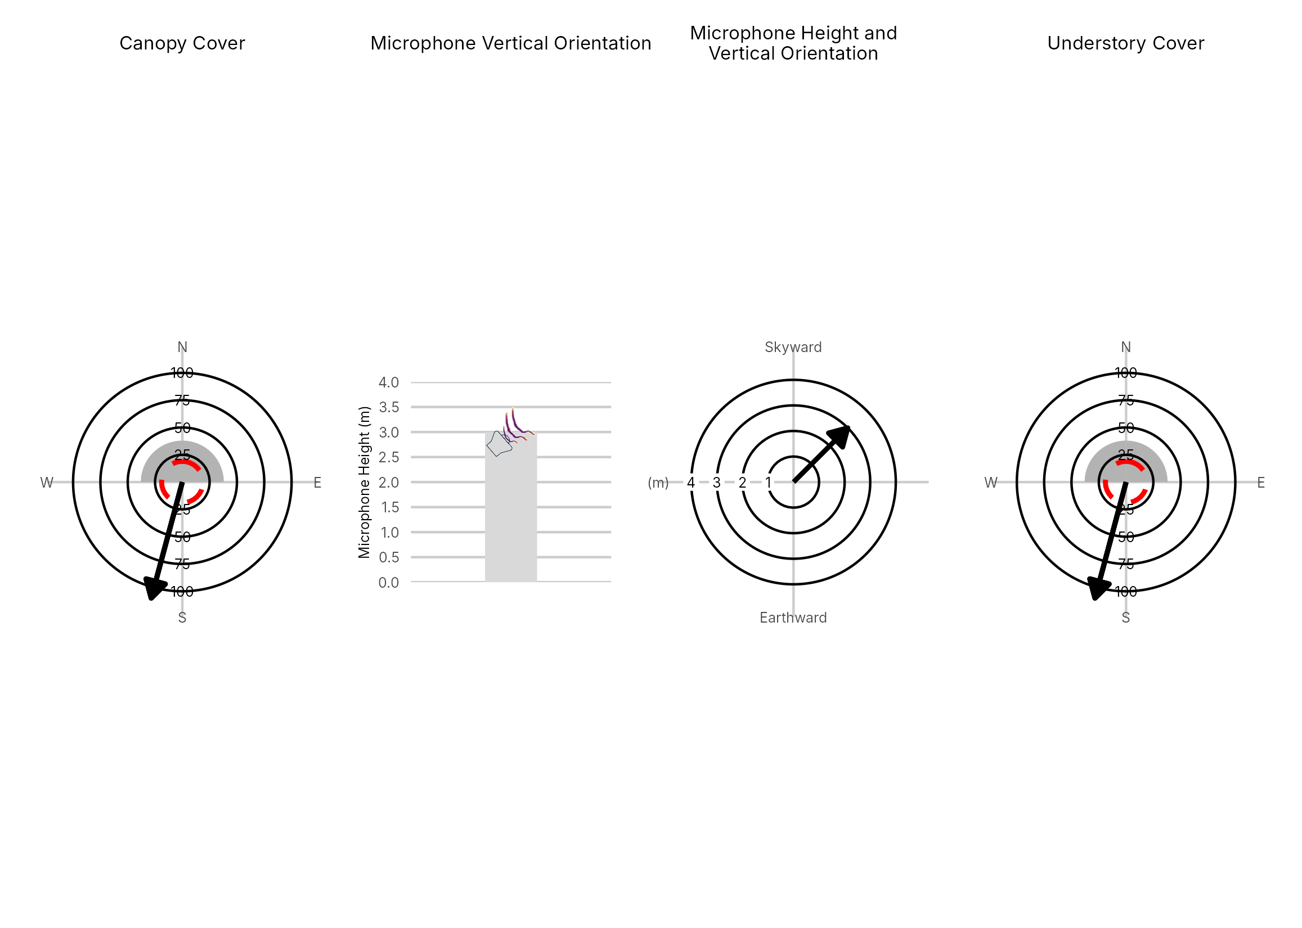

Figure 4: Percentage clutter for the understory and canopy cover at the 108325-2NE compared with all sites within the study. Clutter was measured in each of the four 10x10m quadrants (Northeast, Southeast, Southwest and Northwest), surrounding the microphone. Percentage clutter and canopy cover categories were 0-5%, 10-25,25-50,50-75,76-95, 95-100%. The average clutter for the site was calculated by taking the meaning of the mid-point of each quadrant. The direction of the microphone is indicated by the arrow.

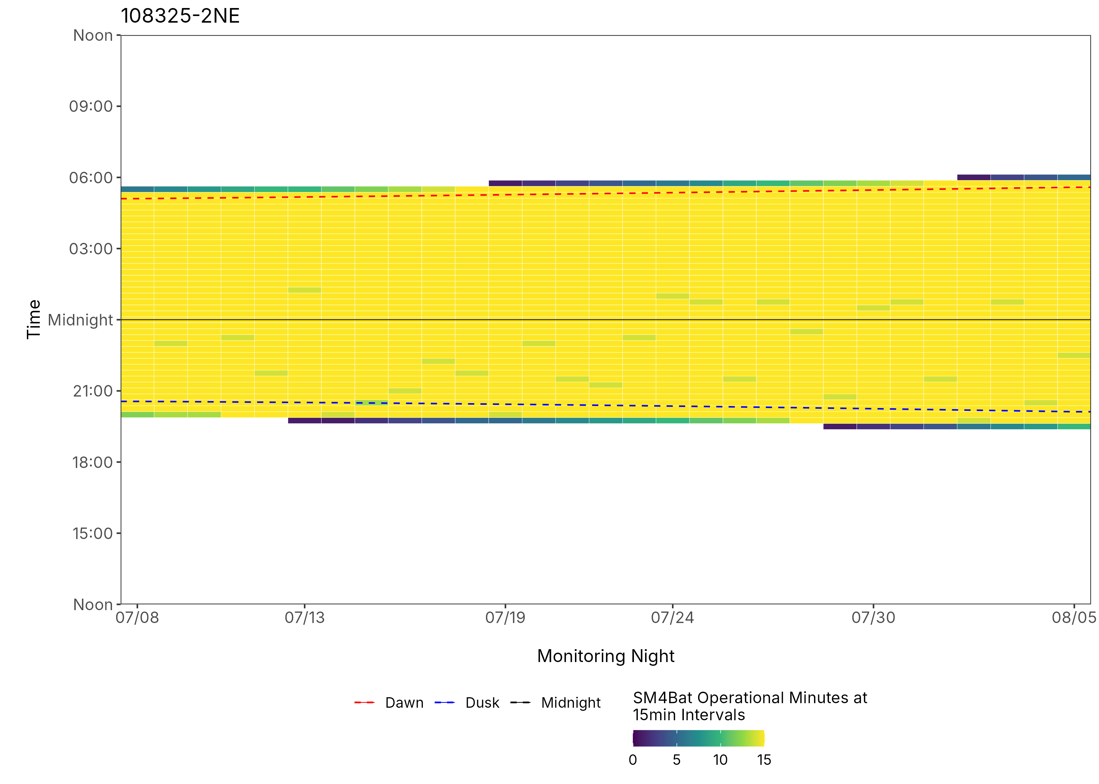
Figure 5: ARU activity plot

 | Client: | Wildlife Management Institute
 | Client Contact: | Meghan Gilbart
 | Project Name: | Maine NABAT
 | Project Code: | MAMM-NG26-007
 | Project Manager: | Joshua Guilbert
Project Information
Name of Permitted Biologist: | Josh Guilbert
Federal Permit Number: | TE63633A
Personnel*: | JMG
Habitat Assessment Dates: | 7/8/2026
First Deployment Date: | 7/8/2026
Target Recovery
Final Recovery/Last Service: | 8/6/2026
Servicing Dates: | None
Survey Type | Summer - Acoustic
Site Type: | Inland
Landowner Information: | Seven Islands
Site: | 108325-3NW
Site Label: | 108325-3NW
County: | Oxford
State: | Maine
Site Coordinates: | 45.180234, -70.882787
Detector Info:
Deployment Date: | 7/8/2026
ARU Make, Model & Serial #: | Wildlife Acoustics, SM4BatFS, S4U19388
Power Make, Model & Serial #: | Internal power, 4 x D Batteries
Microphone Make, Model & Serial: | Wildlife Acoustics, U2, MU230724
Microphone Height (m) | 3
Microphone Direction(degrees): | 333
Microphone Orientation: | 45
Status Check: Settings†: | Yes
Status Check: Hardware ‡: | Yes
Survey Schedule

Servicing Events
Date | Staff* | Action | Notes
None

Recovery Date: | 8/6/2026
ARU Make, Model & Serial #: | Wildlife Acoustics, SM4BatFS, S4U19388
Power Make, Model & Serial #: | Internal power, 4 x D Batteries
Microphone Make, Model & Serial#: | Wildlife Acoustics, U2, MU230724
Microphone Height (m) | 3
Microphone Direction (degrees): | 333
Microphone Vertical Orientation: | 45
Status Check: Settings†:
Status Check: Hardware ‡:
Survey Schedule
Notes

Habitat Assessment:
Assessment date: | 7/8/2026
Habitat Assessment Area: | 20m x 20m plot with mic at the center
Basic Overall Site Description: | Forest edge near stream
Targeted Feature for Deployment: | Forest and Brook
Bat Roost Habitat: | Rock, Snags & damaged live trees
Water Resources: | Good water source present
Distance Mic to Nearest Water (m): | 10
Type of Nearest Water: | flowing freshwater
Tree Species Dominant | Red Spruce
Tree Species All Present (within view) | Red Spruce, Balsam Fir
Understory Species Dominant | White Birch, Black Cherry
Understory Species All Present (within view) | White Birch, Black Cherry
DBH of Surrounding Stand: | >15cm present
Stand Age: | Some diversity in stand
Understory Clutter | Semi-cluttered (cluttered but gaps present)
Microphone Distance to Clutter (m): | 3
Land Cover: | Mostly Forested

ARU Photos
No photo found | No photo found
Figure 1: 108325-3NW deployment setup (Left) and microphone view (Right).
No photo found | No photo found
Figure 2: 108325-3NW view for North (Left) and East (Right)
No photo found | No photo found
Figure 3: 108325-3NW view for South (Left) and West (Right)
No quadrant cover data for this site

Figure 4: Percentage clutter for the understory and canopy cover at the 108325-3NW compared with all sites within the study. Clutter was measured in each of the four 10x10m quadrants (Northeast, Southeast, Southwest and Northwest), surrounding the microphone. Percentage clutter and canopy cover categories were 0-5%, 10-25,25-50,50-75,76-95, 95-100%. The average clutter for the site was calculated by taking the meaning of the mid-point of each quadrant. The direction of the microphone is indicated by the arrow.

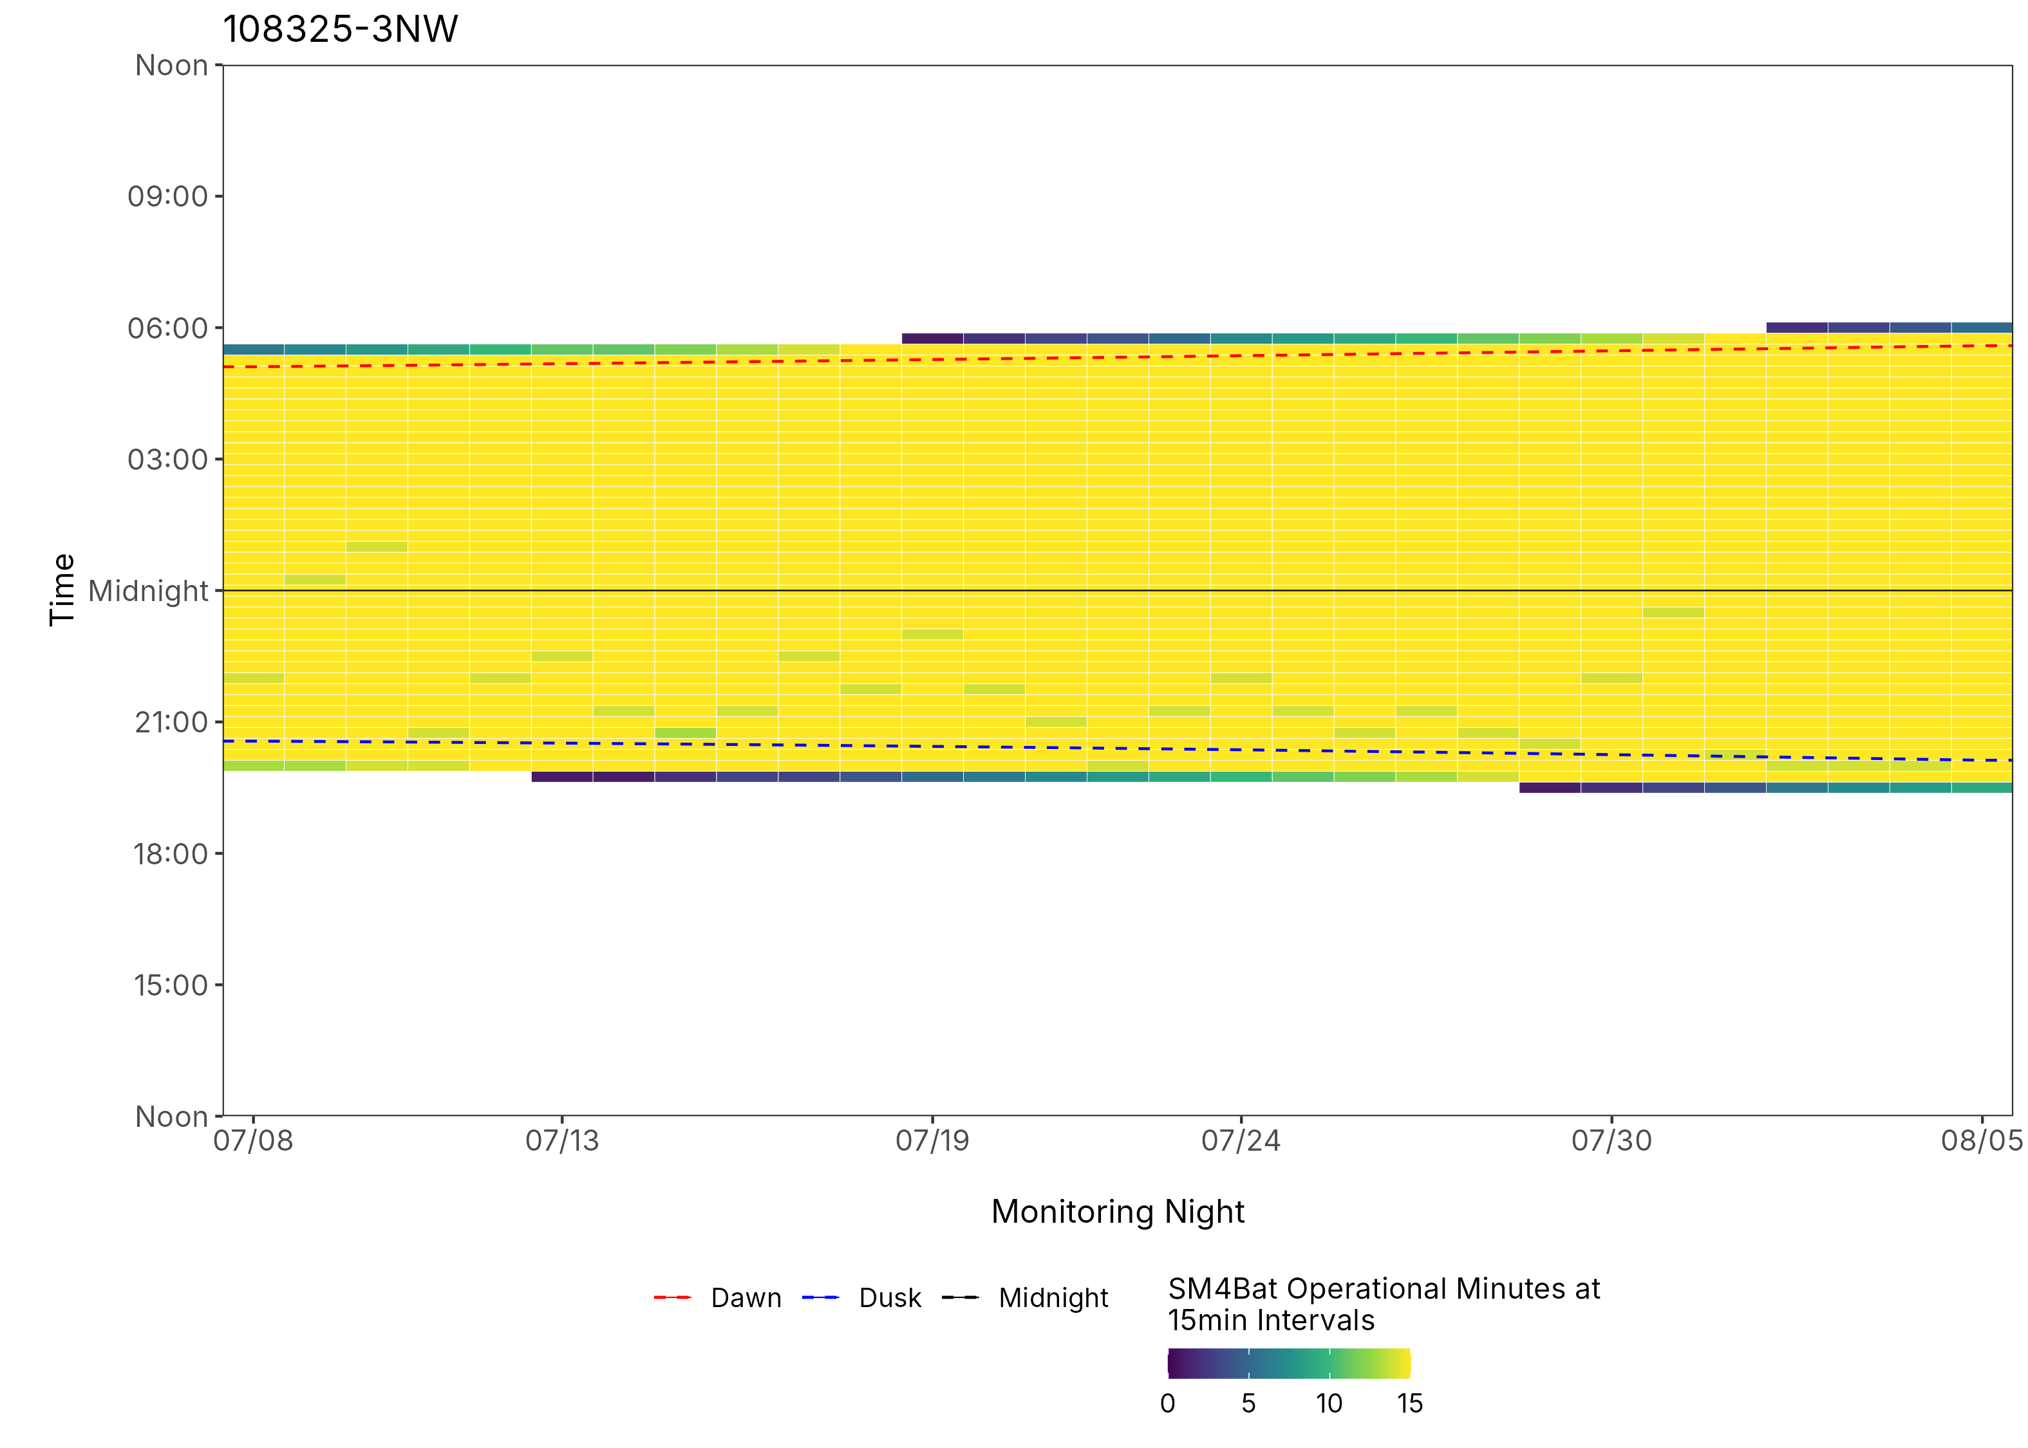
Figure 5: ARU activity plot

 | Client: | Wildlife Management Institute
 | Client Contact: | Meghan Gilbart
 | Project Name: | Maine NABAT
 | Project Code: | MAMM-NG26-007
 | Project Manager: | Joshua Guilbert
Project Information
Name of Permitted Biologist: | Bri Frankina
Federal Permit Number: | TE63633A
Personnel*: | BRF, ECG
Habitat Assessment Dates: | 7/19/2026
First Deployment Date: | 7/19/2026
Target Recovery
Final Recovery/Last Service: | 8/18/2026
Servicing Dates: | None
Survey Type | Summer - Acoustic
Site Type: | Inland
Landowner Information: | Seven Islands
Site: | 5175-NW1
Site Label: | 5175-NW1
County: | Piscataquis
State: | Maine
Site Coordinates: | 46.536318, -68.888660
Detector Info:
Deployment Date: | 7/19/2026
ARU Make, Model & Serial #: | Wildlife Acoustics, SM4BatFS, S4U28483
Power Make, Model & Serial #: | Internal power, 4 x D Batteries
Microphone Make, Model & Serial: | Wildlife Acoustics, U2, MU236350
Microphone Height (m) | 4
Microphone Direction(degrees): | 223
Microphone Orientation: | 45
Status Check: Settings†: | Yes
Status Check: Hardware ‡: | Yes
Survey Schedule

Servicing Events
Date | Staff* | Action | Notes
None

Recovery Date: | 8/18/2026
ARU Make, Model & Serial #: | Wildlife Acoustics, SM4BatFS, S4U28483
Power Make, Model & Serial #: | Internal power, 4 x D Batteries
Microphone Make, Model & Serial#: | Wildlife Acoustics, U2, MU236350
Microphone Height (m) | 4
Microphone Direction (degrees): | 223
Microphone Vertical Orientation: | 45
Status Check: Settings†:
Status Check: Hardware ‡:
Survey Schedule
Notes | 5.1V, 8 GB Card A

Habitat Assessment:
Assessment date: | 7/19/2026
Habitat Assessment Area: | 20m x 20m plot with mic at the center
Basic Overall Site Description: | Corridor leading to stream in post-logged area
Targeted Feature for Deployment: | Brook
Bat Roost Habitat: | Snags & damaged live trees
Water Resources: | Good water source present
Distance Mic to Nearest Water (m): | 30
Type of Nearest Water: | flowing freshwater
Tree Species Dominant | Pine
Tree Species All Present (within view) | White pine, Pine, White Birch, Yellow Birch, Cedar, Maple. Spruce, Quaking Aspen, Fir
Understory Species Dominant | Beech, Balsam Fir, Birch
Understory Species All Present (within view) | Fir, Balsam Fir, Birch, Cedar, Beech
DBH of Surrounding Stand: | 5-15cm present
Stand Age: | Young/even aged
Understory Clutter | Semi-cluttered (cluttered but gaps present)
Microphone Distance to Clutter (m): | 4
Land Cover: | Trees present but fragmented

ARU Photos
No photo found | No photo found
Figure 1: 5175-NW1 deployment setup (Left) and microphone view (Right).
No photo found | No photo found
Figure 2: 5175-NW1 view for North (Left) and East (Right)
No photo found | No photo found
Figure 3: 5175-NW1 view for South (Left) and West (Right)
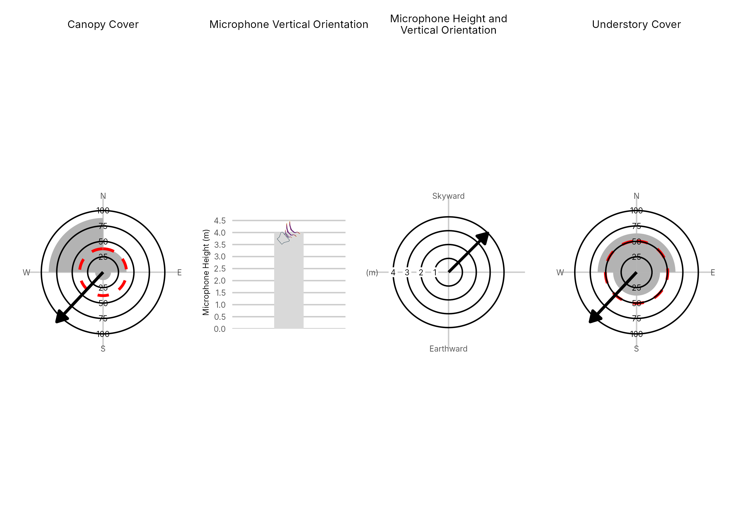

Figure 4: Percentage clutter for the understory and canopy cover at the 5175-NW1 compared with all sites within the study. Clutter was measured in each of the four 10x10m quadrants (Northeast, Southeast, Southwest and Northwest), surrounding the microphone. Percentage clutter and canopy cover categories were 0-5%, 10-25,25-50,50-75,76-95, 95-100%. The average clutter for the site was calculated by taking the meaning of the mid-point of each quadrant. The direction of the microphone is indicated by the arrow.

No SM4 log data for this site
Figure 5: ARU activity plot

 | Client: | Wildlife Management Institute
 | Client Contact: | Meghan Gilbart
 | Project Name: | Maine NABAT
 | Project Code: | MAMM-NG26-007
 | Project Manager: | Joshua Guilbert
Project Information
Name of Permitted Biologist: | Bri Frankina
Federal Permit Number: | TE63633A
Personnel*: | BRF, ECG
Habitat Assessment Dates: | 7/19/2026
First Deployment Date: | 7/19/2026
Target Recovery
Final Recovery/Last Service: | 8/18/2026
Servicing Dates: | 7/31/2026
Survey Type | Summer - Acoustic
Site Type: | Inland
Landowner Information: | Seven Islands
Site: | 5175-SE1
Site Label: | 5175-SE1
County: | Piscataquis
State: | Maine
Site Coordinates: | 46.485362, -68.832656
Detector Info:
Deployment Date: | 7/19/2026
ARU Make, Model & Serial #: | Wildlife Acoustics, SM4BatFS, S4U28628
Power Make, Model & Serial #: | Internal power, 4 x D Batteries
Microphone Make, Model & Serial: | Wildlife Acoustics, U2, MU236535
Microphone Height (m) | 3
Microphone Direction(degrees): | 56
Microphone Orientation: | 45
Status Check: Settings†: | Yes
Status Check: Hardware ‡: | Yes
Survey Schedule

Servicing Events
Date | Staff* | Action | Notes
7/31/2026 | BRF, JMG | SD cards swapped, Location Moved | Mic down upon arrival, likely moose walked through cord.Moved 10 ft out of wildlife trail

Recovery Date: | 8/18/2026
ARU Make, Model & Serial #: | Wildlife Acoustics, SM4BatFS, S4U28628
Power Make, Model & Serial #: | Internal power, 4 x D Batteries
Microphone Make, Model & Serial#: | Wildlife Acoustics, U2, MU236535
Microphone Height (m) | 3
Microphone Direction (degrees): | 56
Microphone Vertical Orientation: | 45
Status Check: Settings†:
Status Check: Hardware ‡:
Survey Schedule
Notes | 5.1V, 11 GB Card A

Habitat Assessment:
Assessment date: | 7/19/2026
Habitat Assessment Area: | 20m x 20m plot with mic at the center
Basic Overall Site Description: | Roadside clearing at junction of road and old forested access roads
Targeted Feature for Deployment: | Forest Edge
Bat Roost Habitat: | Snags & damaged live trees
Water Resources: | No water resources present at site
Distance Mic to Nearest Water (m):
Type of Nearest Water:
Tree Species Dominant | Aspen, Maple
Tree Species All Present (within view) | Aspen, Maple, Quaking Aspen, Bigtooth Aspen, Cedar, Sugar Maple, Poplar
Understory Species Dominant | Aspen, Maple, Spruce
Understory Species All Present (within view) | Quaking Aspen, Maple, Aspen, Spruce, Cedar
DBH of Surrounding Stand: | 5-15cm present
Stand Age: | Young/even aged
Understory Clutter | Minimal clutter (open understory facilitates flight)
Microphone Distance to Clutter (m): | 4
Land Cover: | Trees present but fragmented

ARU Photos
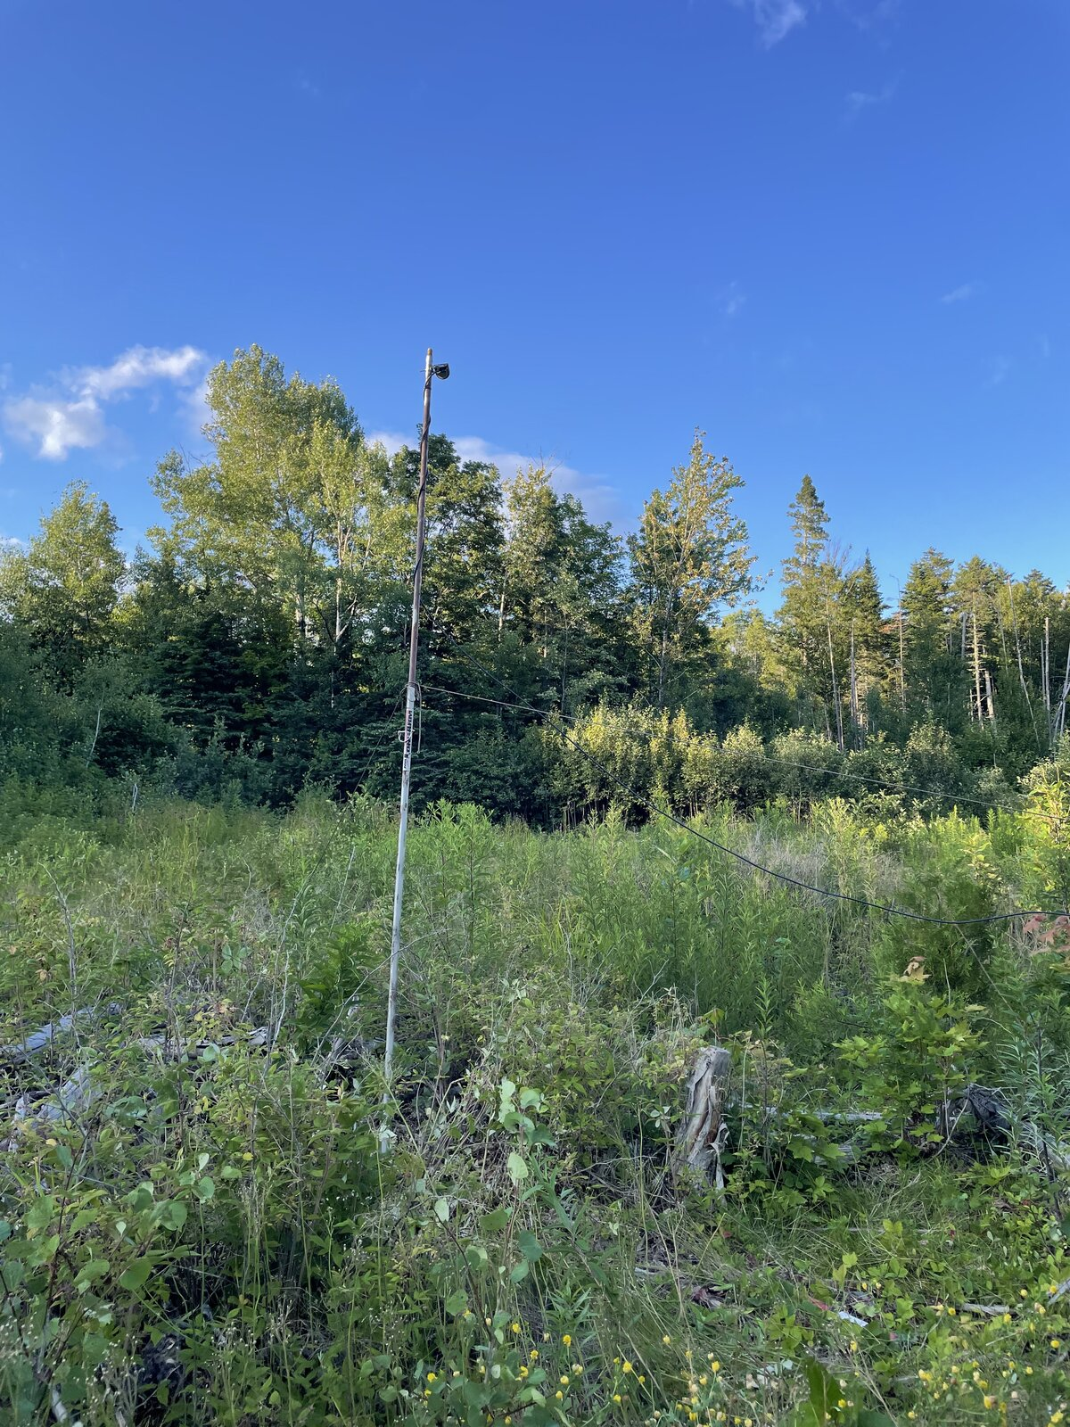 | 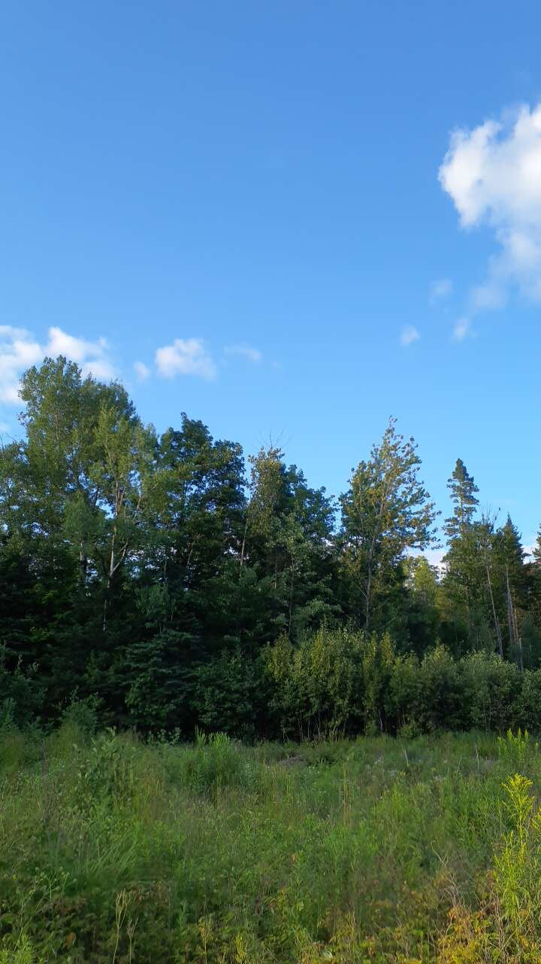
Figure 1: 5175-SE1 deployment setup (Left) and microphone view (Right).
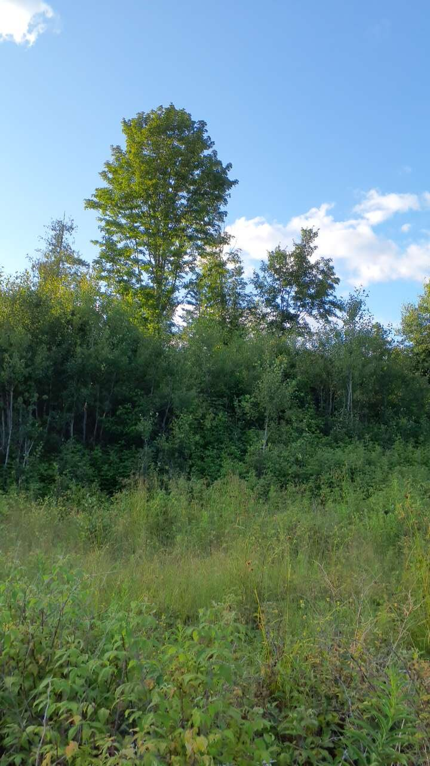 | 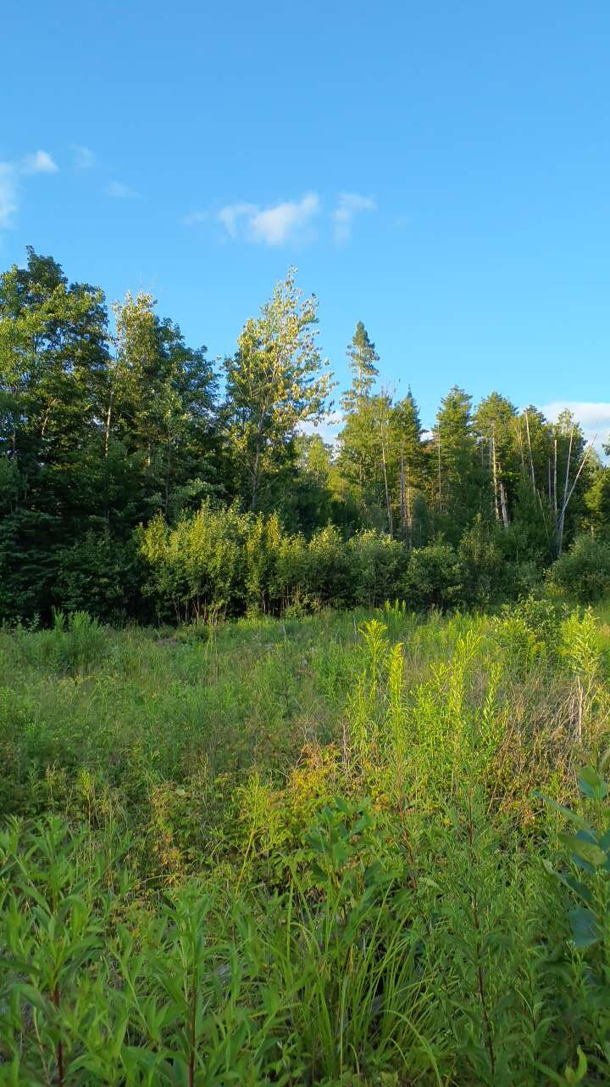
Figure 2: 5175-SE1 view for North (Left) and East (Right)
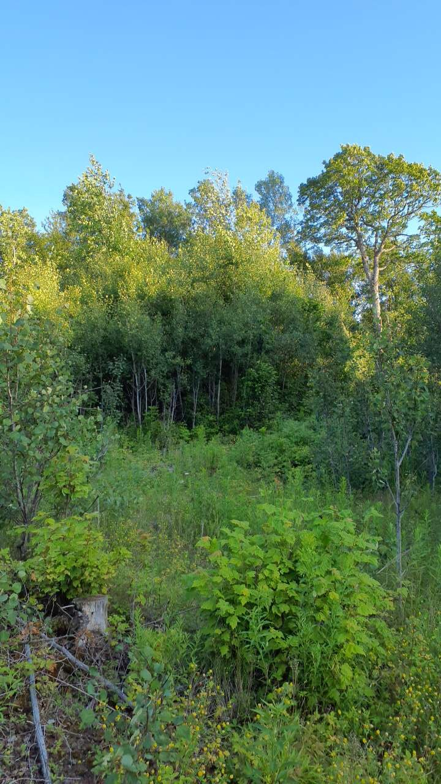 | 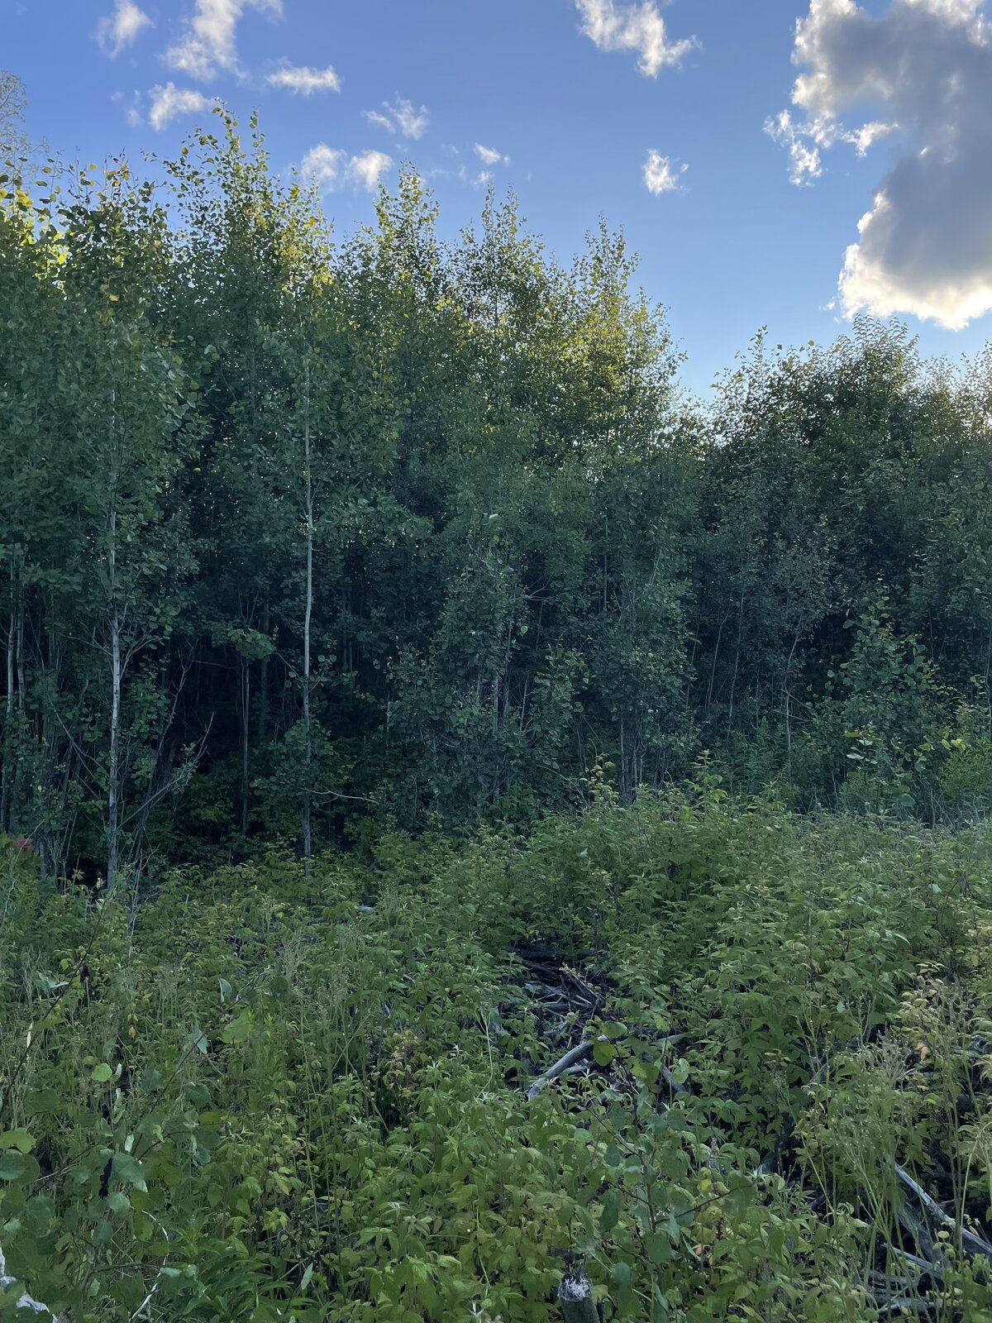
Figure 3: 5175-SE1 view for South (Left) and West (Right)
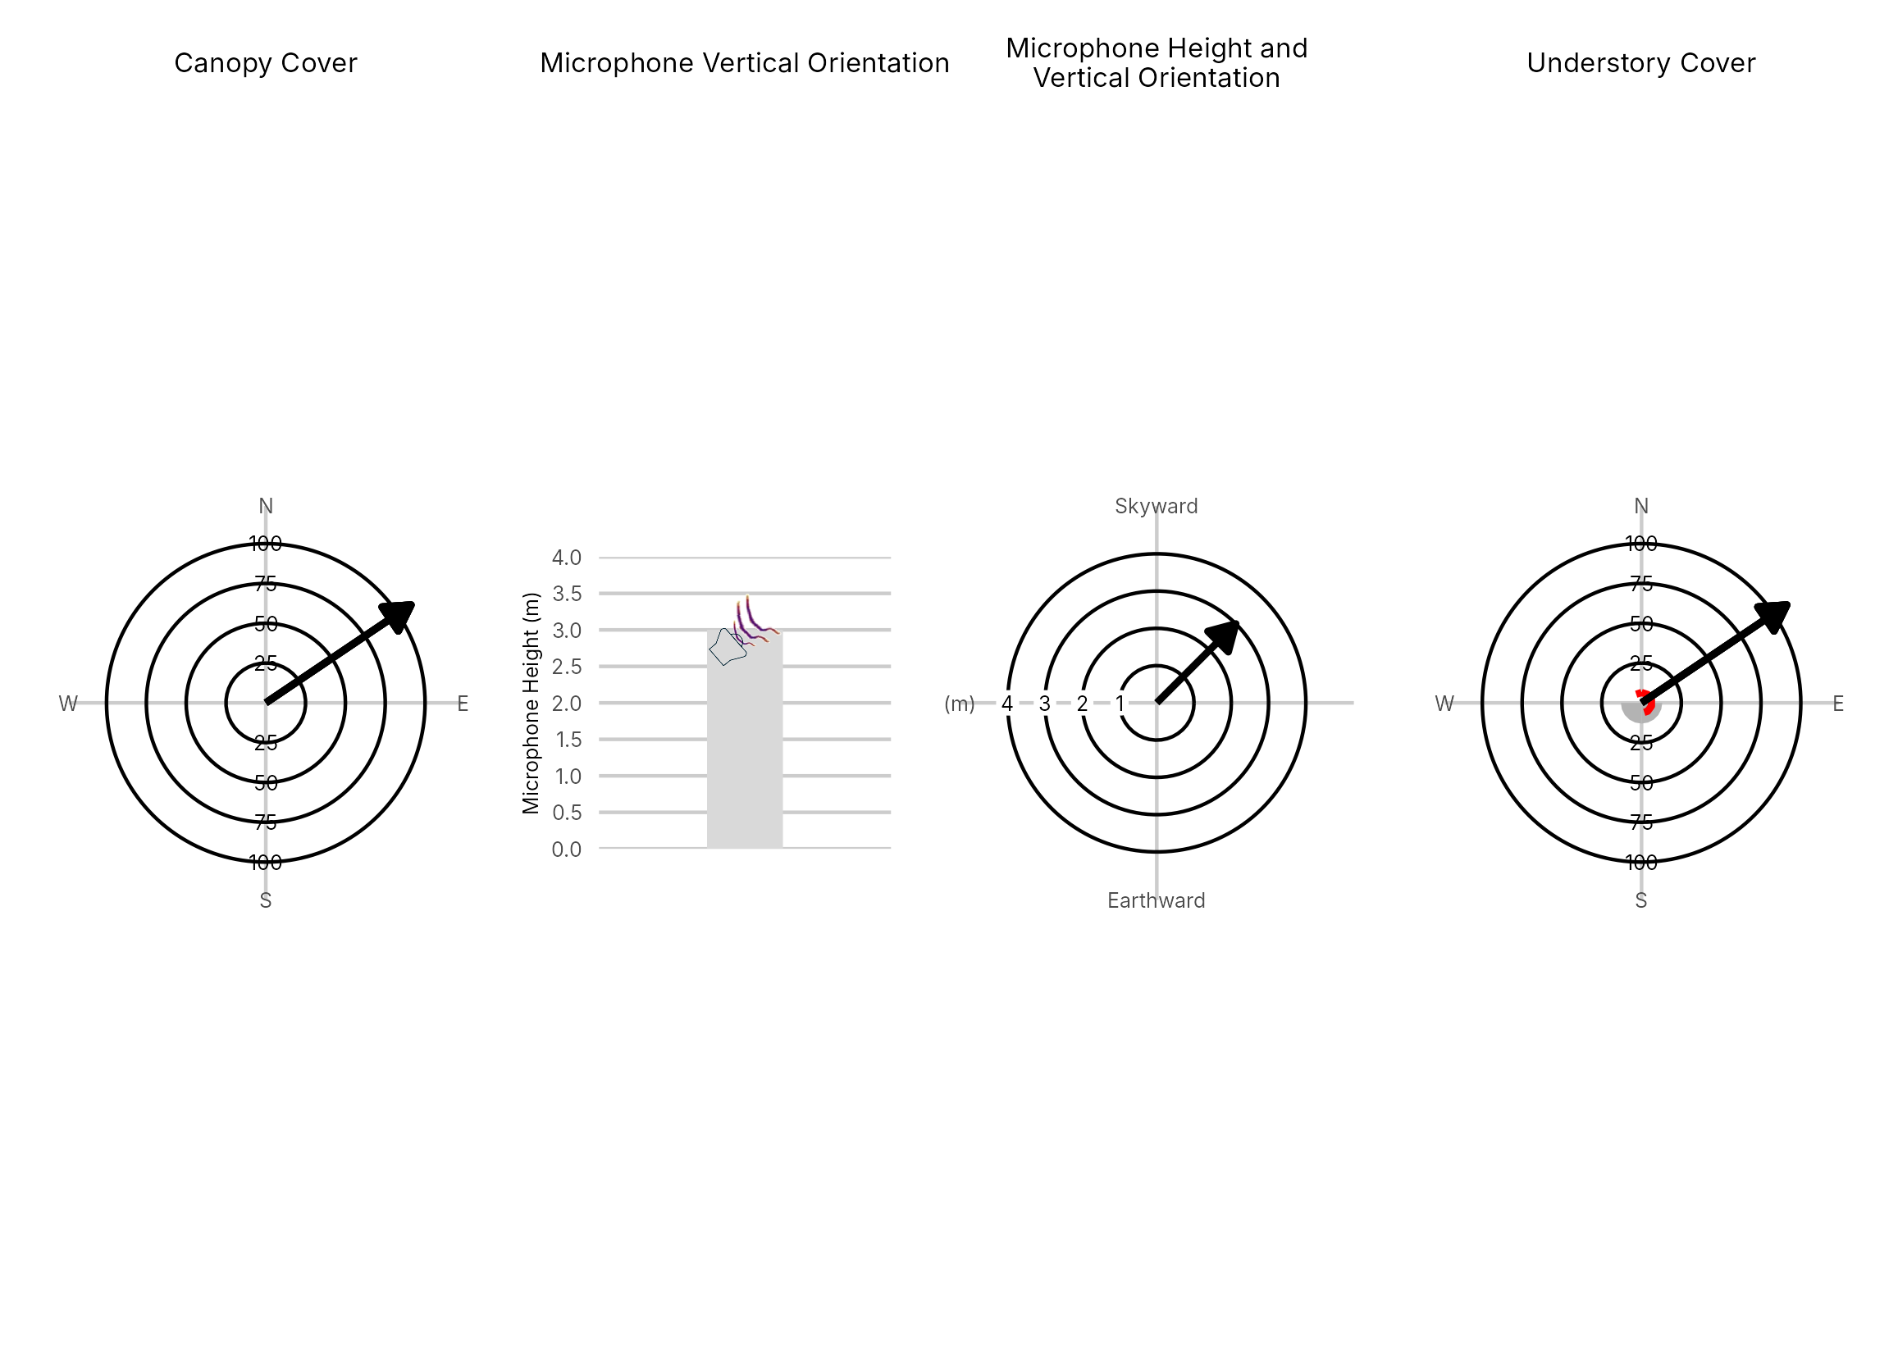

Figure 4: Percentage clutter for the understory and canopy cover at the 5175-SE1 compared with all sites within the study. Clutter was measured in each of the four 10x10m quadrants (Northeast, Southeast, Southwest and Northwest), surrounding the microphone. Percentage clutter and canopy cover categories were 0-5%, 10-25,25-50,50-75,76-95, 95-100%. The average clutter for the site was calculated by taking the meaning of the mid-point of each quadrant. The direction of the microphone is indicated by the arrow.

No SM4 log data for this site
Figure 5: ARU activity plot

 | Client: | Wildlife Management Institute
 | Client Contact: | Meghan Gilbart
 | Project Name: | Maine NABAT
 | Project Code: | MAMM-NG26-007
 | Project Manager: | Joshua Guilbert
Project Information
Name of Permitted Biologist: | Bri Frankina
Federal Permit Number: | TE63633A
Personnel*: | BRF, ECG
Habitat Assessment Dates: | 7/19/2026
First Deployment Date: | 7/19/2026
Target Recovery
Final Recovery/Last Service: | 8/18/2026
Servicing Dates: | 7/31/2026
Survey Type | Summer - Acoustic
Site Type: | Inland
Landowner Information: | Seven Islands
Site: | 5175-SW3
Site Label: | 5175-SW3
County: | Piscataquis
State: | Maine
Site Coordinates: | 46.493806, -68.899817
Detector Info:
Deployment Date: | 7/19/2026
ARU Make, Model & Serial #: | Wildlife Acoustics, SM4BatFS, S4U28491
Power Make, Model & Serial #: | Internal power, 4 x D Batteries
Microphone Make, Model & Serial: | Wildlife Acoustics, U2, MU236534
Microphone Height (m) | 3
Microphone Direction(degrees): | 303
Microphone Orientation: | 45
Status Check: Settings†: | Yes
Status Check: Hardware ‡: | Yes
Survey Schedule

Servicing Events
Date | Staff* | Action | Notes
7/31/2026 | BRF, JMG | SD cards swapped | Battery 5.7, 5 GB on Card A

Recovery Date: | 8/18/2026
ARU Make, Model & Serial #: | Wildlife Acoustics, SM4BatFS, S4U28491
Power Make, Model & Serial #: | Internal power, 4 x D Batteries
Microphone Make, Model & Serial#: | Wildlife Acoustics, U2, MU236534
Microphone Height (m) | 3
Microphone Direction (degrees): | 303
Microphone Vertical Orientation: | 45
Status Check: Settings†:
Status Check: Hardware ‡:
Survey Schedule
Notes | 5.2V, 5GB Card A

Habitat Assessment:
Assessment date: | 7/19/2026
Habitat Assessment Area: | 20m x 20m plot with mic at the center
Basic Overall Site Description: | Clearing at junction of forested roads along edge habitat
Targeted Feature for Deployment: | Forest Edge
Bat Roost Habitat: | Snags & damaged live trees
Water Resources: | Water present but not optimal
Distance Mic to Nearest Water (m):
Type of Nearest Water: | freshwater wetland
Tree Species Dominant | Spruce
Tree Species All Present (within view) | Ash, Spruce, Balsam Fir, Maple. White Pine, Red Spruce, Cherry, Sugar Maple, Birch
Understory Species Dominant | Poplar, Quaking Aspen, Spruce
Understory Species All Present (within view) | Spruce, White Spruce, Ash, Maple, Poplar, Quaking Aspen, Balsalm Fir
DBH of Surrounding Stand: | 5-15cm present
Stand Age: | Young/even aged
Understory Clutter | Semi-cluttered (cluttered but gaps present)
Microphone Distance to Clutter (m): | 3
Land Cover: | Trees present but fragmented

ARU Photos
No photo found | No photo found
Figure 1: 5175-SW3 deployment setup (Left) and microphone view (Right).
No photo found | No photo found
Figure 2: 5175-SW3 view for North (Left) and East (Right)
No photo found | No photo found
Figure 3: 5175-SW3 view for South (Left) and West (Right)
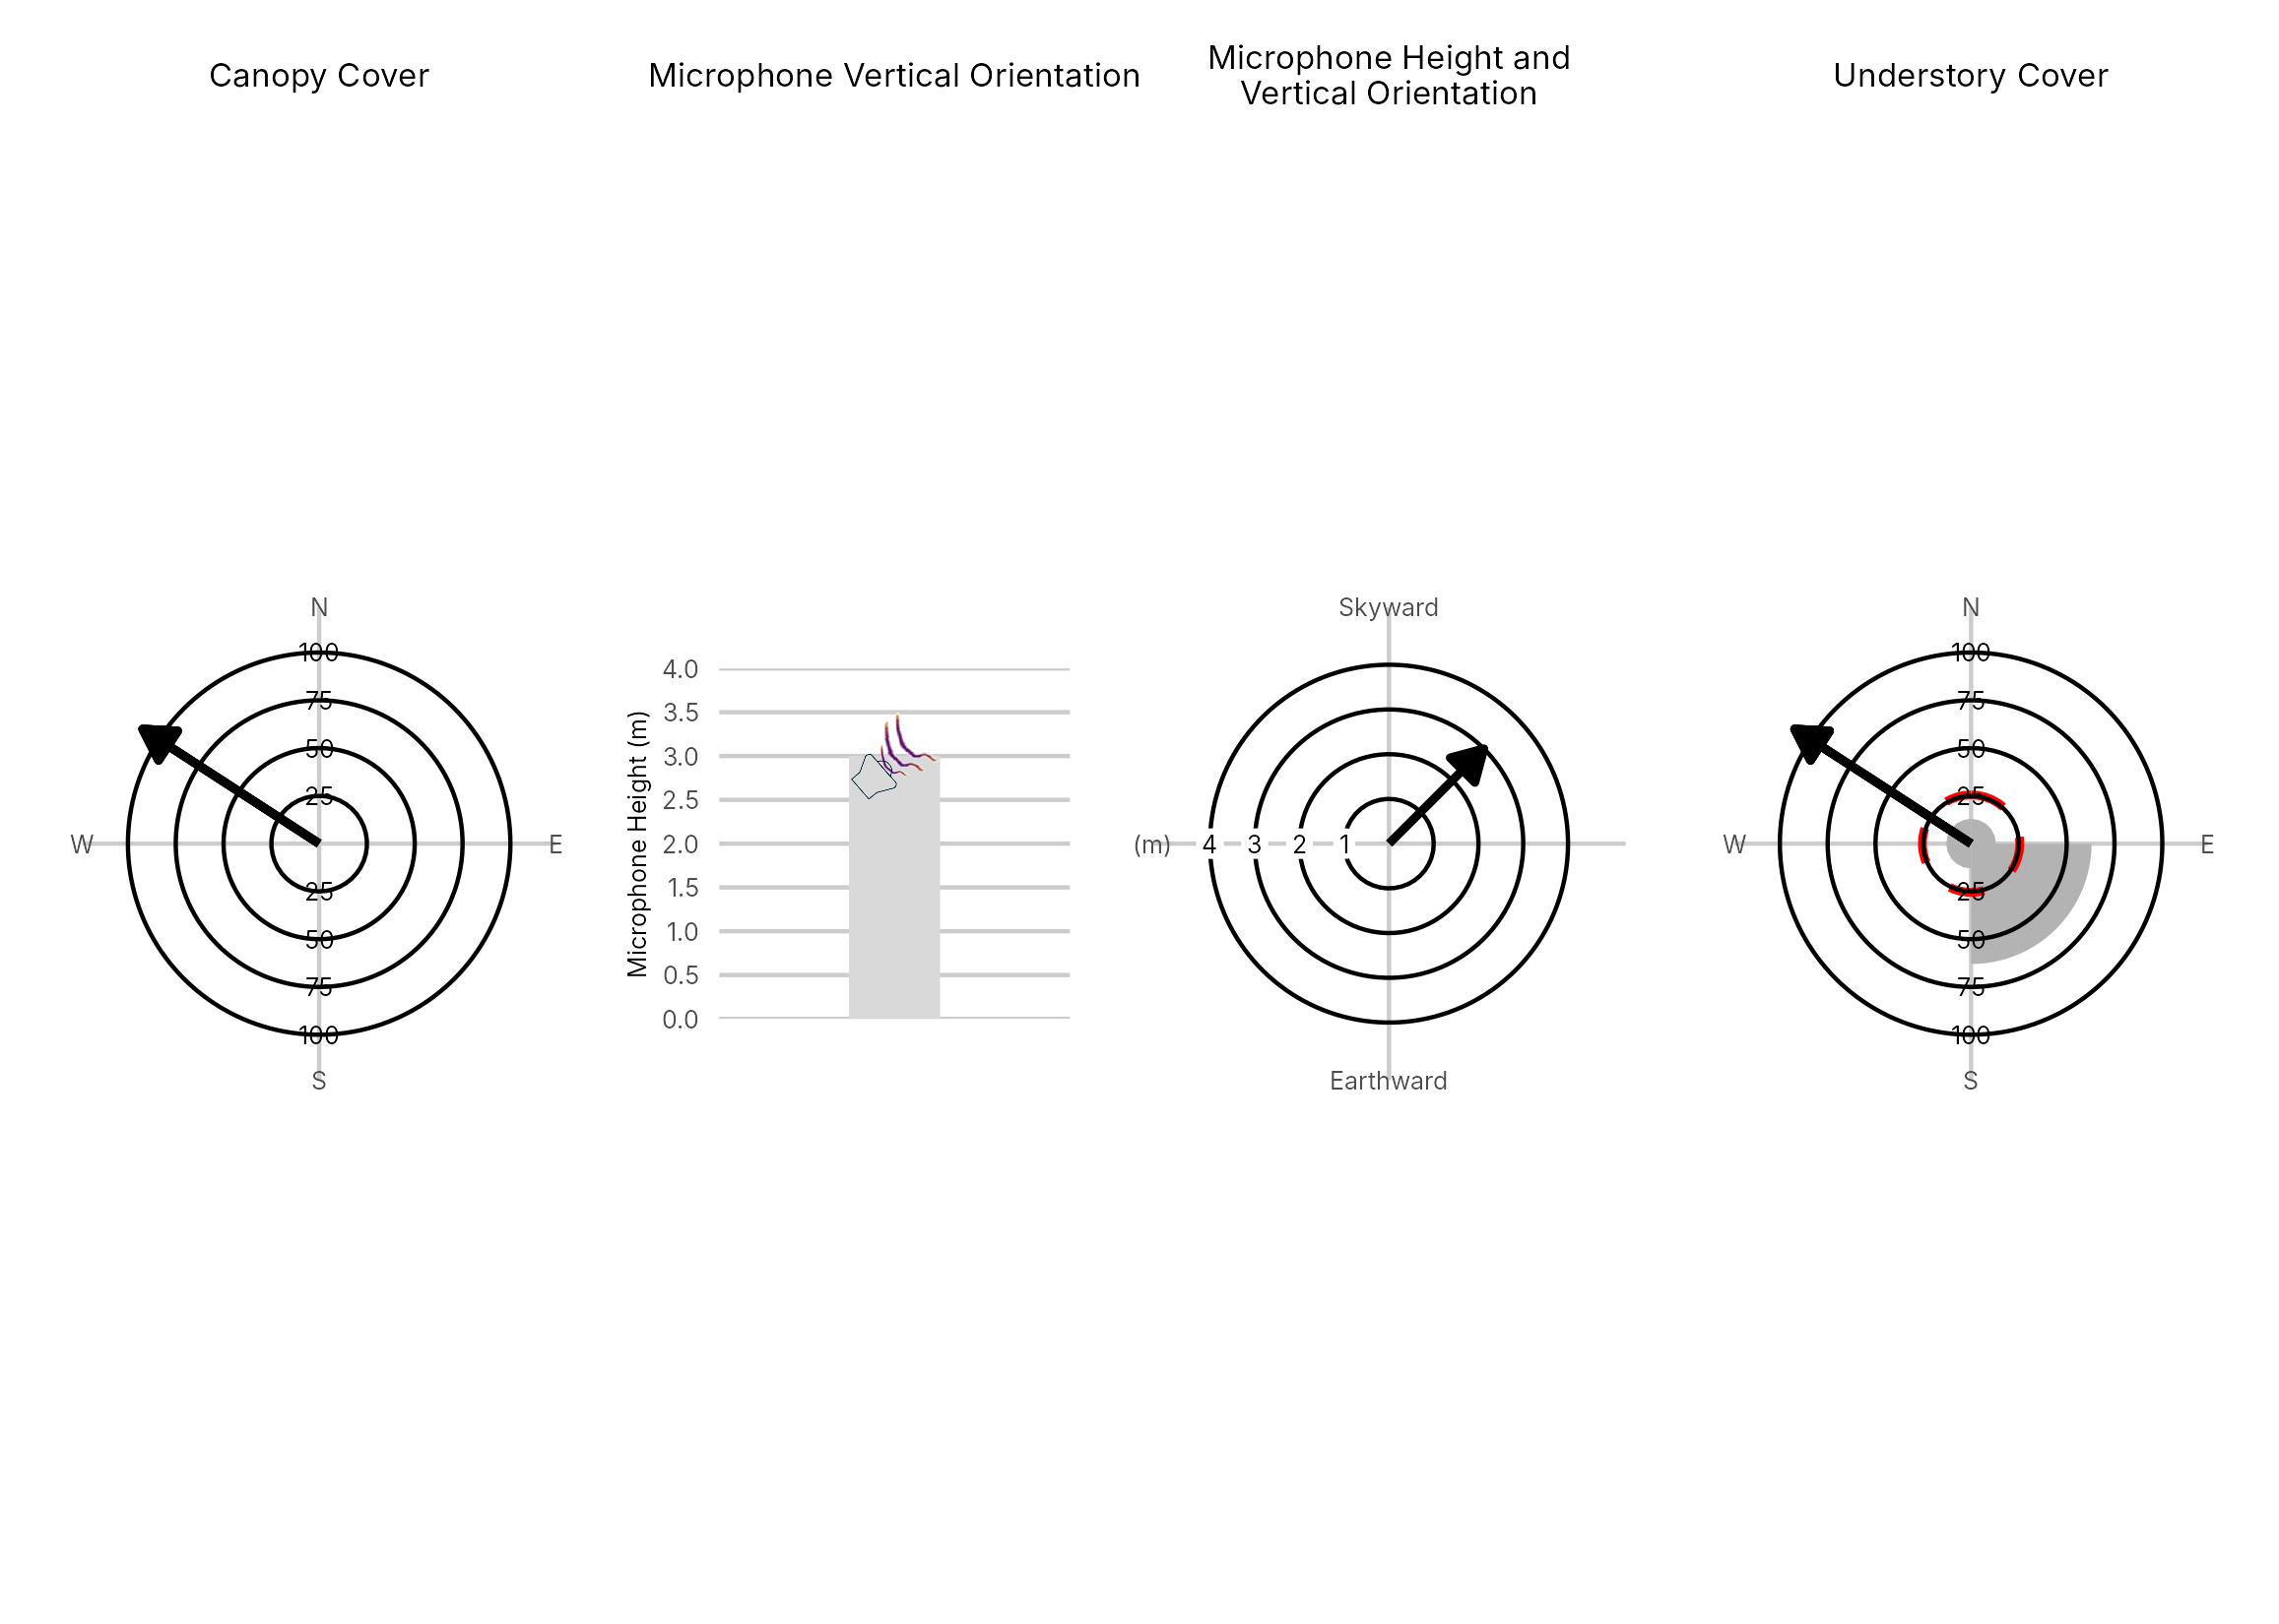

Figure 4: Percentage clutter for the understory and canopy cover at the 5175-SW3 compared with all sites within the study. Clutter was measured in each of the four 10x10m quadrants (Northeast, Southeast, Southwest and Northwest), surrounding the microphone. Percentage clutter and canopy cover categories were 0-5%, 10-25,25-50,50-75,76-95, 95-100%. The average clutter for the site was calculated by taking the meaning of the mid-point of each quadrant. The direction of the microphone is indicated by the arrow.

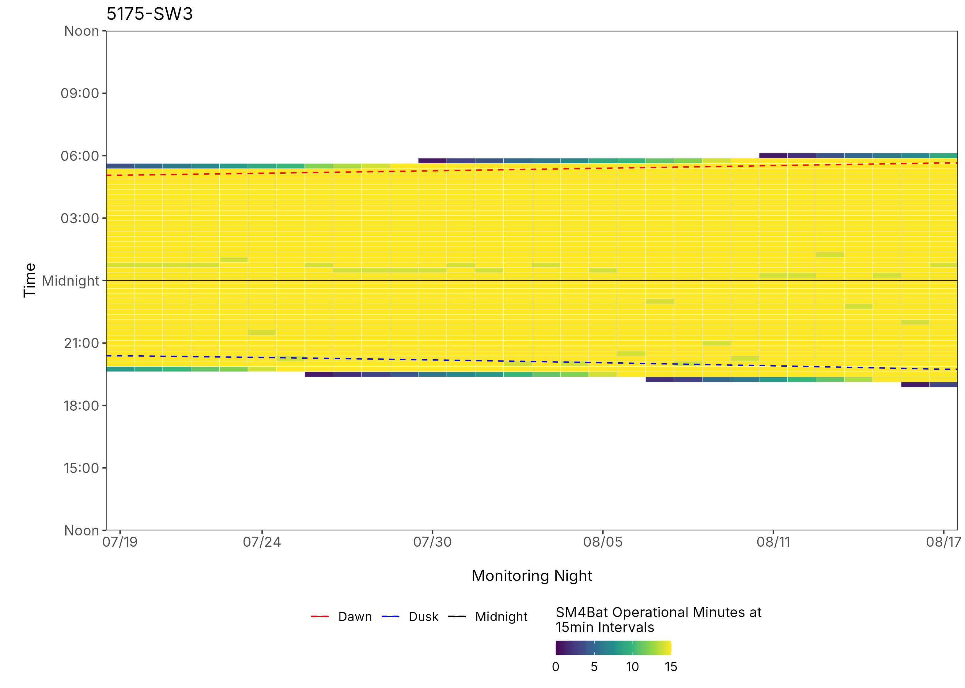
Figure 5: ARU activity plot

 | Client: | Wildlife Management Institute
 | Client Contact: | Meghan Gilbart
 | Project Name: | Maine NABAT
 | Project Code: | MAMM-NG26-007
 | Project Manager: | Joshua Guilbert
Project Information
Name of Permitted Biologist: | Josh Guilbert
Federal Permit Number: | TE63633A
Personnel*: | JMG
Habitat Assessment Dates: | 7/19/2026
First Deployment Date: | 7/19/2026
Target Recovery
Final Recovery/Last Service: | 7/31/2026
Servicing Dates: | 7/31/2026
Survey Type | Summer - Acoustic
Site Type: | Inland
Landowner Information: | Seven Islands
Site: | 55-NW1
Site Label: | 55-NW1
County: | Piscataquis
State: | Maine
Site Coordinates: | 46.386122, -68.950718
Detector Info:
Deployment Date: | 7/19/2026
ARU Make, Model & Serial #: | Wildlife Acoustics, SM4BatFS, S4U28287
Power Make, Model & Serial #: | Internal power, 4 x D Batteries
Microphone Make, Model & Serial: | Wildlife Acoustics, U2, MU221021
Microphone Height (m) | 3
Microphone Direction(degrees): | 180
Microphone Orientation: | 45
Status Check: Settings†: | Yes
Status Check: Hardware ‡: | Yes
Survey Schedule

Servicing Events
Date | Staff* | Action | Notes
7/31/2026 | BRF, JMG | SD cards swapped, Location Moved | Mic too close to clutter

Recovery Date: | No retrieval visit recorded
ARU Make, Model & Serial #:
Power Make, Model & Serial #:
Microphone Make, Model & Serial#:
Microphone Height (m)
Microphone Direction (degrees):
Microphone Vertical Orientation:
Status Check: Settings†:
Status Check: Hardware ‡:
Survey Schedule
Notes

Habitat Assessment:
Assessment date: | 7/19/2026
Habitat Assessment Area: | 20m x 20m plot with mic at the center
Basic Overall Site Description: | Edge of clearing along roadside
Targeted Feature for Deployment: | Forest Edge
Bat Roost Habitat: | Snags & damaged live trees
Water Resources: | Water present but not optimal
Distance Mic to Nearest Water (m): | 5
Type of Nearest Water: | standing or ponded freshwater
Tree Species Dominant | Maple
Tree Species All Present (within view) | Maple, Spruce, Red Maple, Quaking Aspen, Yellow Birch, Balsam Fir, Cedar, Poplar
Understory Species Dominant | Maple, Birch
Understory Species All Present (within view) | Spruce, Ash/Hickory, Sugar Maple, Maple, Birch, Balsam Fir, White Pine
DBH of Surrounding Stand: | 5-15cm present
Stand Age: | Young/even aged
Understory Clutter | Semi-cluttered (cluttered but gaps present)
Microphone Distance to Clutter (m): | 1
Land Cover: | Mostly unforested

ARU Photos
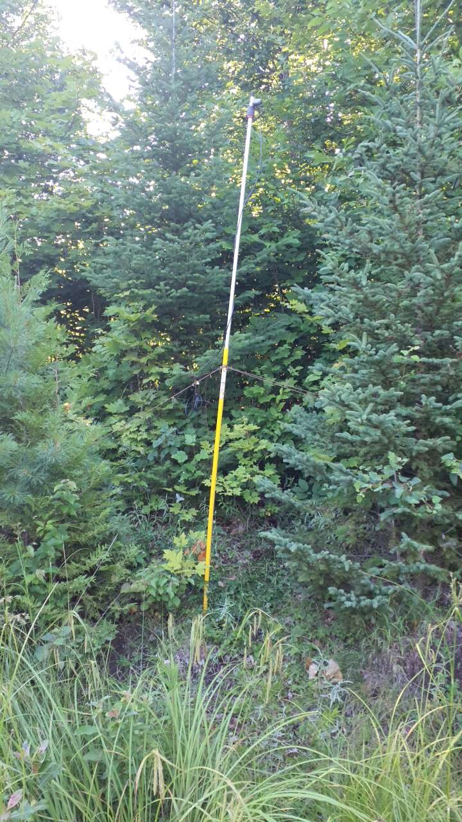 | 
Figure 1: 55-NW1 deployment setup (Left) and microphone view (Right).
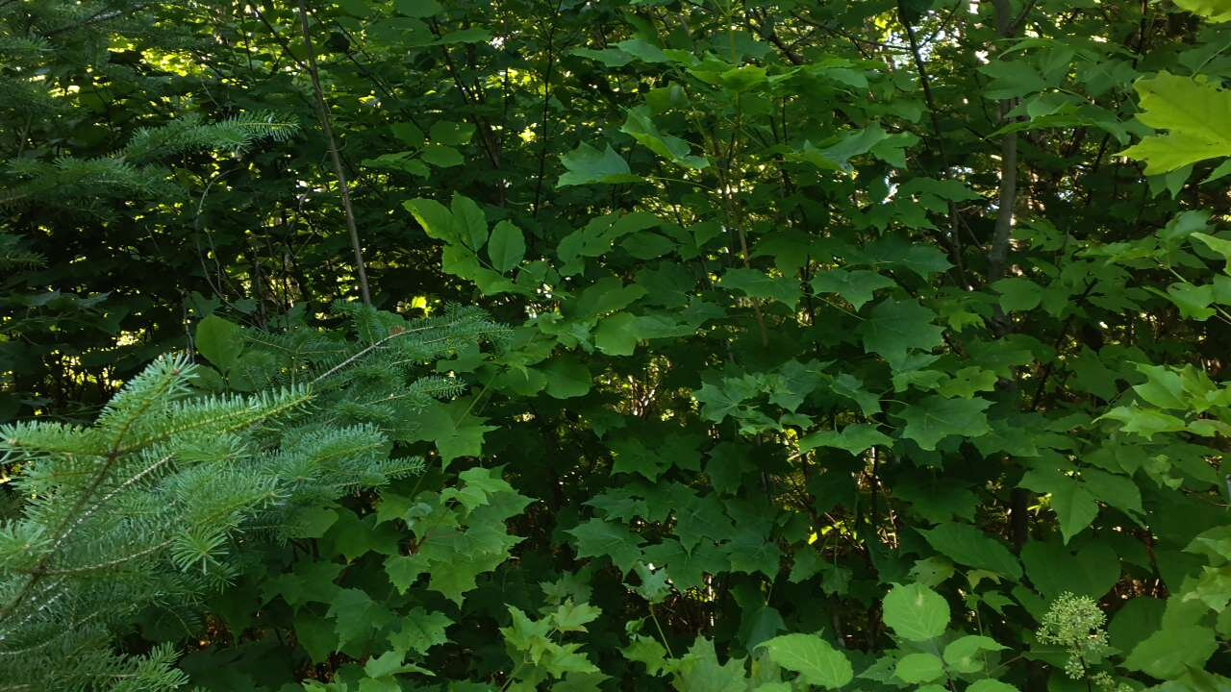 | 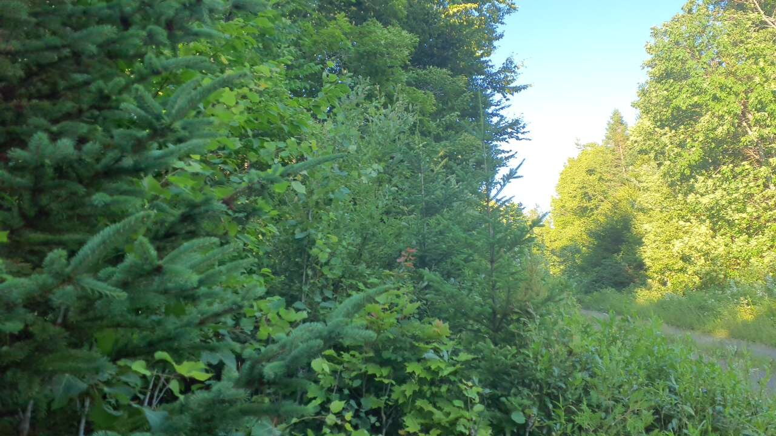
Figure 2: 55-NW1 view for North (Left) and East (Right)
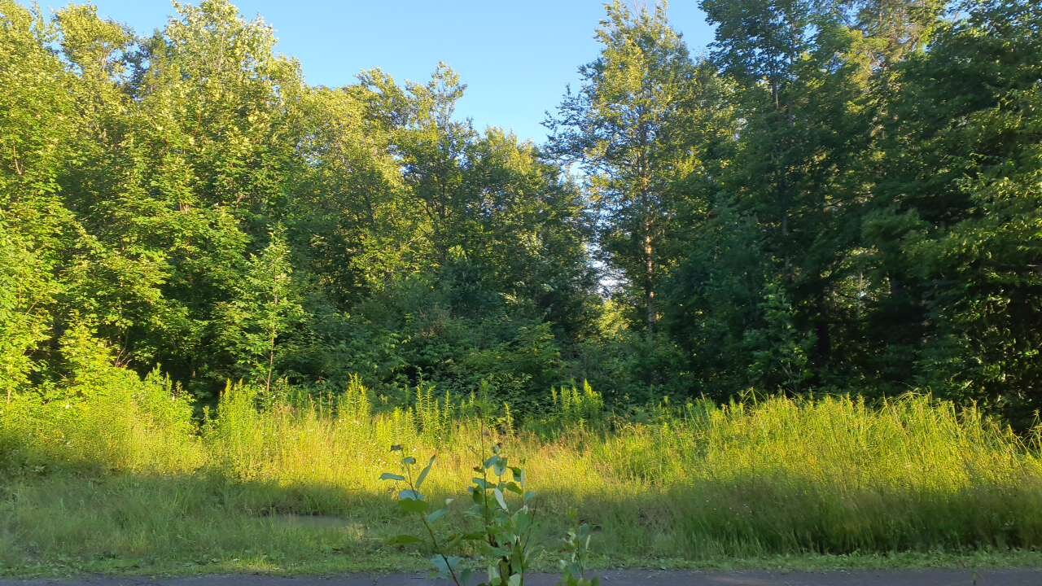 | 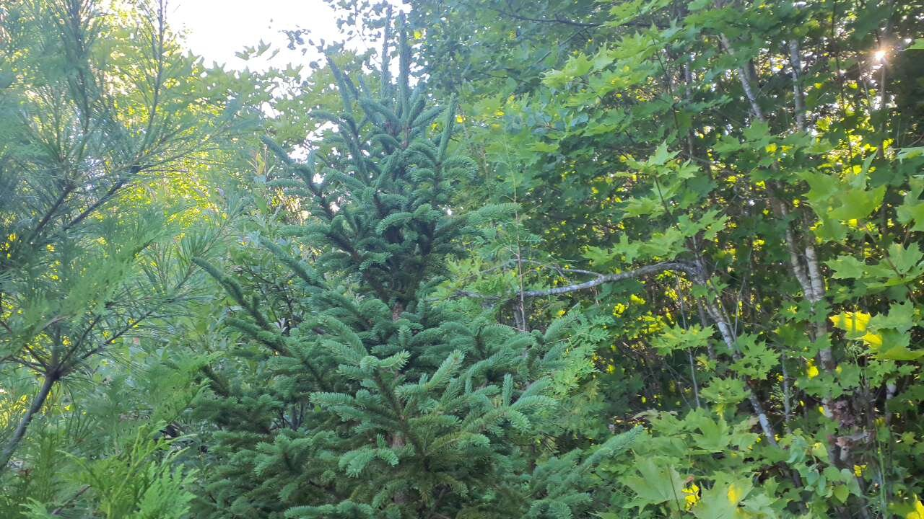
Figure 3: 55-NW1 view for South (Left) and West (Right)
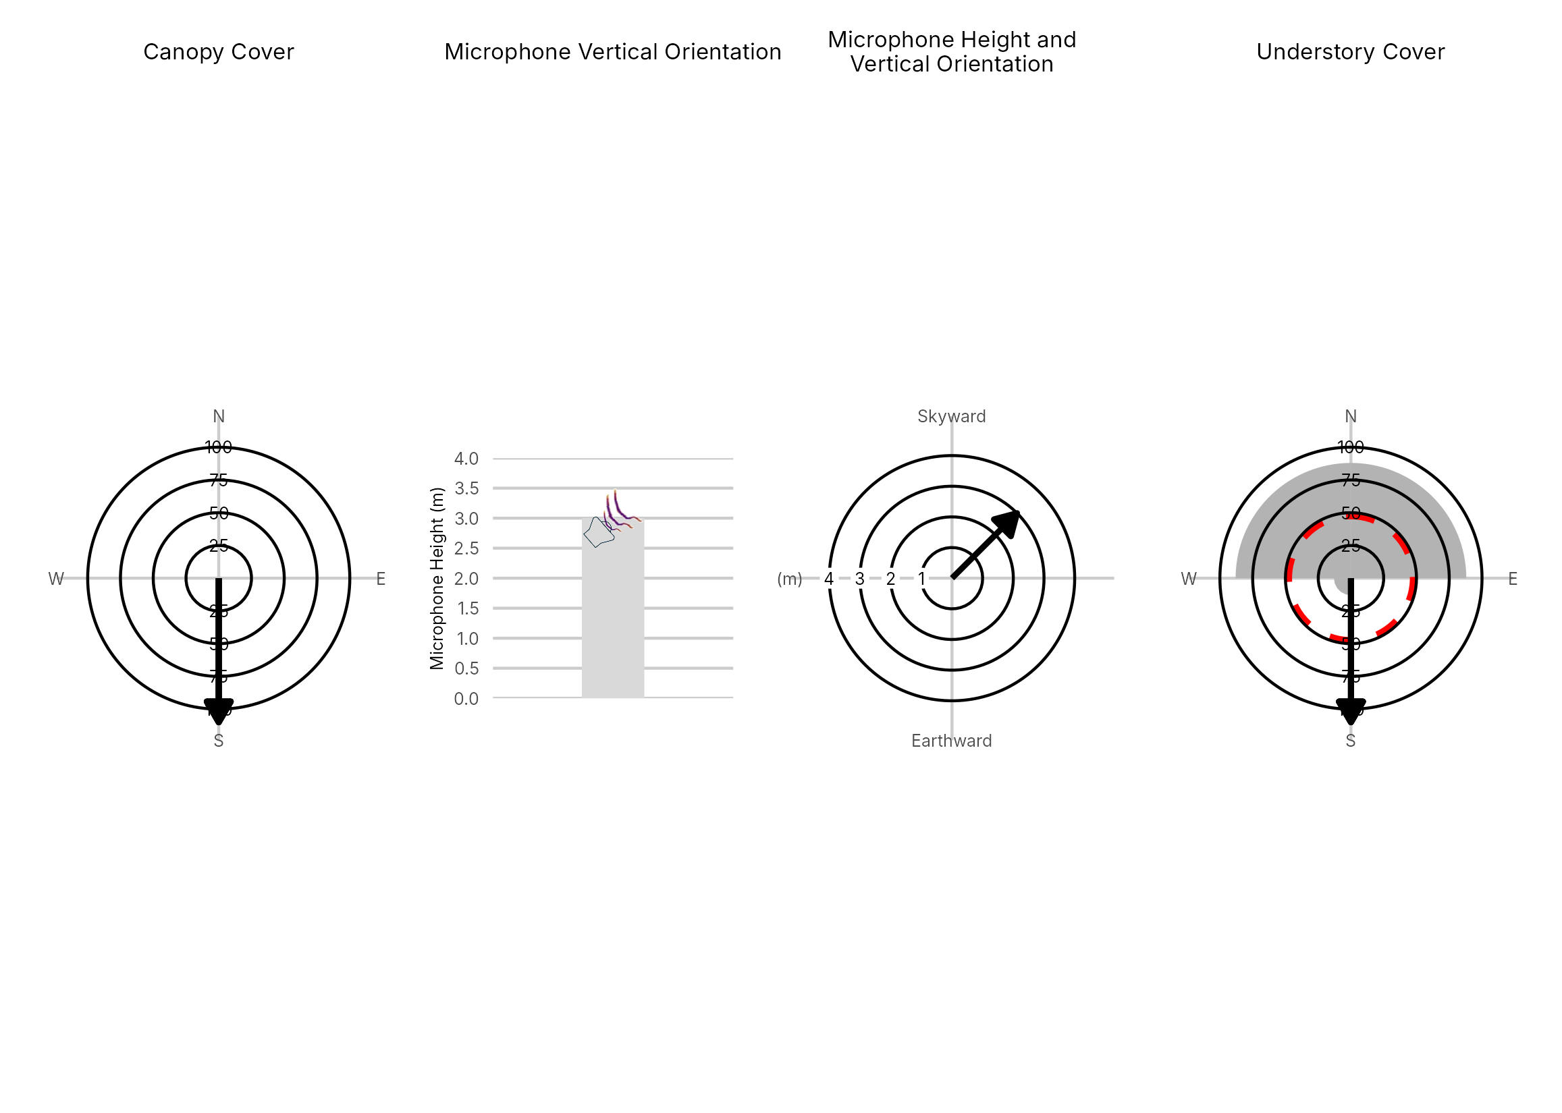

Figure 4: Percentage clutter for the understory and canopy cover at the 55-NW1 compared with all sites within the study. Clutter was measured in each of the four 10x10m quadrants (Northeast, Southeast, Southwest and Northwest), surrounding the microphone. Percentage clutter and canopy cover categories were 0-5%, 10-25,25-50,50-75,76-95, 95-100%. The average clutter for the site was calculated by taking the meaning of the mid-point of each quadrant. The direction of the microphone is indicated by the arrow.

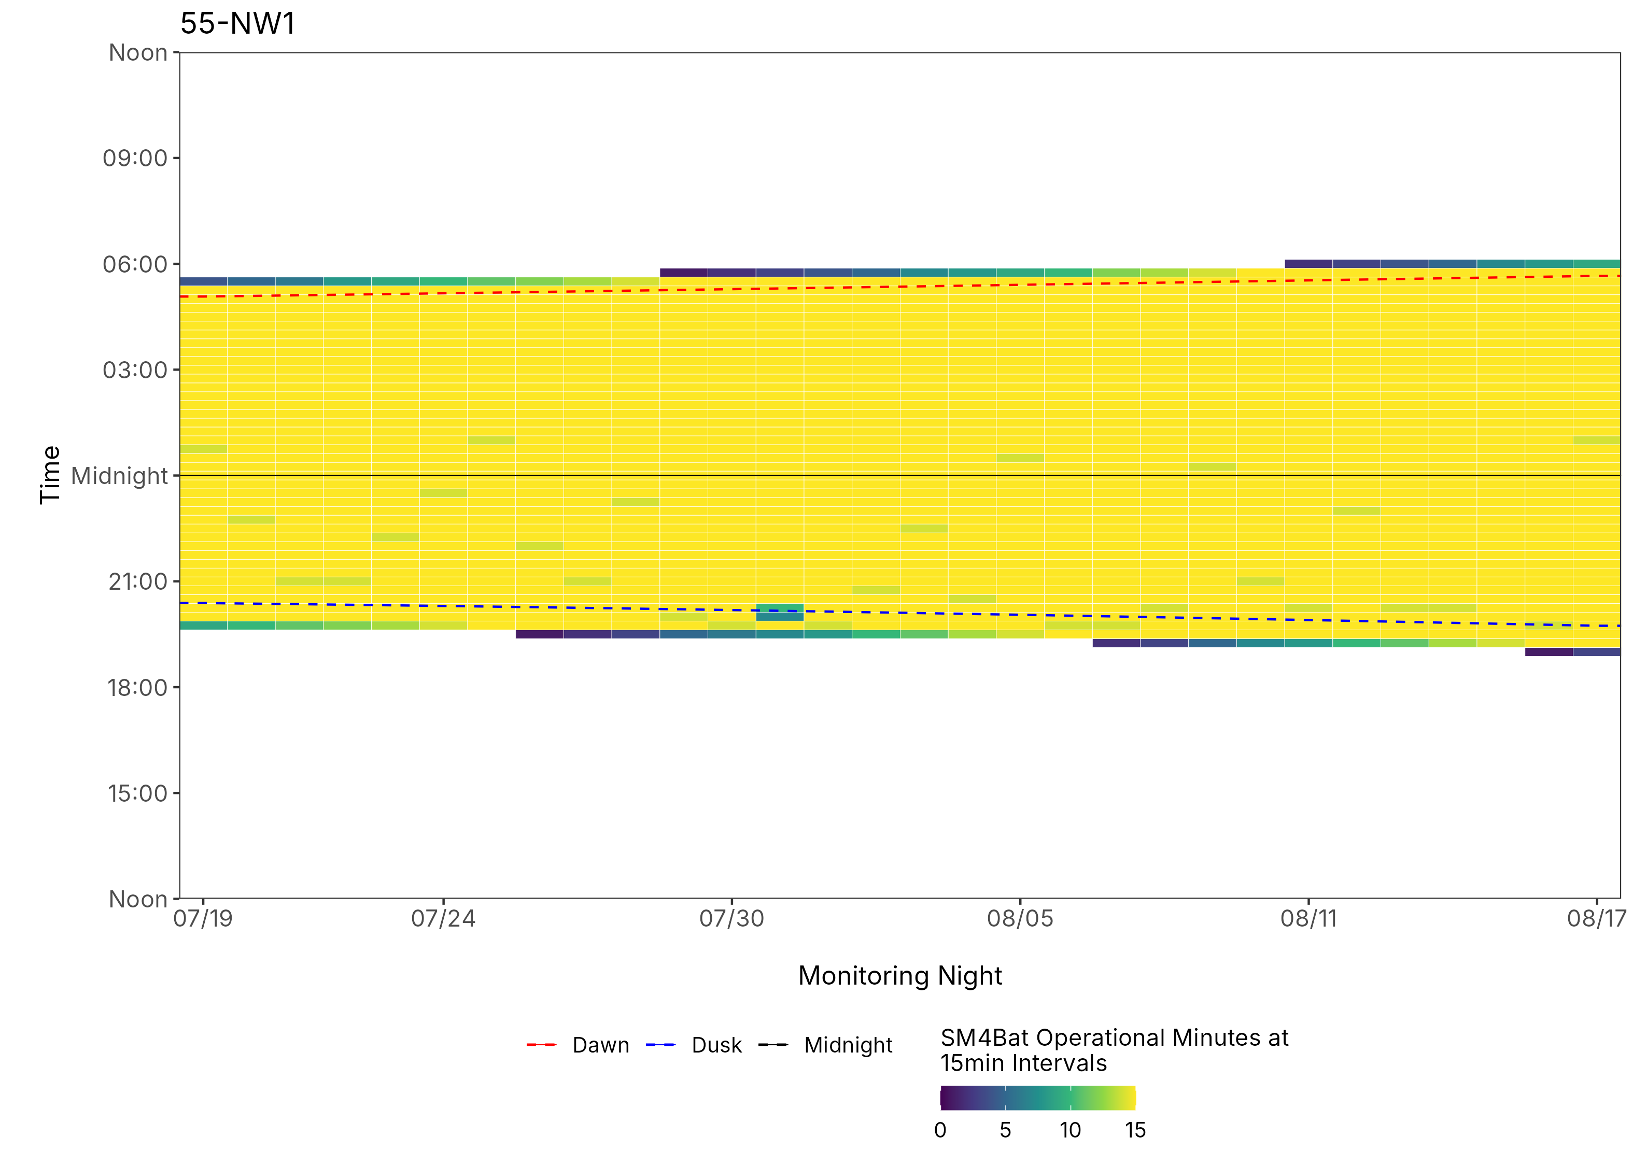
Figure 5: ARU activity plot

 | Client: | Wildlife Management Institute
 | Client Contact: | Meghan Gilbart
 | Project Name: | Maine NABAT
 | Project Code: | MAMM-NG26-007
 | Project Manager: | Joshua Guilbert
Project Information
Name of Permitted Biologist: | Josh Guilbert
Federal Permit Number: | TE63633A
Personnel*: | JMG
Habitat Assessment Dates: | 7/19/2026
First Deployment Date: | 7/19/2026
Target Recovery
Final Recovery/Last Service: | 8/18/2026
Servicing Dates: | 7/31/2026
Survey Type | Summer - Acoustic
Site Type: | Inland
Landowner Information: | Seven islamss
Site: | 55-NW3
Site Label: | 55-NW3
County: | Piscataquis
State: | Maine
Site Coordinates: | 46.360392, -68.955346
Detector Info:
Deployment Date: | 7/19/2026
ARU Make, Model & Serial #: | Wildlife Acoustics, SM4BatFS, S4U28473
Power Make, Model & Serial #: | Internal power, 4 x D Batteries
Microphone Make, Model & Serial: | Wildlife Acoustics, U2, MU236532
Microphone Height (m) | 3
Microphone Direction(degrees): | 60
Microphone Orientation: | 45
Status Check: Settings†: | Yes
Status Check: Hardware ‡: | Yes
Survey Schedule

Servicing Events
Date | Staff* | Action | Notes
7/31/2026 | BRF, JMG | SD cards swapped | Battery 5.6, 3 GB card A.

Recovery Date: | 8/18/2026
ARU Make, Model & Serial #: | Wildlife Acoustics, SM4BatFS, S4U28473
Power Make, Model & Serial #: | Internal power, 4 x D Batteries
Microphone Make, Model & Serial#: | Wildlife Acoustics, U2, MU236532
Microphone Height (m) | 3
Microphone Direction (degrees): | 60
Microphone Vertical Orientation: | 45
Status Check: Settings†:
Status Check: Hardware ‡:
Survey Schedule
Notes | 5V, 25 GB on Card A

Habitat Assessment:
Assessment date: | 7/19/2026
Habitat Assessment Area: | 20m x 20m plot with mic at the center
Basic Overall Site Description: | Edge of clearing along roadside
Targeted Feature for Deployment: | Forest Edge
Bat Roost Habitat: | Snags & damaged live trees
Water Resources: | No water resources present at site
Distance Mic to Nearest Water (m): | 2
Type of Nearest Water:
Tree Species Dominant | Quaking Aspen, Spruce
Tree Species All Present (within view) | Spruce, Quaking Aspen, Yellow Birch, Red Maple, Cedar, Balsam Fir
Understory Species Dominant | Maple, Aspen
Understory Species All Present (within view) | Maple, Aspen, Ash
DBH of Surrounding Stand: | 5-15cm present
Stand Age: | Some diversity in stand
Understory Clutter | Minimal clutter (open understory facilitates flight)
Microphone Distance to Clutter (m): | 2
Land Cover: | Mostly unforested

ARU Photos
No photo found | No photo found
Figure 1: 55-NW3 deployment setup (Left) and microphone view (Right).
No photo found | No photo found
Figure 2: 55-NW3 view for North (Left) and East (Right)
No photo found | No photo found
Figure 3: 55-NW3 view for South (Left) and West (Right)
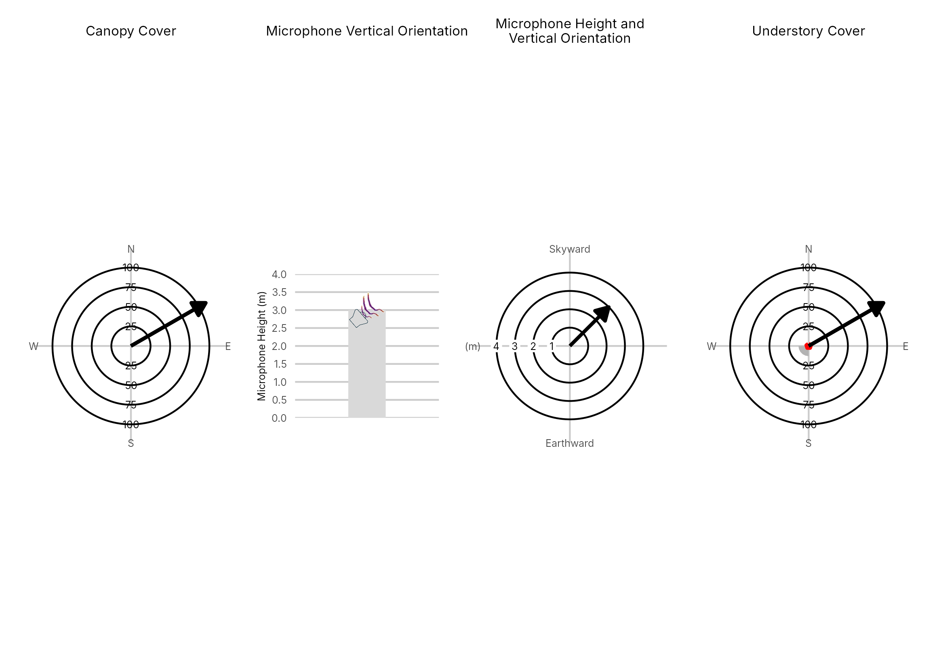

Figure 4: Percentage clutter for the understory and canopy cover at the 55-NW3 compared with all sites within the study. Clutter was measured in each of the four 10x10m quadrants (Northeast, Southeast, Southwest and Northwest), surrounding the microphone. Percentage clutter and canopy cover categories were 0-5%, 10-25,25-50,50-75,76-95, 95-100%. The average clutter for the site was calculated by taking the meaning of the mid-point of each quadrant. The direction of the microphone is indicated by the arrow.

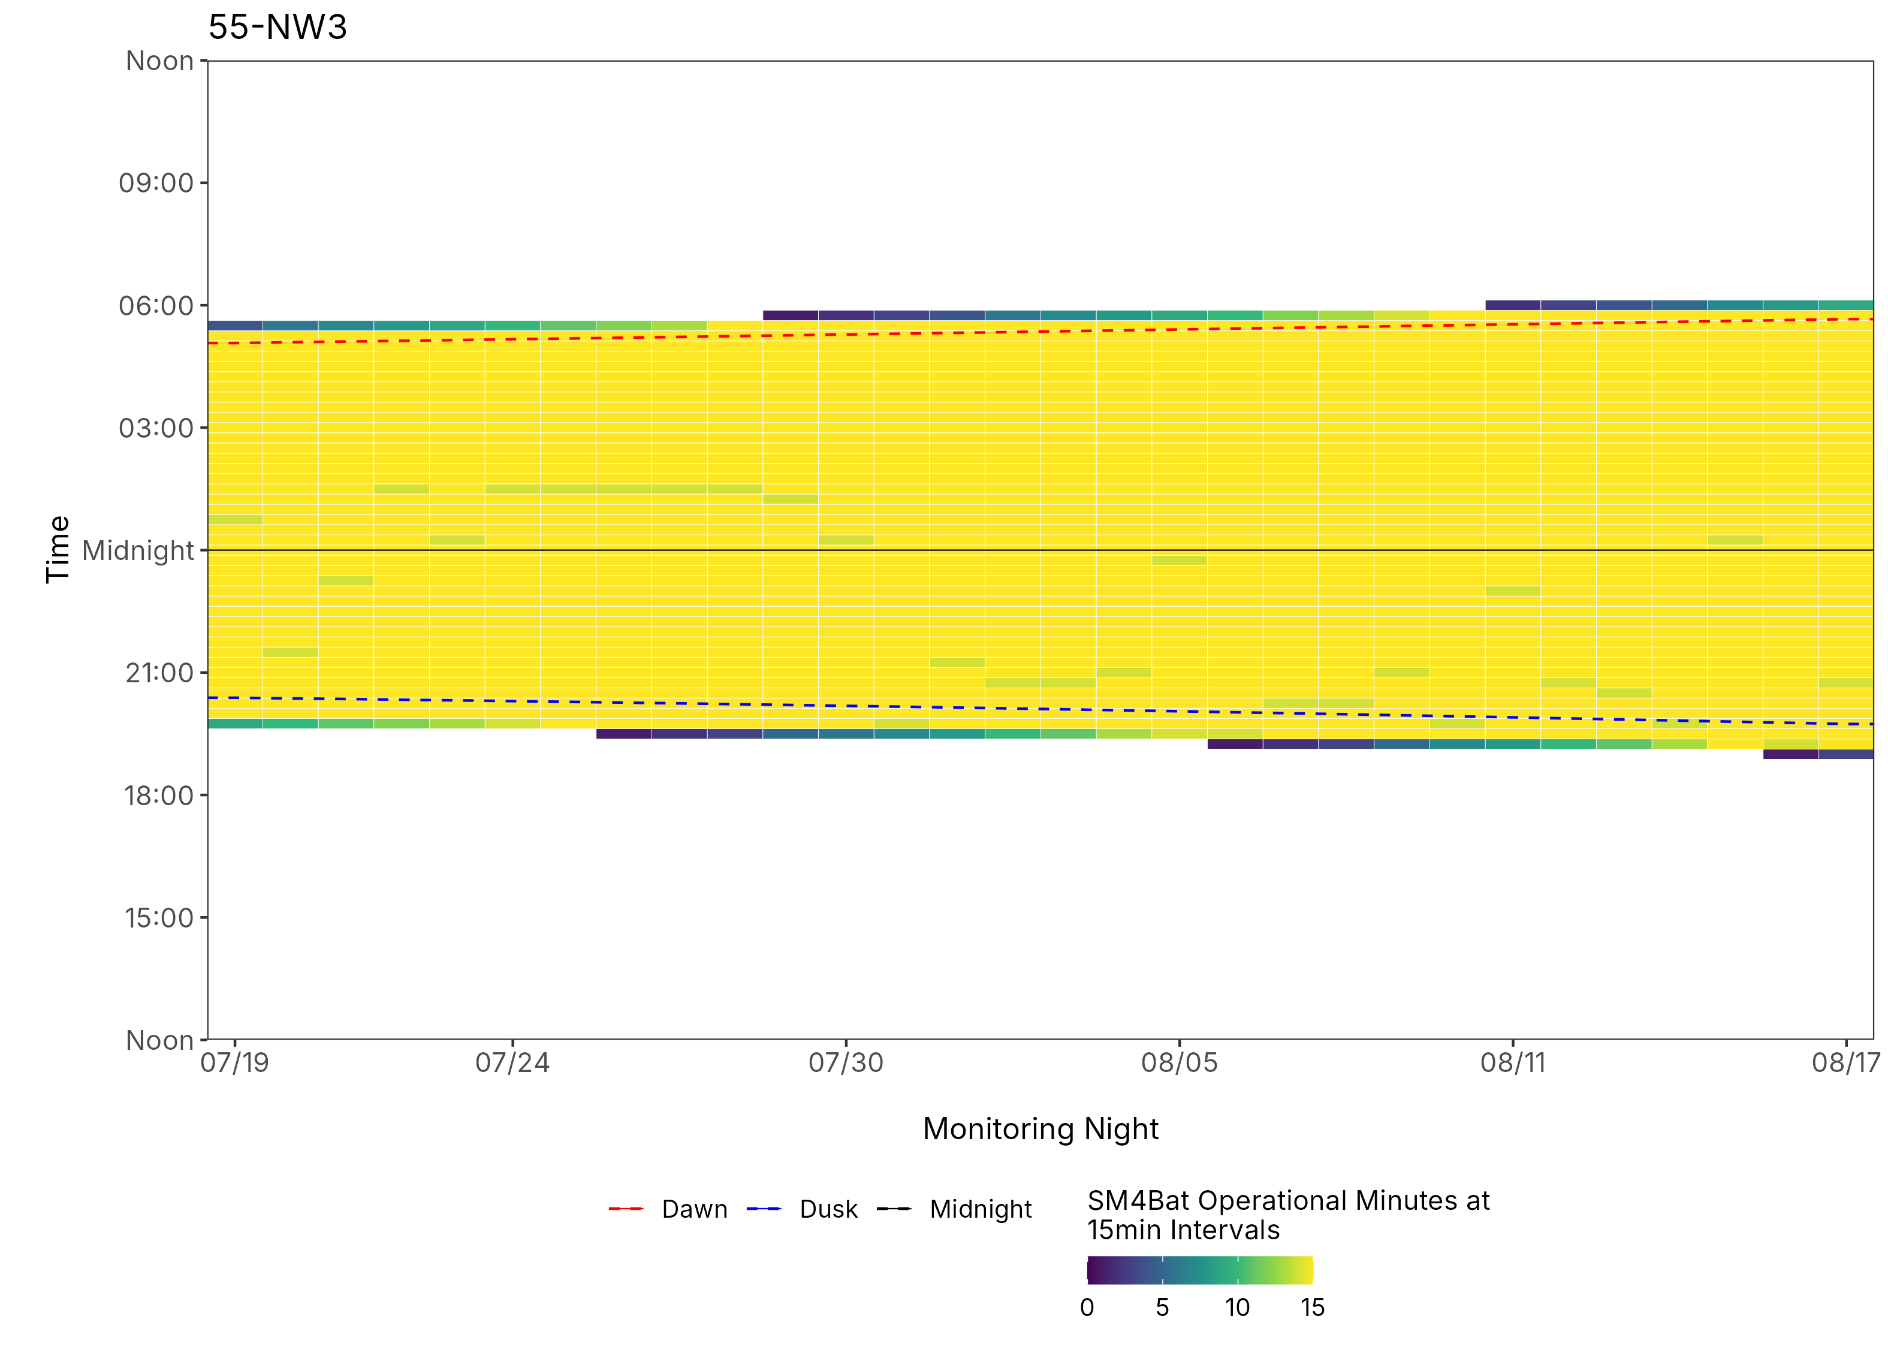
Figure 5: ARU activity plot

 | Client: | Wildlife Management Institute
 | Client Contact: | Meghan Gilbart
 | Project Name: | Maine NABAT
 | Project Code: | MAMM-NG26-007
 | Project Manager: | Joshua Guilbert
Project Information
Name of Permitted Biologist: | Josh Guilbert
Federal Permit Number: | TE63633A
Personnel*: | JMG
Habitat Assessment Dates: | 7/19/2026
First Deployment Date: | 7/19/2026
Target Recovery
Final Recovery/Last Service: | 8/18/2026
Servicing Dates: | 7/31/2026
Survey Type | Summer - Acoustic
Site Type: | Inland
Landowner Information: | Seven Islands
Site: | 55-SW1
Site Label: | 55-SW1
County: | Piscataquis
State: | Maine
Site Coordinates: | 46.321142, -68.967661
Detector Info:
Deployment Date: | 7/19/2026
ARU Make, Model & Serial #: | Wildlife Acoustics, SM4BatFS, S4U28289
Power Make, Model & Serial #: | Internal power, 4 x D Batteries
Microphone Make, Model & Serial: | MU236246
Microphone Height (m) | 3
Microphone Direction(degrees): | 60
Microphone Orientation: | 45
Status Check: Settings†: | Yes
Status Check: Hardware ‡: | Yes
Survey Schedule

Servicing Events
Date | Staff* | Action | Notes
7/31/2026 | BRF, JMG | SD cards swapped | Battery 5.7, 4 GB on Card A.

Recovery Date: | 8/18/2026
ARU Make, Model & Serial #: | Wildlife Acoustics, SM4BatFS, S4U28289
Power Make, Model & Serial #: | Internal power, 4 x D Batteries
Microphone Make, Model & Serial#: | Wildlife Acoustics, U2, MU236346
Microphone Height (m) | 3
Microphone Direction (degrees): | 60
Microphone Vertical Orientation: | 45
Status Check: Settings†:
Status Check: Hardware ‡:
Survey Schedule
Notes | 5.1 V, 6GB Card A

Habitat Assessment:
Assessment date: | 7/19/2026
Habitat Assessment Area: | 20m x 20m plot with mic at the center
Basic Overall Site Description: | Forest logging road
Targeted Feature for Deployment: | Forest Edge
Bat Roost Habitat: | Snags & damaged live trees
Water Resources: | No water resources present at site
Distance Mic to Nearest Water (m): | 200
Type of Nearest Water: | freshwater wetland
Tree Species Dominant | Spruce
Tree Species All Present (within view) | Red Maple, Spruce, White Pine, Quaking Aspen, White Birch, Balsam Fir, Yellow Birch, Striped Maple, Red Spruce
Understory Species Dominant | Spruce, Maple, Cedar
Understory Species All Present (within view) | Cedar, Red Spruce, Spruce, Maple
DBH of Surrounding Stand: | 5-15cm present
Stand Age: | Some diversity in stand
Understory Clutter | Semi-cluttered (cluttered but gaps present)
Microphone Distance to Clutter (m): | 5
Land Cover: | Mostly Forested

ARU Photos
No photo found | No photo found
Figure 1: 55-SW1 deployment setup (Left) and microphone view (Right).
No photo found | No photo found
Figure 2: 55-SW1 view for North (Left) and East (Right)
No photo found | No photo found
Figure 3: 55-SW1 view for South (Left) and West (Right)
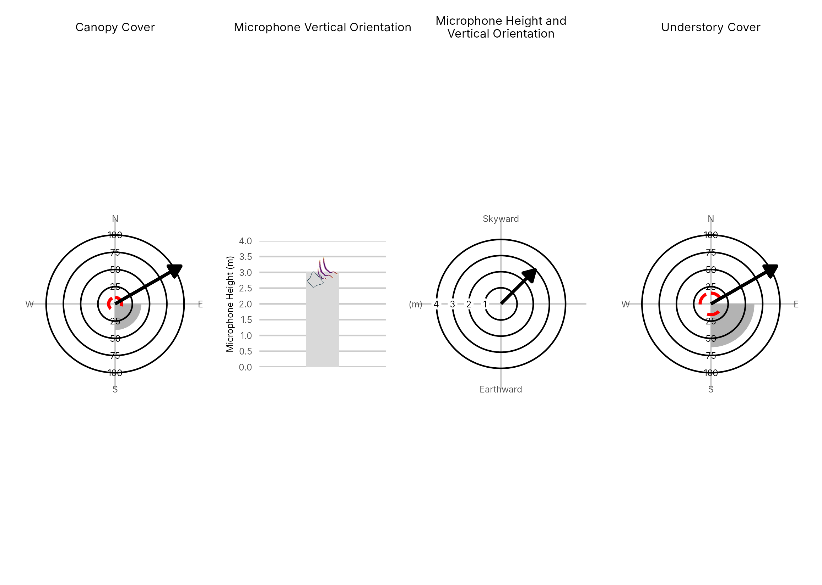

Figure 4: Percentage clutter for the understory and canopy cover at the 55-SW1 compared with all sites within the study. Clutter was measured in each of the four 10x10m quadrants (Northeast, Southeast, Southwest and Northwest), surrounding the microphone. Percentage clutter and canopy cover categories were 0-5%, 10-25,25-50,50-75,76-95, 95-100%. The average clutter for the site was calculated by taking the meaning of the mid-point of each quadrant. The direction of the microphone is indicated by the arrow.

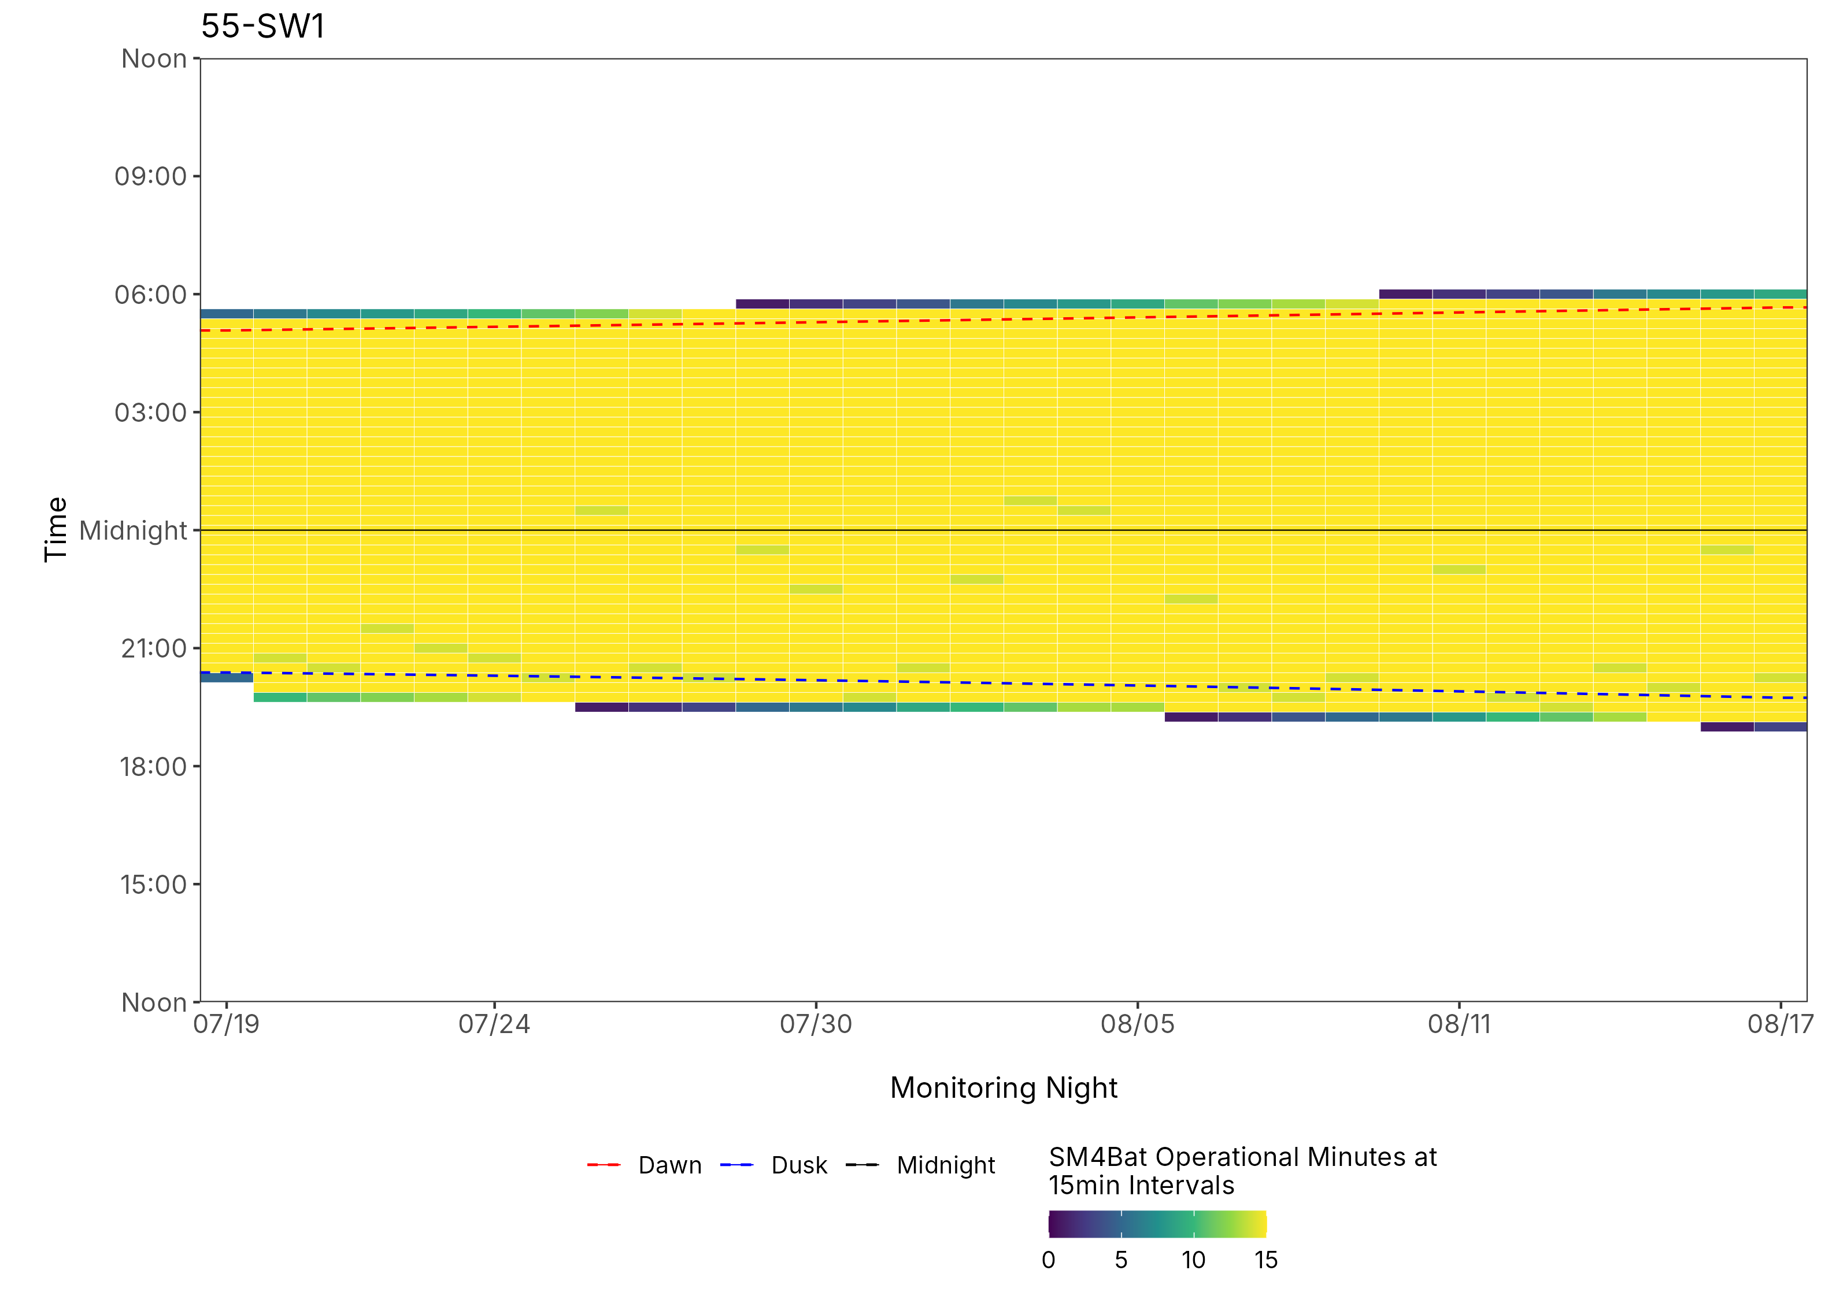
Figure 5: ARU activity plot

* BRF, Bri Frankina, ECG, Ethan Gilardi, JMG, Josh Guilbert; NAF, Nate Fuller, Client;
† Timezone, date, time and recording window all correct.
‡ Microphone reading connected, SD cards formatted & ready
* BRF, Bri Frankina, ECG, Ethan Gilardi, JMG, Josh Guilbert; NAF, Nate Fuller, Client;
† Timezone, date, time and recording window all correct.
‡ Microphone reading connected, SD cards formatted & ready
* BRF, Bri Frankina, ECG, Ethan Gilardi, JMG, Josh Guilbert; NAF, Nate Fuller, Client;
† Timezone, date, time and recording window all correct.
‡ Microphone reading connected, SD cards formatted & ready
* BRF, Bri Frankina, ECG, Ethan Gilardi, JMG, Josh Guilbert; NAF, Nate Fuller, Client;
† Timezone, date, time and recording window all correct.
‡ Microphone reading connected, SD cards formatted & ready
* BRF, Bri Frankina, ECG, Ethan Gilardi, JMG, Josh Guilbert; NAF, Nate Fuller, Client;
† Timezone, date, time and recording window all correct.
‡ Microphone reading connected, SD cards formatted & ready
* BRF, Bri Frankina, ECG, Ethan Gilardi, JMG, Josh Guilbert; NAF, Nate Fuller, Client;
† Timezone, date, time and recording window all correct.
‡ Microphone reading connected, SD cards formatted & ready
* BRF, Bri Frankina, ECG, Ethan Gilardi, JMG, Josh Guilbert; NAF, Nate Fuller, Client;
† Timezone, date, time and recording window all correct.
‡ Microphone reading connected, SD cards formatted & ready
* BRF, Bri Frankina, ECG, Ethan Gilardi, JMG, Josh Guilbert; NAF, Nate Fuller, Client;
† Timezone, date, time and recording window all correct.
‡ Microphone reading connected, SD cards formatted & ready
* BRF, Bri Frankina, ECG, Ethan Gilardi, JMG, Josh Guilbert; NAF, Nate Fuller, Client;
† Timezone, date, time and recording window all correct.
‡ Microphone reading connected, SD cards formatted & ready
* BRF, Bri Frankina, ECG, Ethan Gilardi, JMG, Josh Guilbert; NAF, Nate Fuller, Client;
† Timezone, date, time and recording window all correct.
‡ Microphone reading connected, SD cards formatted & ready
* BRF, Bri Frankina, ECG, Ethan Gilardi, JMG, Josh Guilbert; NAF, Nate Fuller, Client;
† Timezone, date, time and recording window all correct.
‡ Microphone reading connected, SD cards formatted & ready
* BRF, Bri Frankina, ECG, Ethan Gilardi, JMG, Josh Guilbert; NAF, Nate Fuller, Client;
† Timezone, date, time and recording window all correct.
‡ Microphone reading connected, SD cards formatted & ready
* BRF, Bri Frankina, ECG, Ethan Gilardi, JMG, Josh Guilbert; NAF, Nate Fuller, Client;
† Timezone, date, time and recording window all correct.
‡ Microphone reading connected, SD cards formatted & ready
* BRF, Bri Frankina, ECG, Ethan Gilardi, JMG, Josh Guilbert; NAF, Nate Fuller, Client;
† Timezone, date, time and recording window all correct.
‡ Microphone reading connected, SD cards formatted & ready
* BRF, Bri Frankina, ECG, Ethan Gilardi, JMG, Josh Guilbert; NAF, Nate Fuller, Client;
† Timezone, date, time and recording window all correct.
‡ Microphone reading connected, SD cards formatted & ready
* BRF, Bri Frankina, ECG, Ethan Gilardi, JMG, Josh Guilbert; NAF, Nate Fuller, Client;
† Timezone, date, time and recording window all correct.
‡ Microphone reading connected, SD cards formatted & ready
* BRF, Bri Frankina, ECG, Ethan Gilardi, JMG, Josh Guilbert; NAF, Nate Fuller, Client;
† Timezone, date, time and recording window all correct.
‡ Microphone reading connected, SD cards formatted & ready
* BRF, Bri Frankina, ECG, Ethan Gilardi, JMG, Josh Guilbert; NAF, Nate Fuller, Client;
† Timezone, date, time and recording window all correct.
‡ Microphone reading connected, SD cards formatted & ready
* BRF, Bri Frankina, ECG, Ethan Gilardi, JMG, Josh Guilbert; NAF, Nate Fuller, Client;
† Timezone, date, time and recording window all correct.
‡ Microphone reading connected, SD cards formatted & ready
* BRF, Bri Frankina, ECG, Ethan Gilardi, JMG, Josh Guilbert; NAF, Nate Fuller, Client;
† Timezone, date, time and recording window all correct.
‡ Microphone reading connected, SD cards formatted & ready
* BRF, Bri Frankina, ECG, Ethan Gilardi, JMG, Josh Guilbert; NAF, Nate Fuller, Client;
† Timezone, date, time and recording window all correct.
‡ Microphone reading connected, SD cards formatted & ready
* BRF, Bri Frankina, ECG, Ethan Gilardi, JMG, Josh Guilbert; NAF, Nate Fuller, Client;
† Timezone, date, time and recording window all correct.
‡ Microphone reading connected, SD cards formatted & ready
* BRF, Bri Frankina, ECG, Ethan Gilardi, JMG, Josh Guilbert; NAF, Nate Fuller, Client;
† Timezone, date, time and recording window all correct.
‡ Microphone reading connected, SD cards formatted & ready
* BRF, Bri Frankina, ECG, Ethan Gilardi, JMG, Josh Guilbert; NAF, Nate Fuller, Client;
† Timezone, date, time and recording window all correct.
‡ Microphone reading connected, SD cards formatted & ready
* BRF, Bri Frankina, ECG, Ethan Gilardi, JMG, Josh Guilbert; NAF, Nate Fuller, Client;
† Timezone, date, time and recording window all correct.
‡ Microphone reading connected, SD cards formatted & ready
* BRF, Bri Frankina, ECG, Ethan Gilardi, JMG, Josh Guilbert; NAF, Nate Fuller, Client;
† Timezone, date, time and recording window all correct.
‡ Microphone reading connected, SD cards formatted & ready
* BRF, Bri Frankina, ECG, Ethan Gilardi, JMG, Josh Guilbert; NAF, Nate Fuller, Client;
† Timezone, date, time and recording window all correct.
‡ Microphone reading connected, SD cards formatted & ready
* BRF, Bri Frankina, ECG, Ethan Gilardi, JMG, Josh Guilbert; NAF, Nate Fuller, Client;
† Timezone, date, time and recording window all correct.
‡ Microphone reading connected, SD cards formatted & ready
* BRF, Bri Frankina, ECG, Ethan Gilardi, JMG, Josh Guilbert; NAF, Nate Fuller, Client;
† Timezone, date, time and recording window all correct.
‡ Microphone reading connected, SD cards formatted & ready
* BRF, Bri Frankina, ECG, Ethan Gilardi, JMG, Josh Guilbert; NAF, Nate Fuller, Client;
† Timezone, date, time and recording window all correct.
‡ Microphone reading connected, SD cards formatted & ready
* BRF, Bri Frankina, ECG, Ethan Gilardi, JMG, Josh Guilbert; NAF, Nate Fuller, Client;
† Timezone, date, time and recording window all correct.
‡ Microphone reading connected, SD cards formatted & ready
* BRF, Bri Frankina, ECG, Ethan Gilardi, JMG, Josh Guilbert; NAF, Nate Fuller, Client;
† Timezone, date, time and recording window all correct.
‡ Microphone reading connected, SD cards formatted & ready
* BRF, Bri Frankina, ECG, Ethan Gilardi, JMG, Josh Guilbert; NAF, Nate Fuller, Client;
† Timezone, date, time and recording window all correct.
‡ Microphone reading connected, SD cards formatted & ready
* BRF, Bri Frankina, ECG, Ethan Gilardi, JMG, Josh Guilbert; NAF, Nate Fuller, Client;
† Timezone, date, time and recording window all correct.
‡ Microphone reading connected, SD cards formatted & ready
* BRF, Bri Frankina, ECG, Ethan Gilardi, JMG, Josh Guilbert; NAF, Nate Fuller, Client;
† Timezone, date, time and recording window all correct.
‡ Microphone reading connected, SD cards formatted & ready
* BRF, Bri Frankina, ECG, Ethan Gilardi, JMG, Josh Guilbert; NAF, Nate Fuller, Client;
† Timezone, date, time and recording window all correct.
‡ Microphone reading connected, SD cards formatted & ready
* BRF, Bri Frankina, ECG, Ethan Gilardi, JMG, Josh Guilbert; NAF, Nate Fuller, Client;
† Timezone, date, time and recording window all correct.
‡ Microphone reading connected, SD cards formatted & ready
* BRF, Bri Frankina, ECG, Ethan Gilardi, JMG, Josh Guilbert; NAF, Nate Fuller, Client;
† Timezone, date, time and recording window all correct.
‡ Microphone reading connected, SD cards formatted & ready

